[**https://www.vvmf.org/Wall-of-Faces/9527/JAMES-S-CLOSSON/**](https://www.vvmf.org/Wall-of-Faces/9527/JAMES-S-CLOSSON/)

**POSTED ON 11.28.2016 POSTED**

**BY: Gerald M. Carey Re: James Closso**n

I was a marine stationed at Marble Mountain air base in Vietnam in 1969. I believe the recovery record for James is incorrect. I was walking on the beach toward our NCO club at Marble Mountain when I saw what I thought was a guy sunbathing on the beach. I later observed from inside the club that this person had not moved since I last saw him. I approached him and it was obvious he was deceased. I notified our medical unit, and they recovered the body. I was later told it was a service member that had drowned a couple of days earlier at China Beach. The official version is that the Navy recovered him ten days later. I could not find a record of anyone else drowning at China Beach during that period, so I believe it must have been James. I did not know him in life, but I've thought of him often over the years and I'm so sorry for the loss endured by his family. I hope this does not bring up any bad memories, but I felt I needed to correct the record.

# News Article

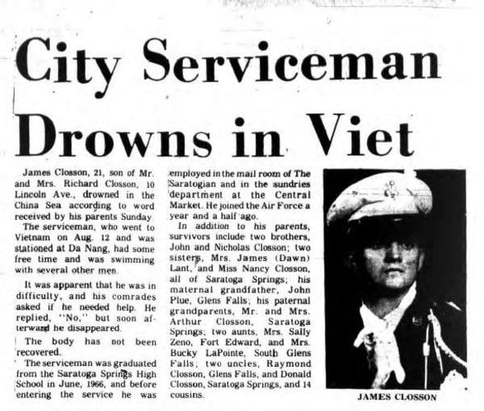

## POSTED ON 11.20.2016

BY: [wkillian@smjuhsd.org](mailto:wkillian@smjuhsd.org)  
Ground Casualty

A1C James S. Closson was a security policeman serving with the 366th Security Police Squadron. On January 12, 1969, A1C Closson was recreational swimming at China Beach in Quang Nam Province, RVN, while his unit was having a cookout when he was caught in the undertow. He drowned in the incident. His body was recovered. [Taken from coffeltdatabase.org and vvmf.org].

**Article**

## POSTED ON 11.17.2005

BY: John E. Lewis, SSgt, USAF, 68-69

[TOPSGTUSA@aol.com](mailto:TOPSGTUSA@aol.com)

**Article**

A terrible day at China Beach

I was a member of the 366 SPS who was at China Beach that day for a Squadron cookout. We never dreamed that we would lose a man to an undertow while swimming.

All these years later I can still hear the guys yelling about a missing man. We searched for hours. We were a demoralized bunch of men as we left the beach going back to the base.  
 **Article**

## POSTED ON 1.24.2005

BY: AIC Mike Manley

**Article**I was there that day at China Beach

We had our 1st cookout that day on China Beach. Jimmy was his usual self...a big smile and talking to everyone. I last saw Jimmy as I was coming out of the water, and he was going in with others from our 366th SPS. He is missed by all of us and someday we'll be at guardmount together again.

**Article**

## POSTED ON 8.29.2002

Uncle I never met

Uncle "Jimmy", Although I never met you, I feel I know you. You died on my birthday, 7 years prior to my birth. I do the same thing you did while in the military and also look a little like you. You are my inspiration, Thank you.

**Article**

## POSTED ON 6.30.2002

My big brother

Jimmy was always my hero. 5 years older than I and 500 feet taller. I still love you and I miss you. Nancy