**The Knife-13 Monument will live for possibly centuries.** Countless SFS and Guardians and future “spacers” will see the Monument. How best are the 56th Security Police to be presented on the monument? I yield this to you. However, I point out the 18 SPs standing in the photo-chalk line ready to board Knife-13 are all wearing either a helmet or beret. You can see that despite the poor lighting. Without photoshop it is not possible to restore all photos we have located. If you do not want photoshop used then we are talking about a completely different Side-1 and it would be more realistic to present the below photo without captions than individual photos. But it is too late in the game to even consider that.

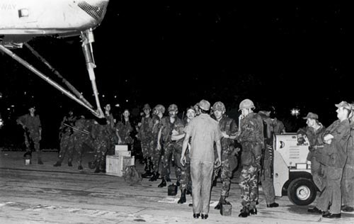

**The following photos demonstrate how current Side-1 photos were enhanced.**

**  
COLLUMS, BOBBY G., SGT.**: All images previously displayed for Collums were low quality and grainy. I have said all along these photos would be enhanced to present well on the monument.  
  
**Two photos and a News article** were available for Sgt. Collums.  
  
**a. News Article** (right): Appears possibly a 10th grade-level HS photo.  
  
**b. High School Photo** (center, right**)** possibly a senior photo).

**c. 1st Composite Image** (above, right): The “Senior HS photo” was placed in a Class A blue uniform (below). However, it resembled a drawing of poor quality.   
d.  **2nd Collums’ photo** (right): Photo located in VSPA achieves, shows him (possibly at NKP) relaxed and sitting in a lawn chair. You can see the strong and aging resemblances in the HS and the third photo. The question, what better represents Collums’ appearance on 13 May 1975 boarding the CH-53C—the lawn chair photo—or a composite?  
  
  
  
  
  
  
  
**e. 2nd Composite Collums Image** (below, right): I removed the lawn chair photo’s background, and placed Collums in the same 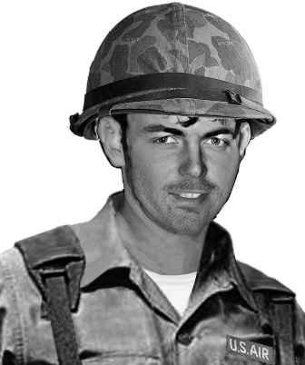uniform as other Knife-13 SPs. This image photo-composite is from an original photo, with a uniform overlayed on his physique.

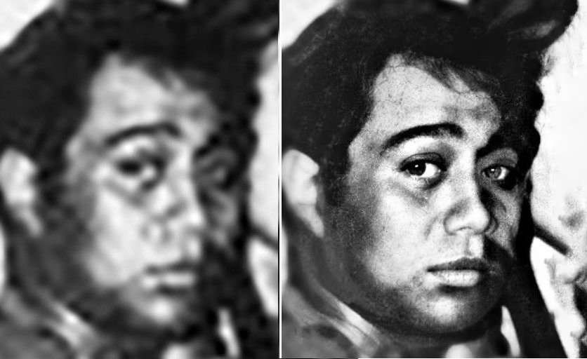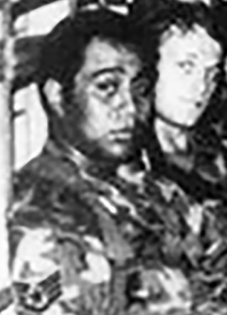 **FALEAGAFULU ILAOA, SSGT.**:  
  
**a. Original photo** (left) on board Knife-13, May 13, 1975.

**b. Photo** (center): Original photo closeup of face; and enhanced version. Side by side for comparison.  
  
  
  
 **c. Enhanced composite** of head (above right) will overlay the original photo (left), forming a clearer image. No other changes to this photo are anticipated.

**MC KELVEY, WILLIAM R.:**

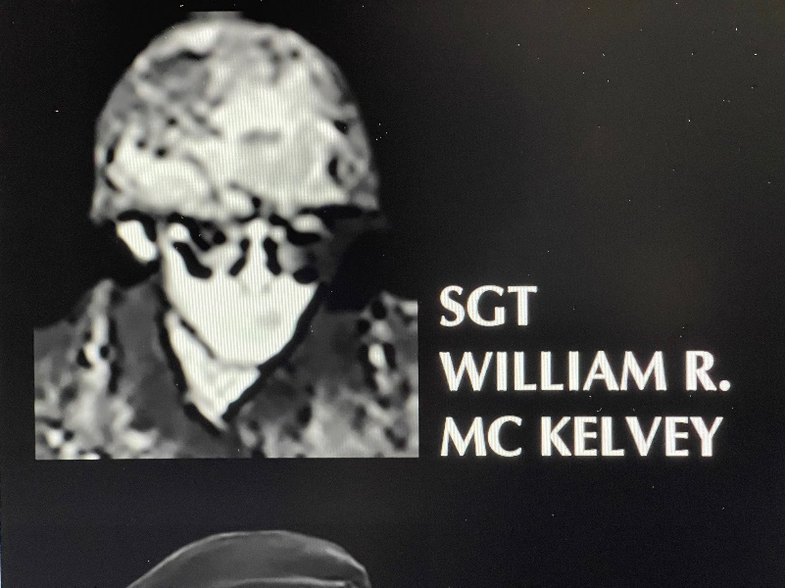**a. Sgt. Mc Kelvey’s original working photo** (below)is from the chalk line photo of the 18 SPs waiting to board Knife-13. It was unsuitable as the face was without definition.

**b. Mc Kelvey: An original** photo (right) with Wife and (was-to-be adopted) daughter, are overlayed on a holiday card.

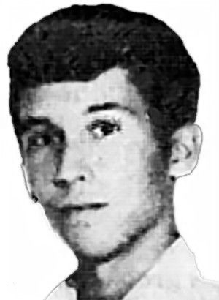**c. Mc Kelvey Photo** (right)**:** Head extracted from the holiday card for a composite image. It was necessary to lighten a *5 o’clock shadow* as it became too dark in the B&W image and looked like a beard.

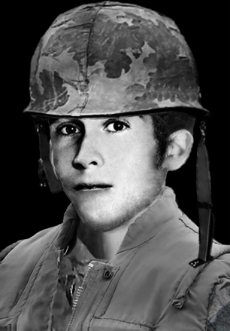**d. Mc Kelvey Photo** (Right): The card-holiday 1970’s shirt was replaced with Knife-13 attire. Although the results are adequate, I am not happy with it preferring the original photo’s Knife-13 pose. I will try to merge the   
original Knife-13 (squatting-photo) with the holiday-card’s face.  
  
Mc Kelvey’s eye glasses: Not sure if the glasses are prescription or  
sunshades (See “a.” above). If shades an option is to keep or remove them to see his face better.

**MATHIAS, ROBERT P.:   
a. High School Photo** (right) used only for comparison to the Knife-13 photo following.

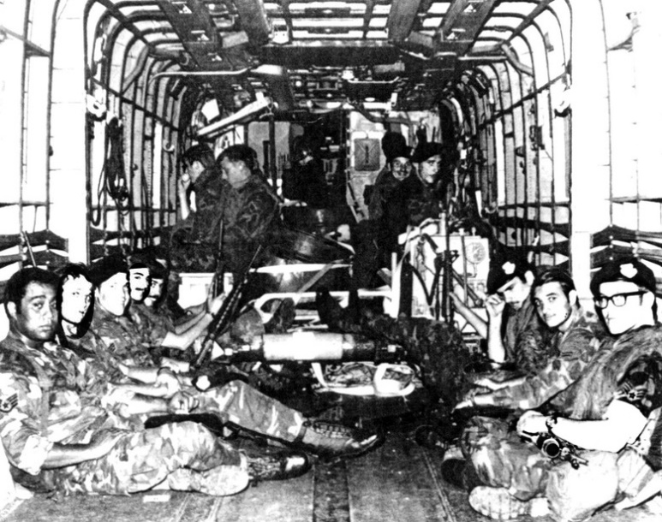**b. 1st ORIGINAL LAST-PHOTO OF KNIFE-13** and SPs onboard (below) was over-exposed. **Sgt. Mathias is seated** on right-side of fuselage; second from right.

**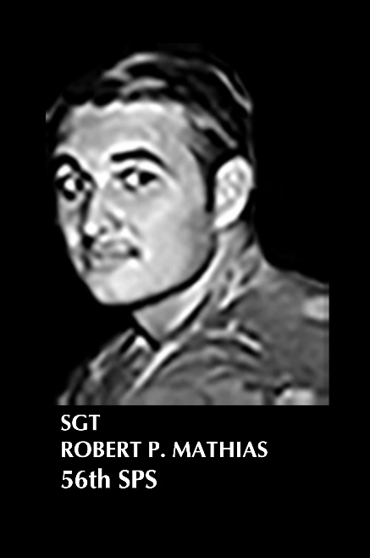  
c. The composite image** was marginally passable with a hazy   
 appearance.

**d. 2nd “Last-Photo” was located** (below, left), enhanced and presented a great image for Mathias. In the composite photo, he is not wearing a helmet or flack jacket in the Knife-13 photo, and none were added for him.

**MORAN, EDGAR C. II, Sgt.:   
Two News Articles were located** accouncing Sgt. Moran’s death.  
News Article #1’s photo may be   
**News Article #2**(right) is the original working photo.

1. A photo *simila*r to article 2’ss was located (below). Not great, but a good start.

1. 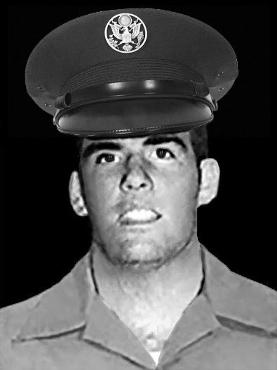**MORAN Article 2’s photo** (above, right) was enhanced with a new hat and 505’s (?):

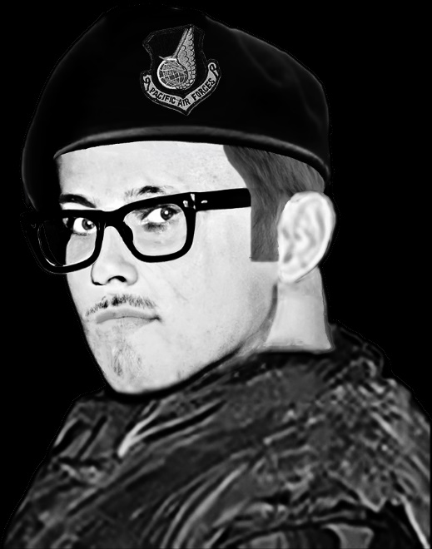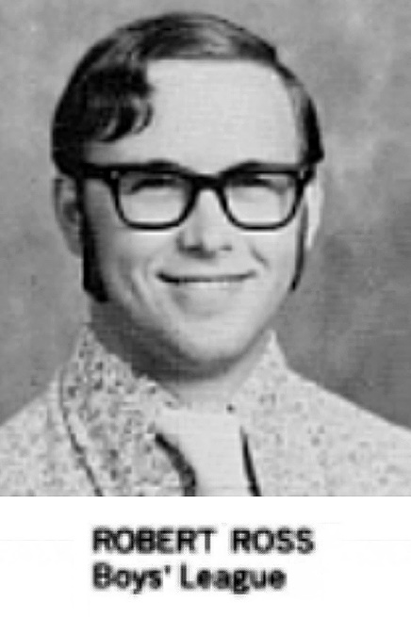**ROSS, RO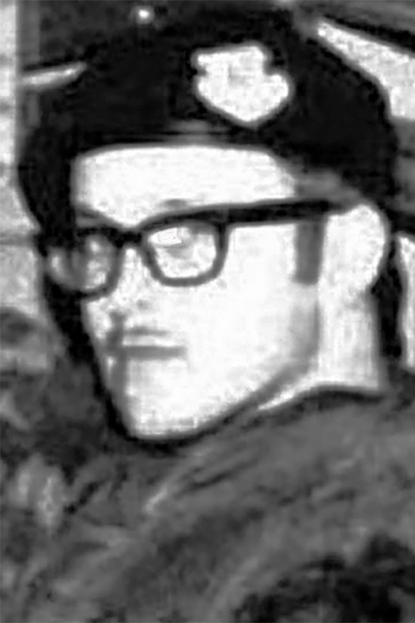BERT T., SGT.**: