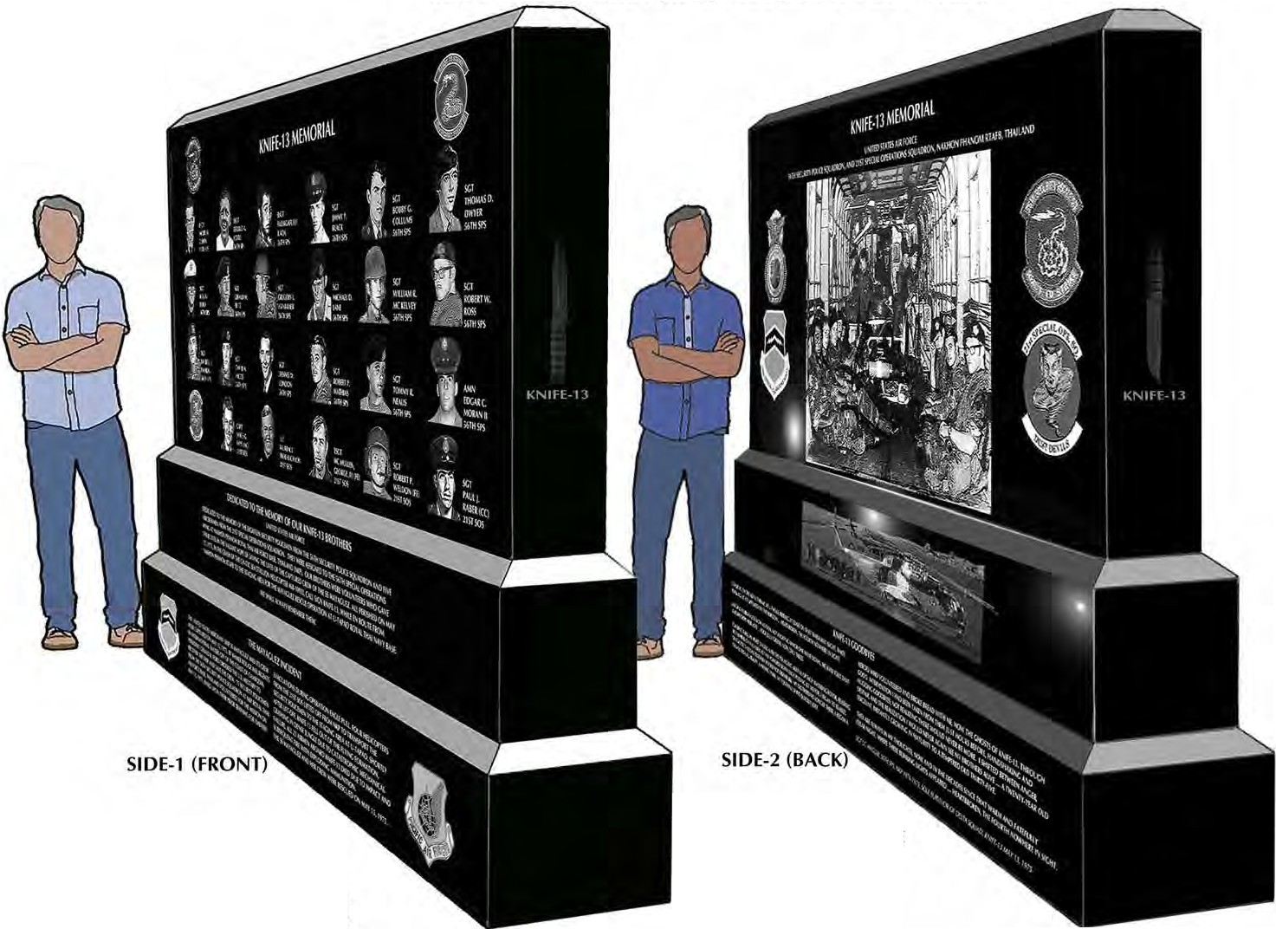
KNIFE-13 DONATE NOW

SIDE-2 Will rotate 180°and
form the Backside of Side-1.
Oblique views of Front, Back,
and Side Panels are to better see
all graphic images. The KNIFE-13
Memorial is the width of Side-1..
(OBLIQUE FRAM[-OUTLINE
DRAWINGS ARE BY THE STONE CUTTER.)

KNIFE-13 DONATE NOW
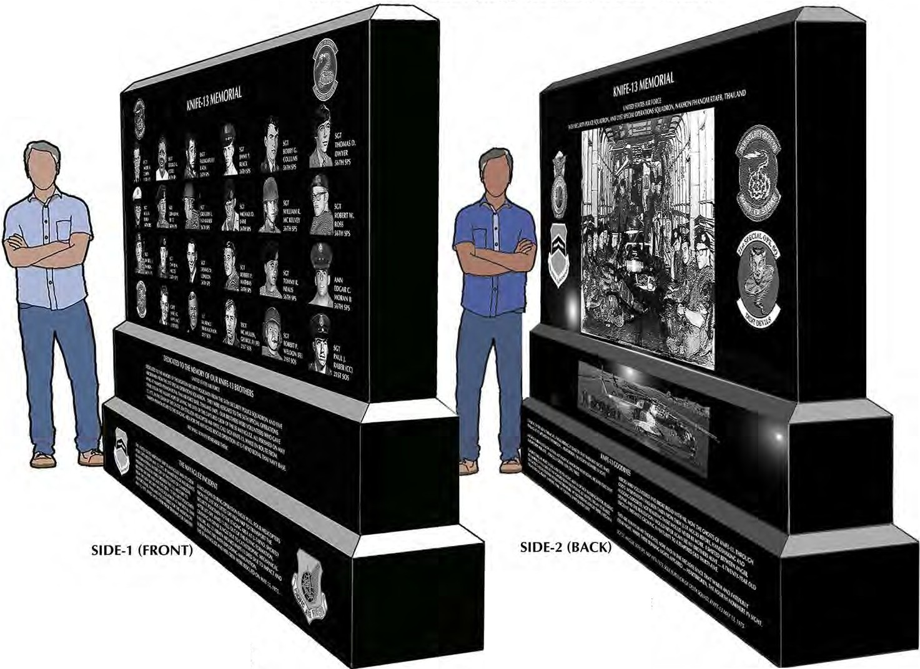

SIDE-2 Will rotate 180°and
form the Backside of Side-1.
Oblique views of Front, Back,
and Side Panels are to better see
all graphic images. The KNIFE-13
Memorial is the width of Side-1.
(OBLIQUE FRAM[-OUTLINE
DRAWINGS ARE BY THE STONE CUTTER.)

