**The Knife-13 Monument will live for possibly centuries. Countless SFS and Guardians will see the Monument. How best are they to be presented on the monument? I yield this to you.**

1. Panel-1 image of Collums: All images previously displayed are low quality and grainy. I have said all along these photos would be enhanced to present well on the monument.
2. A person in a suit and tie

   Description automatically generatedA person in a sweater and suspenders

   Description automatically generatedA close-up of a person

   Description automatically generated **Sgt. Bobby G. Collums’ HS Photos**: There aretwo HS photos (one possible 10th grade (lower left) and the 2nd second (center) possibly a senior photo).   
   Using his Senior HS photo (right), I placed Collums in a Class A blue uniform (below). However, it resembled a drawing. The quality of that can be improved with an enhanced version of the Senior photo.
3. 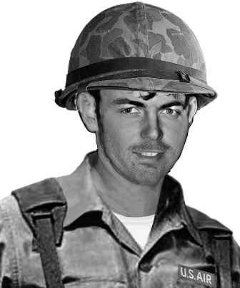**A person with dark hair and a white shirt

   Description automatically generated**A person sitting in a chair

   Description automatically generated**I located third photo** (in VSPA achieves) showing Collums (possibly at NKP) relaxed and sitting in a lawn chair. You can see the strong aging resemblance in these photos. The question is what better represents his appears on 13 May 1975 when boarding the CH-53C? With this photo, I placed him in the same uniform as are other Knife-13 SPs (helmet is optional, but others in that uniform are wearing one). I recommend the one on the right. This is an original photo, with a uniform overlayed his physique.

Other Photos considered:

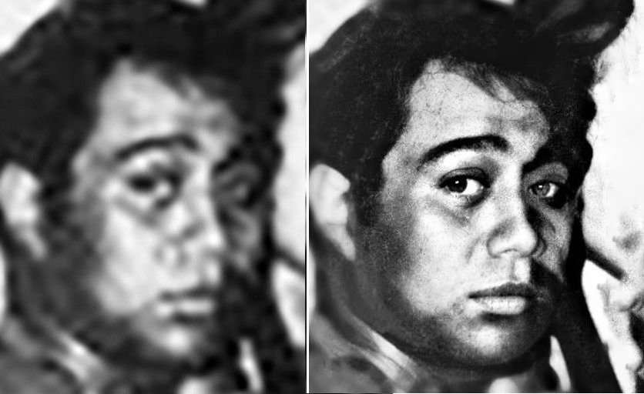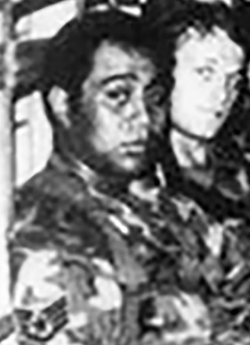  
SSgt. Faleagafulu ILAOA (Original, Left).

Center: Original.  
  
Right: enhanced.

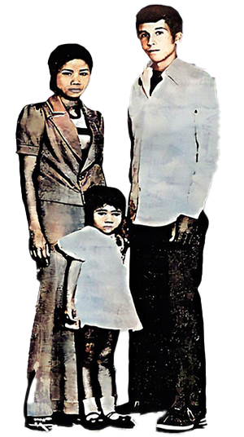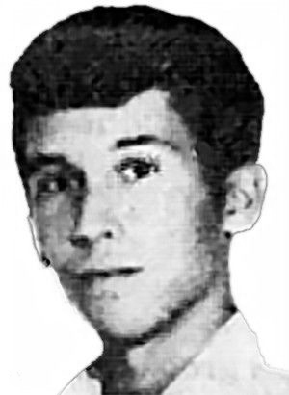

**MC KELVEY:**  
Left: Original photo  
with Wife and to-be  
adopted daughter,  
was overlayed on a  
holiday card.  
  
Center: Head from card.  
  
Right:

