UNITED STATES – Air Force Regular.

AIR POLICE AND SECURITY POLICE KILLED IN ACTION OR LINE OF DUTY

IN THE VIETNAM WAR (Vietnam and Thailand)
Photo & Composite © 2020, Don Poss
Photo & Composite © 2020, Don Poss

A-Z, USAF AP/SP KIA-LOD
ADAMS, ERHARD JIMMIE
SGT – Air Force Regular.
Age 22, Single Caucasian Male
Born 10 OCT 1948, from FAYETTEVILLE, NC
Tour of duty began 02 SEP 1970, at
CAM RANH BAY AIR BASE, REPUBLIC OF VIETNAM,
12th AIR POLICE SQUADRON.
Casualty was on 2 NOV 1970 in
PROVINCE OF KHANH HOA, SOUTH VIETNAM
NON-HOSTILE [LOD]: Died of ILLNESS/INJURY, a
GROUND CASUALTY - HEART ATTACK.
Religion – ROMAN CATHOLIC
Body was Recovered.
Panel 06W - Line 33
*

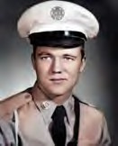
ADAMS, ROYCE HORACE
TSGT – Air Force Regular.
Age 32, Married Caucasian Male
Born 25 AUG 1936, from GRAND RIDGE, FL
Length of service 14 years.
Tour of duty began 18 MAR 1969, at
DA NANG AIR BASE, REPUBLIC OF VIETNAM,
366th SECURITY POLICE SQUADRON.
Casualty was on 14 APR 1969, in QUANG NAM, SOUTH VIETNAM
NON-HOSTILE [LOD]: GROUND CASUALTY VEHICLE CRASH.
Religion – METHODIST.
Body was Recovered.
Panel 27W - Line 79.
Description: Vietnam Casualty Book (NON-HOSTILE): SOUTH VIETNAM (B1): On 14 APR 1969, TSGT Royce H. Adams was killed when the security police vehicle in which he was riding went out of control and rolled over after skidding on wet pavement.*

ANDERSON, HERMAN B.
A1C – Air Force Regular.
Born 09 Jan 1946, from Florida.
Tour of duty at
U-TAPAO RTAFB, THAILAND,
635th SECURITY POLICE SQUADRON.
Casualty was on 08 OCT 1971
NON-HOSTILE: GROUND CASUALTY Body was Recovered.
Description: Vehicle vs. Pedestrian.

*

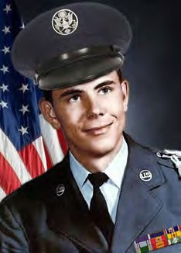
ANTHONY, PAUL WAYNE
A1C – Air Force Regular.
Age 20, Married Male Caucasian.
Born May 27, 1949 - From CHARLOTTE, NC
Length of service 1 years
Tour of duty began Apr 3, 1970, at
DA NANG AIR BASE, REPUBLIC OF VIETNAM
366th SECURITY POLICE SQUADRON.; and
6498th SECURITY POLICE SQUADRON.
Casualty was on Apr 8, 1970, in QUANG NAM, SOUTH VIETNAM
HOSTILE [KIA]: GROUND CASUALTY ARTILLERY, ROCKET, or MORTAR
[KIA 5th day at Da Nang Air Base, RVN]
Religion –PRESBYTERIAN Body was Recovered.
Panel 12W - Line 105.
*

BESTMANN, CHARLES EDWARD
SGT – Air Force Regular.
Age 22, Single Male Negro, Male
Born 01 SEP 1946, from FLUSHING, NY
Length of service 2 years.
Tour of duty began 30 AUG 1968, at
PHAN RANG AIR BASE (TDY), REPUBLIC OF VIETNAM,
821st SECURITY POLICE SQUADRON.
Casualty was on 28 NOV 1968 in GIA DINH, SOUTH VIETNAM
NON-HOSTILE [LOD]: Died of ILLNESS/INJURY, GROUND CASUALTY VEHICLE CRASH Religion - EPISCOPAL, ANGLICAN
Body was Recovered.
Panel 38W - Line 82.
*

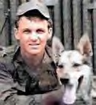
BEVICH, GEORGE MICHAEL, JR.
A2C – Air Force Regular.
Age 22, Single Caucasian Male
Born 10 JUL 1944 - From SUMMIT HILL, PA.
Length of service 3 years.
Tour of duty 13 APR 1966, at
TAN SON NHUT AIR BASE, REPUBLIC OF VIETNAM.
377th SECURITY POLICE SQUADRON.
Casualty was on 04 DEC 1966 in GIA DINH, SOUTH VIETNAM,
HOSTILE, GROUND CASUALTY ARTILLERY, ROCKET, or MORTAR
Body was Recovered.
Panel 13E - Line 9.

Description: The Vietnam Casualty Book (NON-HOSTILE) reads: A2C George Bevich, Jr. was the first – Air Force Regular. Dog Handler to die in Vietnam. He was stationed at TAN SON NHUT AIR BASE AIR BASE, REPUBLIC OF VIETNAM, 377th SECURITY POLICESQUADRON., and was killed in action on the night of DEC 6, 1966.
*

BIRKET, SCOTT LEE
A1C – Air Force Regular.
Age 21, Single Caucasian Male
Born 22 NOV 1950, from LAMIRADA, CA.
Casualty was on 20 SEP 1972 in QUANG NAM, SOUTH VIETNAM,
DA NANG AIR BASE, REPUBLIC OF VIETNAM,
6498th SECURITY POLICE SQUADRON.
NON-HOSTILE [LOD]: GROUND CASUALTY– SUICIDE
Religion - LUTHERAN & MISSOURI SYNOD.
Body was Recovered.
Panel 01W -Line 76.
*

BLACK, JIMMY P.
SGT – Air Force Regular.
Age 20, Male.
Born 24 AUG 1954 - From DAPHNE, AL.
NAKHON PHANOM RTAFB, THAILAND,
56th SECURITY POLICE SQUADRON.
Casualty was on 13 MAY 1975.
NON-HOSTILE, Helicopter Crash (Eighteen 56th SPS and 5 Aircrew were Killed enroute to the Mayaguez Incident and Operation Rescue, Cambodia—the last battle of the Vietnam War).
Body was Recovered.

*

BLAKENEY, MELVIN JASON
SGT – Air Force Regular.
Born 22 OCT 1949, from Pageland, SC
NAKHON PHANOM RTAFB, THAILAND,
56th SECURITY POLICE SQUADRON.
Casualty was on 07 JUL 1973
NON-HOSTILE [LOD]: ILLNESS/Disease. Body was Recovered.
*

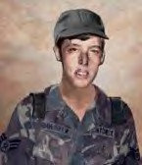
BOLSTER, DAN ARTHUR
A1C - E3 – Air Force Regular. 21years old Single Caucasian Male
Born 2 AUG 1950, from SEATTLE, WA.
Tour of duty began 19 MAR 1971,
DA NANG AIR BASE, REPUBLIC OF VIETNAM,
366th SECURITY POLICE SQUADRON.
Casualty was on 07 JAN 1972 in QUANG NAM, SOUTH VIETNAM
NON-HOSTILE [LOD]: Died of ILLNESS/INJURY GROUND CASUALTY, ACCIDENTAL - SELF-DESTRUCTION.
Religion- EPISCOPAL, ANGLICAN
Body was Recovered. Panel 02W - Line 95
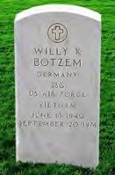
*
BOTZEM, WILLY KUEPPER
SSGT – Air Force Regular. Born 13 JUN 1940
Tour of duty began at
UBON RTAFB, THAILAND,
8th SECURITY POLICE SQUADRON.
Casualty was on 20 SEP 1971
NON-HOSTILEGROUND CASUALTY.
Body was Recovered.
Description: Jeep vs. Pedestrian.
*

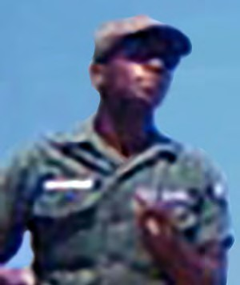
BOYD, JAMES
SGT – Air Force Regular.
Age 22, Married, Negro, Male
Born 24 JUN 1945, from WINSTON-SALEM, NC
Length of service 4 years.
Tour of duty began 04 FEB 1968
BIEN HOA AIR BASE, REPUBLIC OF VIETNAM,
3d AIR POLICE SQUADRON.
Casualty was on 28 FEB 1968 in BIEN HOA, SOUTH VIETNAM,
HOSTILE [KIA], GROUND CASUALTY ARTILLERY, ROCKET, or MORTAR.
Religion –BAPTIST.
Body was Recovered. Panel 41E - Line 59. *

BRIDGES, ROBERT EARL
A2C – Air Force Regular.
Age 20, Single, Caucasian, Male Born 31 JAN 1945, from GRANBY, CT.
Length of service 2 years.
Tour of duty began 28 NOV 1966, at
BIEN HOA AIR BASE, REPUBLIC OF VIETNAM,
3d AIR POLICE SQUADRON.
Casualty was on 17 JUN 1967 in BIEN HOA, SOUTH VIETNAM.
NON-HOSTILE [LOD], GROUND CASUALTY OTHER CAUSES
Body was Recovered.
Panel 21E - Line 117
Description: Struck by Lightning/Guard Tower post.
*

BRYANT, CHARLES E.
SSGT – Air Force Regular.
Tour of duty began at
DON MUANG RTAFB, THAILAND,
631st SECURITY POLICE SQUADRON.
Casualty was on 11 APR 1968
NON-HOSTILE [LOD]: Drowned/Chao Phya River.
Body was Recovered.
*

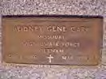
CARR, RODNEY GENE
SSGT – Air Force Regular.
22-Year-oldMale
Born 1 SEP 1941 - From FL.
Tour of duty began at
TAN SON NHUT AIR BASE, REPUBLIC OF VIETNAM,
377th SECURITY POLICE SQUADRON.
DOD: 10 MAR 1973 at SAIGON, 804th (Hospital).
Casualty was on 10 MAR 1973
NON-HOSTILE: Vehicle Crash
*

CLOSSON, JAMES STANLEY
A1C – Air Force Regular.
Age 21, Single Caucasian Male
Born SEP 21, 1947, from SARATOGA SPRINGS, NY
Length of service 1 year
Tour of duty began JUL 13, 1968, at
DA NANG AIR BASE, REPUBLIC OF VIETNAM,
366th SECURITY POLICE SQUADRON.
Casualty was on JAN 12, 1969, from QUANG NAM, SOUTH VIETNAM NON-HOSTILE[KIA], GROUND CASUALTY DROWNED, SUFFOCATED.
Body was Recovered. Panel 35W - Line 75.
Description: Died of accidental drowning at a recreational area with friends.
*

COLE, JOHN MATTHEW
A2C – Air Force Regular.
Age 20, Single Caucasian Male
Born 18 JUN 1946, from PHILADELPHIA, PA
Length of service 2 years.
Tour of duty began 20 JUL 1966, at
TAN SON NHUT AIR BASE, REPUBLIC OF VIETNAM,
377th SECURITY POLICES SQUADRON.
Casualty was on 04 DEC 1966, in GIA DINH, SOUTH VIETNAM,
HOSTILE, GROUND CASUALTY ARTILLERY, ROCKET, or MORTAR
Body was Recovered. Panel 13E - Line 11
*

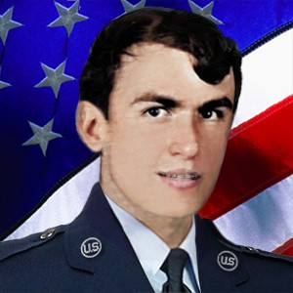
COLLUMS, BOBBY GLEN
SGT – Air Force Regular. Age 22, Male
Born 24 SEP 1952, from HELENA, MT.
Tour of duty at
NAKHON PHANOM RTAFB, THAILAND,
56th SECURITY POLICE SQUADRON.
Casualty was on 13 MAY 1975.
NON-HOSTILE, Helicopter Crash (Eighteen 56th SPS and 5 Aircrew were Killed enroute to the Mayaguez Incident and Operation Rescue, Cambodia—the last battle of the Vietnam War).
Body was Recovered.
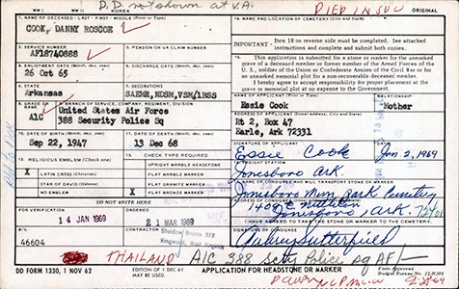
*
COOK, DANNY ROSCOE
A1C – Air Force Regular.
Born 27 SEP 1947
Tour of duty at
KORAT RTAFB, THAILAND,
388th SECURITY POLICE SQUADRON.
Casualty was on: 13 DEC 1968
NON-HOSTILE [LOD]: Truck vs. motorcycle. Body was Recovered.
*

CORDON, HUBERT CLARENCE
A1C – Air Force Regular.
Born 14 May 1943, from Omaha, NB
Tour of duty at
KORAT RTAFB, THAILAND,
388th SECURITY POLICE SQUADRON.
Casualty was on: 30 JUN 1973
NON-HOSTILE [LOD]: Accidental Self-Destruction (Gunshot).

Description: Airman was an entry controller at a munitions marshaling area adjacent to the KORAT RTAFB, THAILAND flight Line; died from a self- inflicted gunshot during chow relief, witnessed by several other SP personnel.
*

COYLE, GERALD A.
SSGT – Air Force Regular.
Age 31, Male
Born 14 MAY 1943, From BENTLEYVILLE, PA.
His tour began at
NAKHON PHANOM RTAFB, THAILAND,
56th SECURITY POLICE SQUADRON.
Casualty was on 13 MAY 1975.
NON-HOSTILE, Helicopter Crash (Eighteen 56th SPS and 5 Aircrew were Killed enroute to the Mayaguez Incident and Operation Rescue, Cambodia—the last battle of the Vietnam War).
Body was Recovered.
*
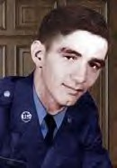
CYR, WILLIAM JOSEPH (Silver Star, posthumously)
SGT - E4 – Air Force Regular.
Age 22, single Male
Born 22 OCT 1945, from WEBSTER, MA.
Length of service 2 years
His tour began on Nov 16,1967 at
TAN SON NHUT AIR BASE, REPUBLIC OF VIETNAM,
377th SECURITY POLICE SQUADRON.
Casualty was on Jan 31, 1968, from GIA DINH, SOUTH VIETNAM,
HOSTILE, GROUND CASUALTY ARTILLERY, ROCKET, or MORTAR.
Religion – Catholic.
Body was Recovered.
Panel 36E - Line 5

Description: On the night of 31 January 1968, SGT. Cyr was one of five men who manned the O-51 Bunker at Tan Son Nhut AB during the attack by NVA forces. They were directly attacked by Bangalore type charges and RPG rockets. The bunker was ultimately overwhelmed by enemy forces.
[Casualties and Losses during the Attack on the Air Base:
22 US; 29 RVN; 669 NVA and Viet Cong; 26 NVA/VC POW.]
*

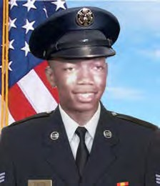
DAVIS, AARON, JR.

SSGT – Air Force Regular.
Age 21, Caucasian Male
Born on 04 OCT 1949, from ROCHESTER, NY
His tour began on 16 May 1970 at
PHU CAT AIR BASE, REPUBLIC OF VIETNAM,
12 th SECURITY POLICE SQUADRON.
Casualty was on 12 FEB 1971, in BINH DINH PROVINCE, SOUTH VIETNAM,
HOSTILE, GROUND CASUALTY OTHER EXPLOSIVE DEVICE.
Body was Recovered. Panel 05W – Line 98
*
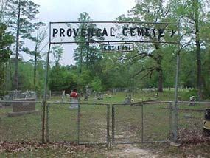
DAVIS, JOHN B.
CMSGT – Air Force Regular.
Born on 19 Sep 1929, from Natchitoches Parish, LA
His tour began at
NAKHON PHANOM RTAFB, THAILAND,
56th SECURITY POLICE SQUADRON.
Casualty was on 14 JUN 1973
NON-HOSTILE [LOD]: Heart Attack.
Body was Recovered.
*

DEWOLF, DALE LEE
SGT – Air Force Regular.
Age 20, Single Caucasian Male
Born 06 JUL 1952, from NEBRASKA CITY, NE
Tour of duty began 29 MAR 1972, at
TAN SON NHUT AIR BASE, REPUBLIC OF VIETNAM,
377th SECURITY POLICE SQUADRON.
Casualty was on 02 MAY 1973, from GIA DINH, SOUTH VIETNAM
NON-HOSTILE [LOD]: Died of Illness/INJURY GROUND, CASUALTY-VEHICLE LOSS CRASH.
Religion– PROTESTANT – NON-DENOMINATIONAL.
Body was Recovered. Panel 01W - Line 115.

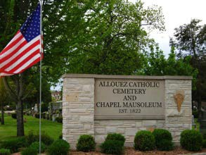
Description: Killed when his jeep rolled over on him. *
DEUSTER, WILLIAM J. JR.
SGT – Air Force Regular.
Tour began at
UDORN RTAFB, THAILAND,
825th Combat Defense Squadron (CDS).
Casualty was on 27 APR 1967.
NON-HOSTILE Crushed between Vehicles (Gate Duty)
Body was Recovered.
*

DWYER, THOMAS D.
SGT – – Air Force Regular.
Age 21, Male
Born JUN 17, 1953, from MIDDLEBURY, CT.
His tour began at
NAKHON PHANOM RTAFB, THAILAND,
56th SECURITY POLICE SQUADRON.
Casualty was on 13 MAY 1975.
NON-HOSTILE, Helicopter Crash (Eighteen 56th SPS and 5 Aircrew were Killed enroute to the Mayaguez Incident and Operation Rescue, Cambodia—the last battle of the Vietnam War).
Body was Recovered.
*
ENGLAND, JAMES C.
SGT – Air Force Regular.
Born on 01/10/1945
His tour began at
U-TAPAO RTAFB, THAILAND,
635th SECURITY POLICE SQUADRON.
Casualty was on 01 MAR 1970 NON-HOSTILE: Gunshot.
Body was Recovered.
*

EVANS, JOHN HARPER, JR.
Airman – Air Force Regular. Age 20, Single, Negro, Male
Born 01 APR 1950, from HEMPSTEAD, NY.
PHAN RANG AIR BASE, REPUBLIC OF VIETNAM,
35th SECURITY POLICE SQUADRON.
Tour of duty began 18 APR 1970.
Casualty was on 07 AUG 1970 in KHANH HOA, SOUTH VIETNAM,
NON-HOSTILE [LOD]: GROUND CASUALTY - ACCIDENTAL SELF-DESTRUCTION
Religion - ROMAN CATHOLIC.
Body was Recovered.
Panel 08W - Line 90
*
FAIRCLOTH, LARRY R.
SSGT – Air Force Regular.
Length of service Vietnam: 1967-1968
His tour began at MUKDAHAN, VIKING STATION RADAR, THAILAND,
DET-6, 621st TAC SQ.
Casualty was on 05 APR 1968, in GIA DINH, SOUTH VIETNAM
NON-HOSTILE: ILLNESS/Disease – Aneurysm (Possible Hospital Evacuate) Body was Recovered.
[No Photo. Drawing from SSGT Faircloth’s obit article]
*

FIELDS, ROBERT LOUIS, III
A2C – Air Force Regular.
Age 21, Single Caucasian Male
Born 01 FEB 1944, from GALESBURG, IL
Length of service 2 years.
Tour of duty was at
CAM RANH BAY AIR BASE, REPUBLIC OF VIETNAM,
12th AIR POLICE SQUADRON.
Casualty was on 27 JAN 1966, in KHANH HOA, SOUTH VIETNAM
NON-HOSTILE GROUND CASUALTY - DROWNED, SUFFOCATED.
Body was Recovered. Panel 04E - Line 99

Description: Robert Louis Fields and Gary Paul Gay died on the same day due to drowning at Cam Ranh Bay. They both drowned in January during the monsoon season when the waters around Cam Ranh Bay are treacherous. The South China Sea is very calm between March and September. However, between September and March over the winter months, during the monsoon season, the tides change dramatically. There is heavy surf full of debris, including hatch covers, and Rip Tides are everywhere. It takes skilled water safety personnel to identify and move barrier buoys for recreational swimming.
I was a Water Safety Instructor and had been a lifeguard. I worked as a lifeguard at Cam Ranh Bay during my off duty hours because we had three named beaches (Baker Beach, West Beach and the Officer's Beach) and regardless of the name or location, people got in trouble at each beach due to the current. I made numerous rescues during the nine months that I worked as a lifeguard, and I didn't work every day. All lifeguards had primary jobs and worked as lifeguards only when off duty. January was a very bad month for water conditions.
*

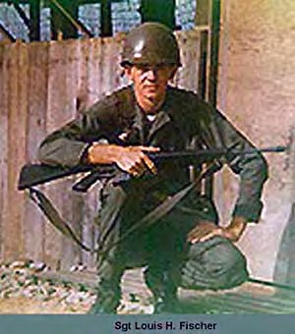
FISCHER, LOUIS HAROLD
SGT - E4 – Air Force Regular.
Age 22, Single Caucasian Male
Born 19 DEC 1945, from WOOD HAVEN, NY
Length of service 2 years
His tour began on Apr 15, 1967, at
TAN SON NHUT AIR BASE, REPUBLIC OF VIETNAM,
7th AF HQ/MACV.
Casualty was on Jan 31, 1968, in GIA DINH, SOUTH VIETNAM.
HOSTILE, GROUND CASUALTY, ARTILLERY, ROCKET, or MORTAR
Religion – Roman Catholic. Body was Recovered.
Panel 36E - Line 8

*

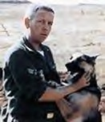
FORD, BERNARD FRANCIS
A1C – Air Force Regular.
Age 33, Single Caucasian Male
Born 09 JAN 1934, from OAK LAWN, IL
Length of service 14 years.
Tour of duty was at
PHAN RANG AIR BASE, REPUBLIC OF VIETNAM,
35th AIR POLICE SQUADRON.
Casualty was on 05 JUL 1967 in NINH THUAN, SOUTH VIETNAM
NON-HOSTILE [LOD]: GROUND CASUALTY - ACCIDENTAL HOMICIDE
Body was Recovered.
Panel 23E - Line 10

*

FORD, BOB WAYNE
SGT – Air Force Regular.
Age 21, Male
Born 19 FEB 1954, from SEMINOLE, TX.
Tour of duty was at
NAKHON PHANOM RTAFB, THAILAND,
56th SECURITY POLICE SQUADRON.
Casualty was on 13 MAY 1975.
NON-HOSTILE, Helicopter Crash (Eighteen 56th SPS and 5 Aircrew were Killed enroute to the Mayaguez Incident and Operation Rescue, Cambodia—the last battle of the Vietnam War).
Body was Recovered.

Steve Davidson - Comment: I have a better understanding of how things are now, but I don't agree with the "Washington D.C. bean counters" [not issuing Purple Hearts to Mayaguez SPs], but that's not unusual. SGT Bob Wayne Ford was a good friend of mine. We were stationed together at Kingslely Field, OR, from 72-75. He left for Thailand in early 1975 and I was attending Camp Bullis en route to Korea when we first learned of his (and the others who were killed) death in the helicopter crash. You have a great web site and I'm glad to see that all Security Police who served in Vietnam are honored and remembered with integrity. Thanks! Steve Davidson.

*

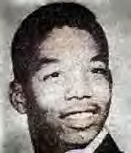
FOSTER, TONY CURTIS
A1C – Air Force Regular.
Age 21, Single, Negro, Male
Born 02 MAR 1948, from PHILADELPHIA, PA
Length of service 2 years.
Tour of duty was at
PHU CAT AIR BASE, REPUBLIC OF VIETNAM,
821st COMBAT SECURITY POLICE, SAFESIDE.
Casualty was on 05 DEC 1969, in BINH DINH, SOUTH VIETNAM
NON-HOSTILE [LOD]: GROUND CASUALTY OTHER ACCIDENT: EXPLOSIVE DEVISE
Religion - EPISCOPAL, ANGLICAN
Body was Recovered.
Panel 15W - Line 27
Description: Died of multiple fragment wounds of the body when he apparently stepped on an explosive device while performing duty as a security policeman on the northwest corner of Phu Cat Air Base.

*

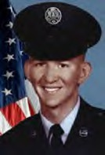
FRANCIS, JAMES EDWARD (Airman's Medal)
A1C – Air Force Regular.
Age 21, Married Caucasian Male
Born 16 JUN 1946, from ST. Louis, MO.
Length of service 2 years.
Tour began on 16 OCT 1967, in Thailand,
KORAT RTAFB, THAILAND,
388th SECURITY POLICE SQUADRON.
Casualty was on 11 MAR 1968
NON-HOSTILE [LOD]: Died of Illness/Injury,
GROUND CASUALTY OTHER EXPLOSIVE DEVICE. Bomb Dump Explosion (and rescue).
Religion – BAPTIST.
Body was Recovered.
Panel 44E - Line 14

*

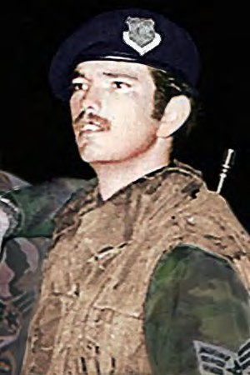
FRITZ, GERALD W.
SGT – Air Force Regular.
Age 21, Male
Born MAY 6, 1954, from JUNCTION, TX.
Tour of duty was at
NAKHON PHANOM RTAFB, THAILAND,
56th SECURITY POLICE SQUADRON.
Casualty was on 13 MAY 1975.
NON-HOSTILE, Helicopter Crash (Eighteen 56th SPS and 5 Aircrew were Killed enroute to the Mayaguez Incident and Operation Rescue, Cambodia—the last battle of the Vietnam War).
Body was Recovered.
*

FULLER, GARY LEROY
A2C – Air Force Regular.
Age 21, Married, Caucasian, Male
Born OCT 18, 1945, from THE PLAINS, OH
Length of service 2 years.
Tour of duty began 26 DEC 1966,
DA NANG AIR BASE, REPUBLIC OF VIETNAM,
366th SECURITY POLICE SQUADRON.
Casualty was on 27 FEB 1967, in QUANG NAM, SOUTH VIETNAM.
HOSTILE, GROUND CASUALTY - ARTILLERY, ROCKET, or MORTAR.
Body was Recovered. Panel 15E - Line 105.
Description: KIA 2 months and 1 day at Da Nang Air Base.

*

GABRIEL, CHARLES DAVID
A2C – Air Force Regular. Age 20, Single, Negro, Male
Born 01 DEC 1946, from PALMER, TX
Length of service 1 year.
Tour of duty began 26 OCT 1966,
TAN SON NHUT AIR BASE, REPUBLIC OF VIETNAM,
377th SECURITY POLICE SQUADRON.
Casualty was on 06 JAN 1967, in GIA DINH, SOUTH VIETNAM.
NON-HOSTILE [LOD]: GROUND CASUALTY - ACCIDENTAL HOMICIDE
Body was Recovered. Panel 13E - Line 118
*

GALLOWAY, MELVIN R.
Airman – Air Force Regular.
Born APR 22, 1947, from BREVARD, NC
Tour of duty began at
KORAT RTAFB, THAILAND,
388th SECURITY POLICE SQUADRON.
Casualty was on 06 MAR 1970, in KORAT RTAFB, THAILAND
NON-HOSTILE [LOD]: Suicide. Body was Recovered.

*

GAY, GARY PAUL
A1C – Air Force Regular.
Age 24, Married Caucasian Male
Born NOV 21, 1941, from CONEMAUGH, PA
Length of service 6 years.
Tour of duty began 22 JAN 1966, at
CAM RANH BAY AIR BASE, REPUBLIC OF VIETNAM, 12th AIR POLICE SQUADRON.
Casualty was on 27 JAN 1966, in KHANH HOA, SOUTH VIETNAM
NON-HOSTILE [LOD]: GROUND CASUALTY - DROWNED, SUFFOCATED
Body was Recovered. Panel 04E - Line 99

Description: Gary Paul Gay and Robert Louis Fields and died on the same day due to drowning at Cam Ranh Bay. They both drowned in January during the monsoon season when the waters around Cam Ranh Bay are treacherous. The South China Sea is very calm between March and September. However, between September and March over the winter months, during the monsoon season, the tides change dramatically. There is heavy surf full of debris, including hatch covers, and Rip Tides are everywhere. It takes skilled water safety personnel to identify and move barrier buoys for recreational swimming.
I was a Water Safety Instructor and had been a lifeguard. I worked as a lifeguard at Cam Ranh Bay during my off duty hours because we had three named beaches (Baker Beach, West Beach and the Officer's Beach) and regardless of the name or location, people got in trouble at each beach due to the current. I made numerous rescues during the nine months that I worked as a lifeguard, and I didn't work every day. All lifeguards had primary jobs and worked as lifeguards only when off duty. January was a very bad month for water conditions. *

GLENN, JACKIE D.
TSGT – Air Force Regular.
Age 36, Male
Born 10 MAY 1939, from SEYMOUR, MO.
Tour of duty at
NAKHON PHANOM RTAFB, THAILAND,
56th SECURITY POLICE SQUADRON.
Casualty was on 13 MAY 1975.
NON-HOSTILE, Helicopter Crash (18 56th SPS and 5 Aircrew were Killed enroute to the Mayaguez Incident and Operation Rescue, Cambodia—the last battle of the Vietnam War).
Body was Recovered.
Panel 01W - Line 126

*

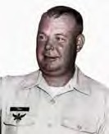
GRAY, GEORGE CHRISTIAN
SMSGT – Air Force Regular.
Age 43, Married Caucasian Male.
Born FEB 06, 1926, from GRINDSTONE, PA
Length of service 20 years.
Tour of duty began 31 JAN 1969, at
QUI NHON AIR BASE, REPUBLIC OF VIETNAM,
37th SECURITY POLICE SQUADRON.
Casualty was on 29 MAR 1969, in BINH DINH, SOUTH VIETNAM
NON-HOSTILE Died of ILLNESS/INJURY GROUND – CASUALTY HEART ATTACK.
Religion – BAPTIST.
Body was Recovered. Panel 28W - Line 81.
*

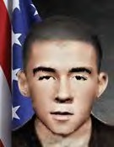
GRENIER, JOSEPH KENT
A1C – Air Force Regular.
Age 23, Single Caucasian Male.
Born OCT 30, 1946, from ST. JOSEPH, MO
Tour of duty began MAY 18, 1970, at
NHA TRANG AIR BASE, REPUBLIC OF VIETNAM,
327th Combat Support Group (CSG).
Casualty was on SEP 04, 1970, in NT, 327th CSG, 1st Flight (Surgical) DET): (LOD) in KHANH HOA PROVIENCE, SOUTH VIETNAM
NON-HOSTILE [LOD]: GROUND CASUALTY - ACCIDENTAL SELF-DESTRUCTION
Body was Recovered. Panel 07W - Line 37

Description: Accidental Self-Destruction: Gunshot.
*

GRILLO, LAWRENCE HUGH
A1C – Air Force Regular.
Age 21, Single Caucasian Male.
Born DEC 15, 1947, from BRIDGEPORT, CT
Length of service 1 year.
Tour of duty began 11 APR 1969, at
PHAN RANG AIR BASE, REPUBLIC OF VIETNAM,
35th SECURITY POLICE SQUADRON.
Casualty was on 28 MAY 1969, in NINH THUAN, SOUTH VIETNAM
NON-HOSTILE [LOD]: GROUND CASUALTY - OTHER CAUSES.
Religion - ROMAN CATHOLIC.
Body was Recovered.
Panel 23W - Line 8.

Description: Struck by lightning/Guard Tower.

*

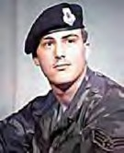
HAMLIN, DARRELL L.
SGT – Air Force Regular.
Age 19, Male
Born 20 OCT 1955, from IOWA CITY, IA.
Tour of duty at
NAKHON PHANOM RTAFB, THAILAND,
56th SECURITY POLICE SQUADRON.
Casualty was on 13 MAY 1975.
NON-HOSTILE, Helicopter Crash (Eighteen 56th SPS and 5 Aircrew were Killed enroute to the Mayaguez Incident and Operation Rescue, Cambodia—the last battle of the Vietnam War).
Body was Recovered.

*

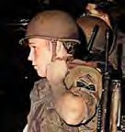
HANKAMER, GREGORY L.
SGT - E4 – Air Force Regular.
Age 21, Caucasian Male
Born 15 SEP 1953, from SAN PEDRO, CA
Tour began at
NAKHON PHANOM RTAFB, THAILAND,
56th SECURITY POLICE SQUADRON.
Casualty was on 13 MAY 1975.
NON-HOSTILE, Helicopter Crash (Eighteen 56th SPS and 5 Aircrew were Killed enroute to the Mayaguez Incident and Operation Rescue, Cambodia—the last battle of the Vietnam War).
Body was Recovered.

*

HARDEN, ROOSEVELT JR.
A3C – – Air Force Regular.
Age 20, Male
Born 18 MAR 1945
Tour began at
NAKHON PHANOM RTAFB, THAILAND,
56th AIR POLICE SQUADRON.
Casualty was on 11 JUL 1967.
NON-HOSTILE. Gunshot/Guard duty. Body was Recovered.
*

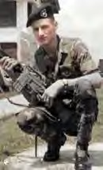
HEBRON, CHARLES EDWARD
SGT (E4) – Air Force Regular. Age 22, Married Male
Born 18 SEP 1945, from: BRYAN, TX.
Length of service 3 years
His tour began on Mar 21, 1967, at
TAN SON NHUT AIR BASE, REPUBLIC OF VIETNAM, 377th SECURITY POLICE SQUADRON.
Casualty was on Jan 31, 1968, in GIA DINH, SOUTH VIETNAM
HOSTILE, GROUND CASUALTY ARTILLERY, ROCKET, or MORTAR
Religion – ROMAN CATHOLIC
Body was Recovered. Panel 3 6E - Line 13

*

HICKS, JAMES RUSSELL
SSGT – Air Force Regular.
Age 21, Single Caucasian Male
Born 29 SEP 1949, from STILLWATER, MN
Tour of duty began on 09 DEC,1970, at
DA NANG AIR BASE, REPUBLIC OF VIETNAM,
366th SECURITY POLICE SQUADRON.
Casualty was on 06 MAR 1971, in QUANG NAM, SOUTH VIETNAM
NON-HOSTILE [LOD]: GROUND CASUALTY - ACCIDENTAL HOMICIDE.
Religion - EVANGELICAL COVENANT.
Body was Recovered. Panel 04W - Line 27.

Description: SGT James Russell Hicks (SSGT, Promoted Posthumously) Died of a gunshot wound to the head.

*

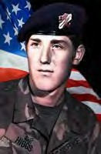
HIGGS, DAVID ALAN
SGT – – Air Force Regular.
Age 20, Male
Born 05 MAY 1955, from SPOKANE, WA.
Tour began at
NAKHON PHANOM RTAFB, THAILAND,
56th SECURITY POLICE SQUADRON.
Casualty was on 13 MAY 1975.
NON-HOSTILE, Helicopter Crash (Eighteen 56th SPS and 5 Aircrew were Killed enroute to the Mayaguez Incident and Operation Rescue, Cambodia—the last battle of the Vietnam War).
Body was Recovered.

*

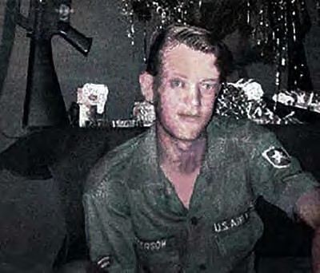
HOLBROOK, HORACE ALVIE
A2C - E3 – Air Force Regular.
Age 21, Single, Caucasian, Male
Born 4 OCT 1945, from JACKSONVILLE, AL
Length of service 2 years
His tour began on Nov 16, 1966, at
BIEN HOA AIR BASE, REPUBLIC OF VIETNAM,
3d AIR POLICE SQUADRON.
Casualty was on May 12, 1967, in BIEN HOA, SOUTH VIETNAM
HOSTILE, GROUND CASUALTY ARTILLERY, ROCKET, or MORTAR
Body was Recovered.
Panel 19E - Line 96
Description: Photo of Holbrook's last Christmas before KIA.
Body was Recovered.
Panel 01W – Line 126

Description: ‘CH-53 KNIFE 13, Serial Number 68-10933, 21st SOS, with 5 Air Crew with a 56th Security Ops Specialist; and 18 56th SPS Airmen onboard, airlifted from NKP enroute to U-Tapao RTAFB. As one of three 3 CH-53s, carrying 75 SPs, as requested by 7th Air Force, to join the assembling force for the SS Mayaguez Incident rescue operation.
At 2130 local, and about 37 miles west of NKP RTAFB, bound for U-Tapao, KNIFE 13 fell out of formation and crashed and exploded on impact. All 23 aboard were killed. Other CH-53s landed nearby, but exploding ammunition and burning fuel hindered all rescue attempts. The marines CH-53s continued on flight to Cambodia and on 15 May 1975, after an ongoing vicious battle, control of the SS Mayaguez returned to the United States.
*

HOLLEY, GLYNN BYRON
A1C – Air Force Regular.
Age 20, Single, Caucasian, Male
Born 27 MAY 1949. From MIDLAND, TX.
Length of service 1 year.
Tour of duty began 06 DEC 1969, at
CAM RANH BAY AIR BASE, REPUBLIC OF VIETNAM,
12th AIR POLICE SQUADRON.
Casualty was on 26 DEC 1969, in KHANH HOA, SOUTH VIETNAM.
NON-HOSTILE [LOD]: Died of ILLNESS/INJURY GROUND CASUALTY
ILLNESS, DISEASE.
Religion - CHURCH OF CHRIST.
Body was Recovered. Panel 15W - Line 93
*

ILAOA, FALEAGAFULA
SSGT — – Air Force Regular. Regular.
Age 27, Male
Born 06 APR 1948, from SAN FRANCISCO, CA.
Tour of duty at
NAKHON PHANOM RTAFB, THAILAND,
56th SECURITY POLICE SQUADRON.
Casualty was on 13 MAY 1975.
NON-HOSTILE, Helicopter Crash (Eighteen 56th SPS and 5 Aircrew were Killed enroute to the Mayaguez Incident and Operation Rescue, Cambodia—the last battle of the Vietnam War).
Body was Recovered.

*

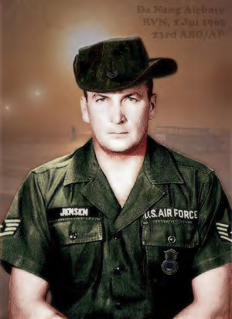
JENSEN, TERANCE KAY [First Air Policeman KIA in Vietnam War]
SSGT – Air Force Regular.
Age 33, Married Caucasian Male
Born 14 JAN 1932, from DETROIT LAKES, MN
Length of service 14 years.
Tour of duty at
DA NANG AIR BASE, REPUBLIC OF VIETNAM,
23rd AIR BASE GROUP/AIR POLICE.
Casualty was on 01 JAN 1965,in QUANG NAM, at
DA NANG AIR BASE, SOUTH VIETNAM
HOSTILE, GROUND CASUALTY OTHER EXPLOSIVE DEVICE
(Sappers, NVA Gun Shot).
Body was Recovered. Panel 02E - Line 26

Description: Email from Patricia Jensen (daughter)
Subject: Re: SSGT Jensen,
DA NANG AIR BASE, REPUBLIC OF VIETNAM, JUL 1, 1965 –
My dad is buried at Oak Grove Cemetery in Detroit Lakes MN. I think the plot is S21. He is in the area where there are no headstones. He has a Silver Star on a stake that says veteran on it.
When you are facing the cemetery at the main gate he is to the left, the section is almost to the farthest side, towards the front. Please let me know if there are any grave sites here in southern Oregon that I could visit. I will try to scan the photo and send it to you; I will need my son to help.
Happy Holidays, Patricia Jensen.
[SSGT Jensen had two daughters who would enlist in the Air Force, Regular, as Security Police.]
*

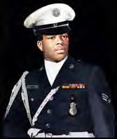
JONES, BRUCE DALE
SGT (Posthumous Promotion)—
Air Force Regular.
Age 20, Single, Negro, Male
Born JAN 14, 1952, From Evergreen, AL
Tour of duty began, 15 JAN 1972, at
TAN SON NHUT AIR BASE, REPUBLIC OF VIETNAM,
377th SECURITY POLICE SQUADRON.
Casualty was on 9 MAR 1972 in GIA DINH, SOUTH VIETNAM.
NON-HOSTILE [LOD]: Died of ILLNESS/INJURY, Accidental Self-Destruction.
Body was Recovered. Panel 02W- Line 114
*

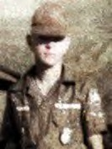
JONES, JAMES BRUCE
[2nd Air Policeman KIA in the Vietnam War]
A3C – Air Force Regular.
Age 20, Single, Caucasian Male
Born 15 DEC 1945, from ALEXANDRIA BAY, NY
Length of service 1 year.
Tour of duty at
DA NANG AIR BASE, REPUBLIC OF VIETNAM,
6252nd AIR POLICE SQUADRON (TFW).
Casualty was on 25 JAN 1966, in QUANG NAM, SOUTH VIETNAM,
DA NANG AIR BASE,
HOSTILE, GROUND CASUALTY - OTHER EXPLOSIVE DEVICE, MORTARS
Body was Recovered.
Panel 04E - Line 093
*

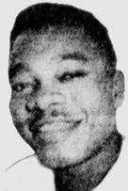
KELSEY, J C
A1C – Air Force Regular.
Age 30, Married, Negro, Male
Born 22 MAR 1936, from DETROIT, MI
Tour began at
NHA TRANG AIR BASE, REPUBLIC OF VIETNAM,
14th AIR POLICE SQUADRON.
Length of service 12 years.
Casualty was on 02 DEC 1966, in KHANH HOA, SOUTH VIETNAM
NON-HOSTILE [LOD]: Died of ILLNESS/INJURY GROUND CASUALTY VEHICLE CRASH
Body was Recovered
Panel 13E - Line 6

*

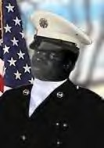
KEMP, JIMMY
A2C – Air Force Regular. Age 19, Single, Negro, Male
Born 08 JUL 1947, from CLEMSON, SC
Length of service 1 year.
Tour of duty began 29 MAR 1967, at
PHU CAT AIR BASE, REPUBLIC OF VIETNAM,
37th AIR POLICE SQUADRON.
Casualty was on 06 JUN 1967 in BINH DINH, SOUTH VIETNAM.
NON-HOSTILE [LOD]: GROUND CASUALTY - DROWNED, SUFFOCATED
Body was Recovered.
Panel 21E - Line 62

Description: While swimming Jimmy Kemp’s body suddenly sank below the surface. As the M60 Gunner, the weight of his equipment and the swift current of the river, he was unable to surface. His remains were subsequently recovered.
*

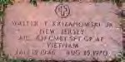
KRIZANOWSKI, WALTER T. JR.
A1C – Air Force Regular. Age 24. Born 19 JAN 1946.
Tour of duty at
DON MUANG RTAFB, THAILAND,
631st SECURITY POLICE SQUADRON / CSG.
Casualty was on 25 AUG 1970, NON-HOSTILE [LOD]: Train vs. Vehicle.
Body was Recovered.
BANGKOK, Thailand, Aug. 26 (Reuters) — An express train traveling at full speed struck bus, killing seven American airmen and injuring four others at a railroad crossing near Bangkok's Don Muang airport, police sources said today. The bus was taking the airmen to their headquarters from the airport 15 miles north of Bangkok last night when the collision occurred at an unguarded crossing, the police said.
Police identified the dead airmen as: Thomas J. Broad water, Age 26, Handel Emila Jr. 26; Paul C. Saver, 22; Richard H. Stanton; 40; Walter Krizanowski, 24; Richard Gregsby, 21, and Paul Edmundson, 22.
Burial Location: Rosedale and Rosehill Cemetery, Lined, New Jersey.
*
LANE, MICHAEL DAVID
SGT – Air Force Regular.
Age 25, Male Born 04 JAN 1950.
From JACKSONVILLE, FL.
NAKHON PHANOM RTAFB, THAILAND,
56th SECURITY POLICE SQUADRON.
Casualty was on 13 MAY 1975.
NON-HOSTILE, Helicopter Crash (Eighteen 56th SPS and 5 Aircrew were Killed enroute to the Mayaguez Incident and Operation Rescue, Cambodia—the last battle of the Vietnam War).
Body was Recovered.
*

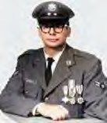
LEHMAN, MILLARD WESLEY
A1C - E4 – Air Force Regular. Age 23, Single Caucasian Male
Born 14 MAY 1943, from NACO, AZ
Tour of duty at
BINH TUY AIR BASE, REPUBLIC OF VIETNAM,
632nd AIR POLICE SQUADRON.
Length of service 4 years.
Casualty was on 06 Jul 1966 In PHONG DINH, SOUTH VIETNAM
HOSTILE, GROUND CASUALTY ARTILLERY, ROCKET, or MORTAR
Body was Recovered. Panel 09E - Line 7
*

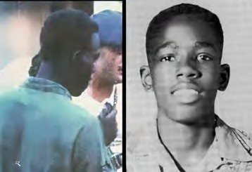
LOFTIS, JOEL CONRAD
A1C – Air Force Regular.
Age 22, Single, Negro, Male
Born JUN 17, 1946, from LA MANQUÉ, TX
Length of service 1 years.
His tour began on 7 Dec 1968, at
PHAN RANG AIR BASE, REPUBLIC OF VIETNAM,
35th SECURITY POLICE SQUADRON.
Casualty was on 07 JUN 1969, in NINH THUAN, SOUTH VIETNAM
HOSTILE, GROUND CASUALTY ARTILLERY, ROCKET, or MORTAR
Religion – ROMAN CATHOLIC
Body was Recovered.
Panel 23W - Line 104

Description: Hostile Rocket attack. *

LONDON, DENNIS WAYNE
SGT – Air Force Regular.
Age 25, Male
Born 21 AUG 1949, from SPARKS, NC
Tour began at
NAKHON PHANOM RTAFB, THAILAND,
56th SECURITY POLICE SQUADRON.
Casualty was on 13 MAY 1975.
NON-HOSTILE, Helicopter Crash (Eighteen 56th SPS and 5 Aircrew were Killed enroute to the Mayaguez Incident and Operation Rescue, Cambodia—the last battle of the Vietnam War).
Body was Recovered.

*

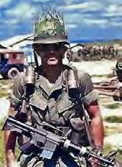
MAISEY, REGINAL VICTORY (Air Force Cross, posthumously)
CAPT – Air Force Regular Age 33, Married Caucasian Male
Born NOV 17, 1934, from SONOMA, CA
Length of service 10 years.
Tour of duty began 26 AUG 1967, at
BIEN HOA AIR BASE, REPUBLIC OF VIETNAM,
3d AIR POLICE SQUADRON.
Casualty was on 31 JAN 1968 in BIEN HOA, SOUTH VIETNAM
HOSTILE, GROUND CASUALTY ARTILLERY, ROCKET, or MORTAR
Religion – ROMAN CATHOLIC.
Body was Recovered. Panel 36E - Line 23.

Description (Combat): Battle of Bunker Hill-10, Bien Hoa Air Base. Capt. Maisey led Security Police Forces contributing to enemy KIA of 159 confirmed NVA. Bodies buried in mass grave. Decades later, Security Police helped identify the mass grave location, and the remains were returned to Vietnamese families by the joint Vietnam/U.S. recovery efforts. *

MALONE, BOBBY J.
SGT – Air Force Regular.
Born 3 APR 1944, from Slaton, TX
Tour began at
UBON RTAFB, THAILAND,
8th SECURITY POLICE SQUADRON.
Casualty was on 3 FEB 1968
NON-HOSTILE [LOD]: - GROUND CASUALTY - DROWNED, SUFFOCATED.
Body was Recovered.
*

MAC ARTHUR, DALE ALAN
Age 22, Single Caucasian Male
Born 16 JAN 1947, from SUNNYSIDE, WA
Tour of duty began SEP 01, 1969, at
PHU CAT AIR BASE, REPUBLIC OF VIETNAM,
821st COMBAT SECURITY POLICE, SAFESIDE.
Casualty was on DEC 08, 1969 in NINH THUAN, SOUTH VIETNAM.
NON-HOSTILE [LOD]: Died of ILLNESS/INJURY, GROUND CASUALTY VEHICLE ACCIDENT - Thrown from jeep.
Religion - DISCIPLES OF CHRIST.
Body was Recovered. Panel 15W - Line 39.

*

MATELSKI, LEONARD JAMES
SSGT (E5) – Air Force Regular.
Age 37, married Caucasian Male
Born 24 DEC 1934, from BRENHAM, TX.
His tour began on May 11, 1971, at
NHA TRANG AIR BASE, REPUBLIC OF VIETNAM,
327th COMBAT SECURITY GROUP (CSG)
Casualty was on 4 FEB 1972, In KHANH HOA, SOUTH VIETNAM.
[Casualty database: BIEN HOA PROVINCE, prior to 1997]
NON-HOSTILE [LOD]: Died of ILLNESS/Injury, GROUND CASUALTY,
INTENTIONAL HOMICIDE [SSGT Matelski often assigned Intel around Nha Trang].
Body was Recovered.
Panel 02W – Line 104
*

MATHIAS, ROBERT P.
SGT – Air Force Regular. Age 21, Male
Born 13 OCT 1953
From GRANADA HILLS, CA
NAKHON PHANOM RTAFB, THAILAND,
56th SECURITY POLICE SQUADRON.
Casualty was on 13 MAY 1975.
NON-HOSTILE, Helicopter Crash (Eighteen 56th SPS and 5 Aircrew were Killed enroute to the Mayaguez Incident and Operation Rescue, Cambodia—the last battle of the Vietnam War).
Body was Recovered.
*

MCFADDEN, SAMUEL L.
SGT – Air Force Regular.
Born on 29 JUL 1934,from MACON, GA.
U-TAPAO RTAFB, THAILAND,
635th SECURITY POLICE SQUADRON.
Casualty was on 10 MAR 1971 in KHANH HOA, SOUTH VIETNAM
NON-HOSTILE: Drowned, U-TAPAO RTAFB, THAILAND: Beach, Gulf of Tonkin.
Body was Recovered.

Comment - Michael Quinlan: I didn't know SSGT McFadden well. I had arrived a U- Tapao in early March after nine months at Takhli. SSGT. McFadden was our section leader for Delta sector, the beach part of the perimeter. Each night at Guardmount, he would call out the present-for-duty roster to, "yo", or "here". We were A bit ragtag, in the heat of the night. Four sections of SECURITY POLICE SQUADRON. and, I believe, two of Thai Guard's, made up Tiger Flight. One evening in March we learned that SSGT McFadden had tragically drowned at the beach, earlier that day. It was rough to hear that he had drown at the beach, on base, in the Gulf of Thailand. He was our section leader on Tiger Flight, 635th SECURITY POLICE SQUADRON., in March 1971. We did not really realize then, how those days would never be forgotten, even after many years. The Sarge was A Good Man. Mike Quinlan, E-4, 635th SECURITY POLICE SQUADRON., MAR-JUN 1971. *
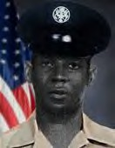
MCDONALD, RONALD IRVIN
A1C – Air Force Regular.
Age 20, Male Black, Single,
Born 21 MAY 1949, from New York City, NY.
Tour of duty began 11 MAR 1970, at
TAN SON NHUT AIR BASE, REPUBLIC OF VIETNAM,
377th SECURITY POLICE SQUADRON, K-9 Handler.
Casualty was on 14 APR 1970, in GIA DINH, NON-HOSTILE [LOD]: Died of illness/injury,
GROUND CASUALTY OTHER ACCIDENT.
Body was Recovered. Panel 11W - Line 3.

Description: A1C Ronald I. McDonald, a K-9 sentry dog handler, assigned Blue Patrol, 377th Security Police Squadron, Tan Son Nhut Air Base, Gia Dinh Province, RVN On April 14, 1970, died from a brain-stem contusion suffered in the Line of duty. *

MCKELVEY, WILLIAM R.
SGT – Air Force Regular.- Age 23, Male
Born 30 JAN 1952, from PHILADELPHIA, PA
NAKHON PHANOM RTAFB, THAILAND,
56th SECURITY POLICE SQUADRON.
Casualty was on 13 MAY 1975.
NON-HOSTILE, Helicopter Crash (Eighteen 56th SPS and 5 Aircrew were Killed enroute to the Mayaguez Incident and Operation Rescue, Cambodia—the last battle of the Vietnam War).
Body was Recovered.
Panel 01W – Line 128

Description: McKelvey was the last of the 630 servicemen from Philadelphia to die in the Vietnam Theater of Operations during the Vietnam Era, which the Department of Defense defines as the period from August 1964 through May 1975. The 23-year-old – Air Force Regular. sergeant was killed when the from CH-53 helicopter in which he was riding crashed 35 miles southwest of Nakhon Phanom, Thailand, on May 13, 1975. McKelvey had left Roxborough High School in 1969 at the age of 17 to enlist. He was assigned to the 56th Security Police Squadron in Vietnam. McKelvey had married a Thai woman
and planned to adopt her daughter. In addition to his wife, he was survived by his parents and a sister. William lived on DuPont Street, in Roxborough, (PA. Source: Philadelphia Daily News 10/26/1987, Saturday, December 20, 2003). Don Graham.

*
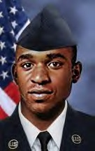

MCKNIGHT, CLARENCE
A1C – Air Force Regular. Age 23, Male
Born July 10, 1949, from Kingsport, TN
Casualty was on June 12, 1973, in
NAKHON PHANOM RTAFB, THAILAND,
56th SECURITY POLICE SQUADRON.
NON-HOSTILE [LOD]: GROUND CASUALTY ACCIDENTAL SELF-DESTRUCTION
(Gunshot wound in chest). Body was Recovered.

*

MCNEILL, MICHAEL SIDNEY
A1C (E3) – Air Force Regular.
Age 23, Caucasian Single Male Born 18 OCT 1949, from OKULGEE, OK
Length of service 2 years
DA NANG AIR BASE, REPUBLIC OF VIETNAM,
6498th SECURITY POLICE SQUADRON. in QUANG NAM, SOUTH VIETNAM
Casualty was on Dec 5, 1972
NON-HOSTILE [LOD]: GROUND CASUALTY ACCIDENTAL SELF-DESTRUCTION.
Religion – ROMAN CATHOLIC.
Body was Recovered. Panel 01W – Line 93.

*

MIDKIFF, GARY BRUCE
SGT (E3) – Air Force Regular.
Age 22, Male Born 7 July 1945 From Miami, OK.
Length of service 2 years.
Tour of duty began 01 OCT 1967, at
BINH THUY AIR BASE,
632nd SECURITY POLICE SQUADRON.
Casualty was on 4 FEB 1968 in PHONG DINH, SOUTH VIETNAM
HOSTILE, GROUND CASUALTY, ARTILLERY, ROCKET, or MORTAR.
Religion – Protestant.
Body was Recovered. Panel 37E – Line 25.
Description: Binh Thuy AB SGT Gary Bruce Midkiff. A1C (E4) Gary Midkiff Killed In Action, Binh Thuy AB, 1968 Offensive: On Feb. 4, 1968
at approximately 2:00 a.m. the TET Offensive became a reality for Binh Thuy AB. The first casualty for the 632nd Security Police Squadron, during the 1968 Offensive, was SGT Gary Midkiff. Gary was assigned to Alpha-2 post, which was a machine gun bunker. *
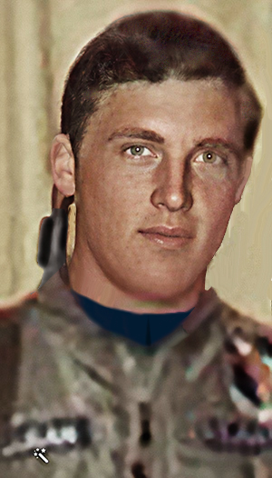

MILLIGAN, RANDALL GALE
A1C – Air Force Regular.
Age 20, Single Caucasian Male
Born AUG 10, 1947, from LATON, CA.
Length of service 1 year.
Tour of duty began 09 FEB 1968, at
CAM RANH BAY AIR BASE, REPUBLIC OF VIETNAM,
12th SECURITY POLICE SQUADRON.
Casualty was on 13 MAY 1968 in KHANH HOA, SOUTH VIETNAM
NON-HOSTILE [LOD]: GROUND CASUALTY ILLNESS, DISEASE. Religion – BRETHREN (DUNKERS)
Body was Recovered. Panel 60E - Line 27

*

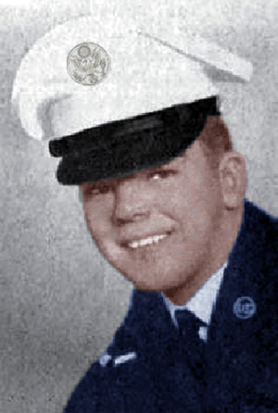

MILLS, ROGER BERTHA
SGT (E4) – Air Force Regular.
Age 21, Single Caucasian Male
Born 30 Aug 1946, from HAVRE DE GRACE, MD.
Length of service 3 years. His tour began on 29 Dec 1967
TAN SON NHUT AIR BASE, REPUBLIC OF VIETNAM,
377th SECURITY POLICE SQUADRON.
Casualty was on 31 JAN 1968 in GIA DINH, SOUTH VIETNAM
HOSTILE, GROUND CASUALTY ARTILLERY, ROCKET, or MORTAR. Religion – BAPTIST - SOUTHRN.
Body was Recovered. Panel 36E – Line 25

*

MORAN, EDGAR CRAIG, II
AIRMAN – Air Force Regular. Age 19, Male|
Born 16 FEB 1956 From PITTSBURG, PA
NAKHON PHANOM RTAFB, THAILAND, 56th SECURITY POLICE SQUADRON.
Casualty was on 13 MAY 1975.
NON-HOSTILE, Helicopter Crash (Eighteen 56th SPS and 5 Aircrew were Killed enroute to the Mayaguez Incident and Operation Rescue, Cambodia—the last battle of the Vietnam War).
Body was Recovered.

*

MORGAN, CHARLES R.
SGT – Air Force Regular.
Born 13 Feb 1920
NAKHON PHANOM RTAFB, THAILAND,
56th SECURITY POLICE SQUADRON.
Casualty was on 08 DEC 1968.
Non Hostile: Illness/Disease
Body was Recovered.

*

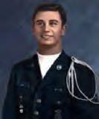
MOON, JERRY RUDOLPH
A2C - E3 – Air Force Regular.
Age 21, Married Caucasian Male
Born 10 APR 1946, from LANETT, AL
Length of service 2 years.
Tour of duty began 25 DEC 1966, at
TUY HOA AIR BASE, REPUBLIC OF VIETNAM,
31st AIR POLICE SQUADRON.
Casualty was on 07 SEP 1967 in PHU YEN, SOUTH VIETNAM
HOSTILE, GROUND CASUALTY - GUN, SMALL ARMS FIRE.
Body was Recovered. Panel 26E - Line 28.

*

MUSE, EDWARD GRADY
A1C – Air Force Regular.
Age 20, Single Caucasian, Male
Born 04 OCT 1947, from TUTWILER, MS
Length of service 1 year
Tour of duty began 09 SEP 1967, at
BIEN HOA AIR BASE, REPUBLIC OF VIETNAM,
3d AIR POLICE SQUADRON (Augmentee)
Casualty was on 31 JAN 1968, in BIEN HOA, SOUTH VIETNAM
HOSTILE, GROUND CASUALTY ARTILLERY, ROCKET, or MORTAR
Religion CHURCH OF CHRIST
Body was Recovered. Panel 36E - Line 27 *

NEALIS, TOMMY R.
SGT – Air Force Regular. Age 22, Male
Born 23 APR 1953
From MT STERLING, CT.
Tour of duty began at,
NAKHON PHANOM RTAFB, THAILAND,
56th SECURITY POLICE SQUADRON.
Casualty was on 13 MAY 1975.
NON-HOSTILE, Helicopter Crash (Eighteen 56th SPS and 5 Aircrew were Killed enroute to the Mayaguez Incident and Operation Rescue, Cambodia—the last battle of the Vietnam War).
Body was Recovered.
Panel 01W – Line 128 *

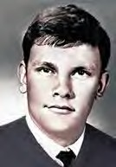
NEEL, ROBERT RAY
SGT – Air Force Regular.
Age 21, Single Caucasian Male
Born APR 12, 1948, from HOUSTON, TX
Tour of duty began 02 JUL 1969, at
NHA TRANG AIR BASE, REPUBLIC OF VIETNAM,
14th AIR POLICE SQUADRON.
Casualty was on 02 MAY 1970 in KHANH HOA, SOUTH VIETNAM
NON-HOSTILE [LOD]: GROUND CASUALTY ACCIDENTAL HOMICIDE.
Religion – PENTECOSTAL.
Body was Recovered. Panel 11W - Line 86.
Description: Gunshot/horseplay with weapons,
from: CLIFFADIO@aol.com.
Subject: VSPA: Memorial of AP/SP KIA or Line of Duty was just perusing the memorial and saw the entry for NEEL, Robert Ray was incomplete. Bobby was killed due to a weapons horseplay incident at CAM RANH BAY AIR BASE. I believe he was on in-country R&R from the 14th or the 90th
SECURITY POLICE SQUADRON. at NHA TRANG, having departed PCS from CAM RANH BAY AIR BASE for NT earlier. Thanks, Clifford Wilson. *
NIX, JOHN DAVID
SGT – Air Force Regular.
Age 23, Married Caucasian Male
Born DEC 15, 1947, from LOUISVILLE, KY
Tour of duty began 01 JUN 1970, in GIA DINH, SOUTH VIETNAM.
PHAN RANG AIR BASE, REPUBLIC OF VIETNAM,
35th SECURITY POLICE SQUADRON.
Casualty was on 25 APR 1971
NON-HOSTILE - Died of ILLNESS/INJURY GROUND CASUALTY VEHICLE CRASH.
Body was Recovered. Panel 03W - Line 12.
Description: Jeep Crash.
*

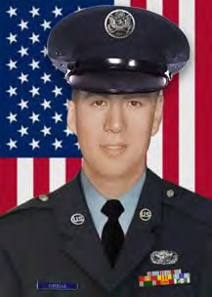
ORSUA, CHARLES DAVID
A1C – Air Force Regular.
Age 19, Single Caucasian Male
Born 19 APR 1950, from SUNNYVALE, CA
Tour of duty began 28 APR 1969, PHAN RANG AIR BASE, REPUBLIC OF VIETNAM, 35th SECURITY POLICE SQUADRON.
Casualty was on 15 JUL 1969, in
NINH THUAN, SOUTH VIETNAM.
NON-HOSTILE [LOD]: Died of ILLNESS/INJURY GROUND CASUALTY VEHICLE CRASH
Religion - ROMAN CATHOLIC.
Body was Recovered.
Panel 20W - Line 2.

Description: K-9 Truck rollover.
*

PACIO, GEORGE HENRY
A1C – Air Force Regular.
Age 23, Single Caucasian Male
Born 15 MAR 1947, from LONG BEACH, NY
Tour of duty began 27 OCT 1970, at
TAN SON NHUT AIR BASE, REPUBLIC OF VIETNAM,
377th SECURITY POLICE SQUADRON.
Casualty was on DEC 21, 1970. in GIA DINH, SOUTH VIETNAM.
NON-HOSTILE [LOD]: GROUND CASUALTY ACCIDENTAL SELF-DESTRUCTION.
Body was Recovered.
Religion – ROMAN CATHOLIC. Panel 06W - Line 135.

*

PACKER, JOSEPH EVERETT, JR.
A2C (E3) – Air Force Regular.
Age 20, Single Caucasian Male
Born 13 JUL 1945, from CAMDEN, NJ
Length of service 2 years.
Tour of duty began 16 MAR 1966, at
DONG HA AIR BASE, REPUBLIC OF VIETNAM,
6250th AIR POLICE SQUADRON; Det/620th 14th APS (TCS).
Casualty was on 16 JUN 1966, in QUANG TRI, SOUTH VIETNAM.
NON-HOSTILE [LOD]: GROUND CASUALTY, VEHICLE CRASH JEEP.
Body was Recovered. Panel 08E - Line 53.

Description: Died JUN 16, 1966, Vehicle crash near Dong Ha AIR BASE, REPUBLIC OF VIETNAM, while on duty driving a weapons carrier and swerved to avoid hitting a Vietnamese woman. Was assigned to Dong Ha Air Base as base defense/security, DH, 14th APS; DET, 1/620th TCS/AP. Augmentee (AUG). Tactical Radar SQUADRON.

*

PALMER, ROBERT A.
Sgt - Air Force
56th SPS, NKP Thailand
Casualty on 07 MAY 1970 Non
Non-Hostile: Illness/Disease
Body was Recovered.

*

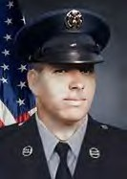
PARK, IRVING GEON
SGT – Air Force Regular.
20 years old Single Caucasian Male
Born 06 DEC 1948, from FORT WAYNE, IN.
Length of service 2 years.
Tour of duty began 05 JAN 1969, at
PHU CAT AIR BASE, REPUBLIC OF VIETNAM,
37th AIR POLICE SQUADRON.
Casualty was on 03 JUN 1970, in
BINH DINH, SOUTH VIETNAM.
NON-HOSTILE [LOD]: GROUND CASUALTY VEHICLE CRASH.
Religion – PROTESTANT.
Body was Recovered. Panel 13W - Line 88.

Description: K-9 Truck rollover.

*

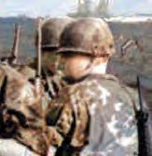
PASCOE, ROBERT EDWARD
A1C – Air Force Regular.
Age 24, Married Caucasian Male
Born 17 APR 1943, from ARLINGTON, VA. Tour of duty began at,
PLEIKU AIR BASE, REPUBLIC OF VIETNAM,
633d AIR POLICE SQUADRON.
Casualty was on 18 JUL 1967, in PLEIKU, SOUTH VIETNAM.
NON-HOSTILE [LOD]: GROUND CASUALTY OTHER ACCIDENT.
Body was Recovered. Panel 23E - Line 88.
Description: Accidental Grenade/Armory Explosion.
*

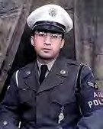
PEREZ, CARLOS AUGUSTO
SGT – Air Force Regular.
Age 35, Single Caucasian Male
Born JUN 01, 1932, from AGUADILLA, PR.
Length of service 16 years.
Tour of duty began APR 17, 1967, at
PLEIKU AIR BASE, REPUBLIC OF VIETNAM,
633d AIR POLICE SQUADRON.
Casualty was on 01 DEC 1967, in PLEIKU, SOUTH VIETNAM
NON-HOSTILE [LOD]: GROUND CASUALTY ILLNESS, DISEASE.
Religion - ROMAN CATHOLIC.
Body was Recovered. Panel 31E - Line 22. *

PETERSON, RUFUS G. JR.
A1C – Air Force Regular. Age 21, Born 22 JUN 1951
Tour of duty began at,
PLEIKU AIR BASE, REPUBLIC OF VIETNAM,
633d AIR POLICE SQUADRON.
Casualty was on 19 NOV 1971.
NON-HOSTILE [LOD]: Drowned: Lake Suan Kaset Lingsun, Udorn RTAFB, Thailand. Body was Recovered. *

PINER, JOHN ROBERT
SGT – Air Force Regular. Age 21, Single Caucasian Male Born MAY 08, 1948
From SAN GABRIEL, CA
Length of service 2 years.
Tour of duty began 17 APR 1969
TAN SON NHUT AIR BASE, REPUBLIC OF VIETNAM, 377th SECURITY POLICE SQUADRON.
Casualty was on 11 MAR 1970, in
BIEN HOA, SOUTH VIETNAM
NON-HOSTILE [LOD]: GROUND CASUALTY ILLNESS, DISEASE
Religion – METHODIST. Body was Recovered. Panel 13W - Line 113. *

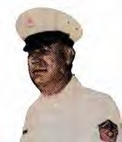
POROVICH, STEVE
SMSGT – Air Force Regular.-Regular. Married Male Caucasian Age 47, Male.
Born NOV 03, 1924 From TUCSON, AZ
Tour of duty began 15 JAN 1972
TAN SON NHUT AIR BASE, REPUBLIC OF VIETNAM, 377th SECURITY POLICE SQUADRON.
Casualty was on 21 APR 1972 in GIA DINH, SOUTH VIETNAM
NON-HOSTILE [LOD]: Died of ILLNESS/INJURY GROUND, CASUALTY HEART ATTACK.
Religion - RUSSIAN ORTHODOX.
Body was Recovered.
Panel 01W - Line 5.

*

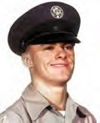
RIDDLE, OLIVER JOHN
A2C – Air Force Regular.
Age 21, Single Caucasian Male
Born 23 OCT 1945, from CORAOPOLIS, PA
Length of service 2 years.
Tour of duty began 29 NOV 1966
TAN SON NHUT AIR BASE, REPUBLIC OFVIETNAM, 377th SECURITY POLICE SQUADRON.
Casualty was on 04 DEC 1966. in
GIA DINH, SOUTH VIETNAM.
HOSTILE, GROUND CASUALTY ARTILLERY, ROCKET, or MORTAR
Body was Recovered. Panel 13E - Line 12.

*

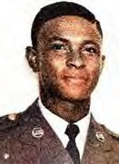
ROBERTSON, ROBERT MERLIN
SGT – Air Force Regular. Age 22, Married Negro Male
Born 20 MAY 1947, from RALEIGH, NC
Length of service 2 years.
Tour of duty began 20 MAY 1969.
NAKHON PHANOM RTAFB, THAILAND, 56th SECURITY POLICE SQUADRON.
Casualty was on 27 JAN 1970.
NON-HOSTILE, Died of ILLNESS/INJURY, GROUND CASUALTY - HEART ATTACK.
Religion - UNITED CHURCH OF CHRIST.
Body was Recovered.
Panel 12W – Line 103.
*

ROSS, ROBERT WAYNE
SGT – Air Force Regular. Age 20, Male
Born 09 JUL 1954, from CYPRESS, CA
NAKHON PHANOM RTAFB, THAILAND, 56th SECURITY POLICE SQUADRON.
Casualty was on 13 MAY 1975.
NON-HOSTILE, Helicopter Crash (Eighteen 56th SPS and 5 Aircrew were Killed enroute to the Mayaguez Incident and Operation Rescue, Cambodia—the last battle of the Vietnam War).
Body was recovered.
01W – Line 129 *

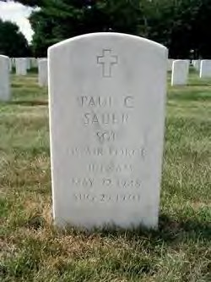
SAUER, PAUL C.
SGT – Air Force Regular. Age 22, Male
Born 22 MAY 1948, from NEW YORK CITY, NY
Casualty was on 25 AUG 1970
DON MUANG RTAFB, THAILAND, 631st SECURITY POLICE SQUADRON.
NON-HOSTILE- Train vs. Vehicle.
Body was Recovered.

Description: NON-HOSTILE, Train vs. Vehicle. The New York Times, 1996 BANGKOK, Thailand, Aug. 26 (Reuters) — An express train traveling at full speed struck bus, killing seven American Airmen, and injuring four others at a railroad crossing near Bangkok's Don Muang airport, police sources said today. The bus was taking the airmen to their headquarters from the airport 15 miles north of Bangkok last night when the collision occurred at an unguarded crossing, the police said. The police identified the dead Airmen as Thomas J. Broad water, Age 26, Handel Emila Jr. 26; Paul C. Saver, 22; Richard H. Stanton; 40; Walter Krizanowski, 24; Richard Gregsby, 21, and Paul Edmunson, 22. *

SISLEY, RUSSELL JAY
SMSGT- E8 – Air Force Regular. Age 38, Married Caucasian Male
Born 30 NOV 1927, from CARTER LAKE, IA
Length of service18 years.
Tour of duty began 24 JAN 1966, in QUANG TRI PROVINCE,
DONG HA AIR BASE, REPUBLIC OF VIETNAM, 6250th AIR POLICE SQUADRON. Casualty was on 16 JUN 1966 in QUANG TRI, SOUTH VIETNAM.
NON-HOSTILE, GROUND CASUALTY, WEAPONS CARRIER CRASH.
Body was Recovered. - Panel 08E - Line 54.

Description: Died 16 JUN 1966 in a Vehicle crash near Dong Ha AIR BASE, REPUBLIC OF VIETNAM, while on duty driving a weapons carrier and swerved to avoid hitting a Vietnamese woman. Was assigned to
Dong Ha Airfield as base defense/security for the 620th Tactical Radar SQUADRON. May have TDY to Dong Ha Air Base. *

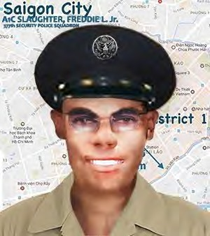
SLAUGHTER, FREDDIE L. JR.
A1C – Air Force Regular.
Age 20, Single, Negro, Male
Born 14 JUL 1952, from JACKSON, MS
Tour of duty began 17 MAR 1972.
TAN SON NHUT AIR BASE, REPUBLIC OF VIETNAM, 377tjh SECURITY POLICE SQUADRON.
Casualty was on 30 JUL 1972, in GIA DINH, SOUTH VIETNAM
NON-HOSTILE, GROUND CASUALTY DROWNED, SUFFOCATED
Religion – BAPTIST
Body was Recovered
Panel 01W - Line 61 *

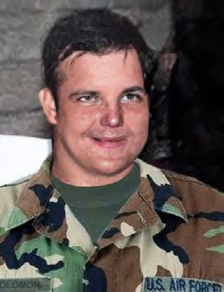
SOLOMON, SIDNEY MORTON
SSGT - E5 – Air Force Regular. (Korea; Vietnam)
Age 39, Married Caucasian Male
Born 08 NOV 1930, from Roslyn Heights, NY Tour of duty began 28 JAN 1970
BINH TUY AIR BASE, REPUBLIC OF VIETNAM, 632nd SECURITY POLICE SQUADRON.
Casualty was on 16 MAY 1970.
NON-HOSTILE, Ground Casualty - Vehicle Crash
Religion – Jewish Body was Recovered. Panel 10W - Line 54.
Description: The accident claimed the lives of two SP's on their way to post and were
hit by a drunk driver, driving a deuce and a half. *
STEEN, LENORD LARRY
A1C – Air Force Regular.
UBON RTAFB, THAILAND, 8th AIR POLICE SQUADRON.
CASUALTY WAS ON 08 OCT 1967
NON-HOSTILE [LOD]: Gunshot. Body was Recovered. *

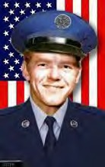
STEPP, CHARLES HAROLD
A1C – Air Force Regular.
Age 18, Single. Caucasian Male
Born FEB 12, 1954. From POPLAR BLUFF, MO
Tour of duty began JAN 01, 1972
DA NANG AIR BASE, REPUBLIC OF VIETNAM, 6498th SECURITY POLICE SQUADRON. Casualty was on SEP 05, 1972 in QUANG NAM, SOUTH VIETNAM,
NON-HOSTILE, GROUND CASUALTY ACCIDENTAL SELF DESTRUCTION
(Gunshot wound in the chest)
Religion – BAPTIST
Body was Recovered.
Panel 01W -Line 70.
*

STEWART, ERI C V. V. D.
U- TAPAO RTAFB, T HAI L AND, 635t h SEC URI TY P OLI CE S QUADR ON
Casualty was on 09 DEC 1970. NON-HOSTILE [LOD]: Vehicle Crash.
Body was Recovered.

*

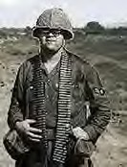
WILLIS, THOMAS MURTEN
A2C - E3 – Air Force Regular. Age 20, Single Caucasian Male Born 03 OCT 1946
From MC CALL, ID
Length of service 3 years.
Tour of duty began MAY 02, 1966
PHAN RANG AIR BASE, REPUBLIC OF VIETNAM, 35th SECURITY POLICE SQUADRON. Casualty was on JUN 05, 1967 in QUANG TRI, SOUTH VIETNAM.
NON-HOSTILE, Died of ILLNESS/INJURY, GROUND CASUALTY ILLNESS, DISEASE.
Body was Recovered. Panel 21E – Line 59.

*

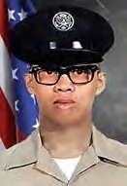
SUPNET, RICHARD ARELLANO
A1C – Air Force Regular.
Age 19, Single, Malayan, Male
Born MAR 17, 1952- From SAN FRANCISCO, CA
Tour of duty began JAN 07, 1971
CAM RANH BAY AIR BASE, REPUBLIC OF VIETNAM, 483rd SECURITY POLICE SQUADRON.
Casualty was on SEP 23, 1971
in KHANH HOA, SOUTH VIETNAM.
NON-HOSTILEGROUND CASUALTY, ACCIDENTAL SELF-DESTRUCTION.
Religion - ROMAN CATHOLIC.
Body was Recovered.
Panel 02W - Line 24.

Description: Accidental Self-Destruction (Gunshot: dropped his weapon).

*

TREEN, HARLIN PERRY
MAJ – Air Force Regular. Age 39, Married, Caucasian, Male
Born MAY 10, 1929
From ENID, Garfield County, OKLAHOMA Length of service 20 years.
Tour of duty began APR 25, 1968 TAN SON NHUT AIR BASE, 377th CSG
Casualty was on AUG 12, 1968 in GIA DINH, SOUTH VIETNAM,
NON-HOSTILE, GROUND CASUALTY ACCIDENTAL SELF-DESTRUCTION
Body was Recovered. Religion - BAPTIST Panel 48W - Line 4 *

WEBB, ROBERT C.
MSGT – Air Force Regular.
UDORN RTAFB, THAILAND, 432nd SECURITY POLICE SQUADRON.
Casualty was on 18 NOV 1968
NON-HOSTILE [LOD]: ILLNESS/Disease. Body was Recovered.
*

WHITFIELD, JESSE J.
SGT – Air Force Regular.
UDORN RTAFB, THAILAND, 432nd SECURITY.
08 OCT 1970 NON-HOSTILE. Body was Recovered.

Description: Accidental Self-Destruction: Gunshot – I am not a member of VSPA, but I am well aware of one of our fallen that you have listed on your website. I was a Security Policeman for 22 years and retired as a MSGT on 1 JUN 1989. I was SGT. Jesse Whitfield’s Flight Chief at the time of his death.
At the time his death occurred, he was assigned to Det-1, 432nd SECURITY POLICE SQUADRON. (Nam Phong Airfield, Thailand). Our TDY site was located approximately 60-70 miles south of our main base at Udorn RTAFB. Jesse was a quiet, yet humorous young man. He bunked in the same trailer as I did. His room was right next to mine. I do not know what compelled Jesse to do what he did on that fateful night, but; I will never understand why.

He was a "good" troop. He never gave any indication that were any problems in his life. If there were problems, he hid them well. As I said earlier, Jesse was a good man and a fine 'Security Policeman.' I cannot give anyone any answers. All I can say is that SGT. Jesse Whitfield performed his duties in an outstanding manner, and whatever his persona problems may have been, they didn't detract from his dedication to his duties. Bill McGeorge, SGT (USAFRET.)
*

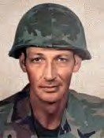
WISSIG, EDWARD SIMON
SSGT - E5 – Air Force Regular. Age 39, Caucasian Male Married Born 24 May 1931
From LAKE RONKONKOMA, NY
His tour began on Jul 31, 1970.
PHU CAT AIR BASE, 12th SPS, SOUTH VIETNAM
Casualty was on Feb 12, 1971 In BINH DINH, SOUTH VIETNAM.
HOSTILE, GROUND CASUALTY OTHER EXPLOSIVE DEVICE.
Religion – ROMAN CATHOLIC.
Body was Recovered. Panel 05W - Line 100. *

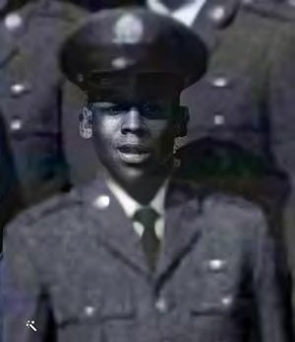
WOOD, BERTRAM, JR.
A1C – Air Force Regular. Age 20, Single, Negro, Male
Born 30 OCT 1949, from BALTIMORE, MARYLAND
Tour of duty began 04 JUN 1970
PLEIKU AIR BASE, 6254th APB/Security POLICE SQUADRON.
Casualty was on 25 SEP 1970 in KHANH HOA, SOUTH VIETNAM NON-HOSTILE, GROUND CASUALTY, ACCIDENTAL SELF-DESTRUCTION
Religion – BAPTIST Body was Recovered. Panel: 07W–Line 88. *
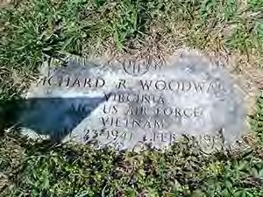

WOODWARD, RICHARD RANDOLPH
A1C – Air Force Regular. Age 24, Single, Negro, Male
Born 23 APR 1941, from SPOTSYLVANIA, VA
Length of service 6 years.
Tour of duty began 04 FEB 1966
DA NANG AIR BASE, REPUBLIC OF VIETNAM, 6252nd AIR POLICE
SQUADRON.
Casualty was on 08 FEB 1966 in GIA DINH, SOUTH VIETNAM
NON-HOSTILE, Died of ILLNESS/INJURY GROUND CASUALTY ILLNESS, DISEASE
Body was Recovered. Panel 05E - Line 19.
*

In Memory of Jackie Kays (RIP-111 10/13/2020), Warrior, Poet, Hero, Friend.
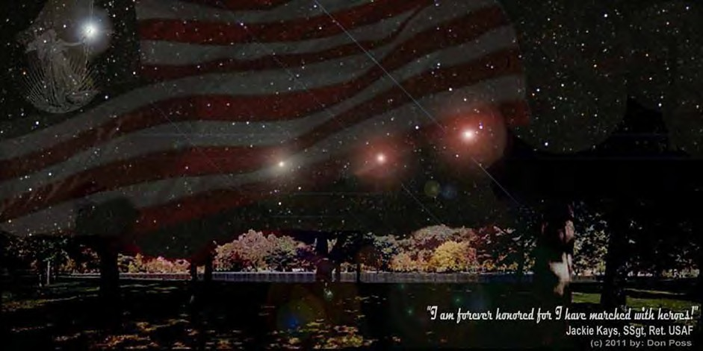
Names of 58,212 Killed in Action or Line of Duty are inscribed in the black granite Wall, at rest beneath a blanket of starlight and flares. (c) Photo & Composite 2011, by Don Poss

SSGT Jackie Kays (Ret. USAF, Da Nang AB, 1965, RIP Sep 2020) said it best:

“I am forever honored, for I have marched with heroes.”

We Take Care of Our Own

