UNITED STATES – Air Force Regular.

AIR POLICE AND SECURITY POLICE KILLED IN ACTION OR LINE OF DUTY

IN THE VIETNAM WAR (Vietnam and Thailand)
Photo & Composite © 2020, Don Poss
Photo & Composite © 2020, Don Poss

A-Z, USAF AP/SP KIA-LOD

UNITED STATES AIR FORCE
BLACK, JIMMY P.
SGT (E4) – Air Force Regular.
Age 20, Male.
Born 24 AUG 1954, from DAPHNE, AL.
Tour of Duty began at,
NAKHON PHANOM RTAFB, ROYAL THAILAND,
56th SECURITY POLICE SQUADRON.
Casualty was on 13 MAY 1975.
NON-HOSTILE [LOD]: Thailand.
Helicopter Crash from NKP (Eighteen 56th SPS and 5 Aircrew were Killed enroute to the SS Mayaguez Incident and Operation Rescue, Thailand—the Last Battle of the Vietnam War.
Body was Recovered. Panel 01W – Line 124

Description: On the night of 31 January 1968, Sgt. Cyr was one of five men who manned the O-51 Bunker at Tan Son Nhut AB during the attack by NVA forces. They were directly attacked by Bangalore type charges and RPG rockets. The bunker was ultimately overwhelmed by enemy forces.
Casualties and Losses during the Attack on TSN Air Base:
KIA: 22 US; 29 RVN; 669 NVA/Viet Cong;.
POW: 0 US; 0 RVN; 26 NVA/Viet Cong.
*

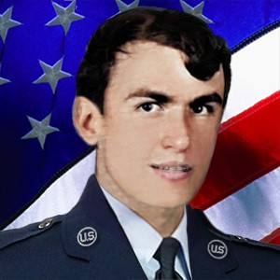
COLLUMS, BOBBY GLEN
SGT (E4) – Air Force Regular. Age 22, Male
Born 24 SEP 1952, from HELENA, AR.
Tour of Duty began at,
NAKHON PHANOM RTAFB, ROYAL THAILAND,
56th SECURITY POLICE SQUADRON.
Casualty was on 13 MAY 1975.
NON-HOSTILE [LOD]: Helicopter Crash (Eighteen 56th SPS and 5 Aircrew were Killed enroute to the SS Mayaguez Incident and Operation Rescue, Thailand—the Last Battle of the Vietnam War.
Body was Recovered. Panel 01W – Line 125 *

COYLE, GERALD A.
SSGT (E5) – Air Force Regular.
Age 31, Male
Born 14 MAY 1943, from BENTLEYVILLE, PA.
Tour of Duty began at,
NAKHON PHANOM RTAFB, ROYAL THAILAND,
56th SECURITY POLICE SQUADRON.
Casualty was on 13 MAY 1975.
NON-HOSTILE [LOD]: Helicopter Crash (Eighteen 56th SPS and 5 Aircrew were Killed enroute to the SS Mayaguez Incident and Operation Rescue, Thailand—the Last Battle of the Vietnam War.
Body was Recovered.
Panel 01W – Line 125
*

DWYER, THOMAS D.
SGT (E4) – Air Force Regular.
Age 21, Male
Born JUN 17, 1953, from MIDDLEBURY, CT.
Tour of Duty began at,
NAKHON PHANOM RTAFB, ROYAL THAILAND,
56th SECURITY POLICE SQUADRON.
Casualty was on 13 MAY 1975.
NON-HOSTILE [LOD]: Helicopter Crash (Eighteen 56th SPS and 5 Aircrew were Killed enroute to the SS Mayaguez Incident and Operation Rescue, Thailand—the Last Battle of the Vietnam War.
Body was Recovered.
Panel 01W – Line 125
*

FORD, BOB WAYNE
SGT (E4) – Air Force Regular.
Age 21, Male
Born 19 FEB 1954, from SEMINOLE, TX.
Tour of Duty was at,
NAKHON PHANOM RTAFB, ROYAL THAILAND,
56th SECURITY POLICE SQUADRON.
Casualty was on 13 MAY 1975.
NON-HOSTILE [LOD]: Helicopter Crash (Eighteen 56th SPS and 5 Aircrew were Killed enroute to the SS Mayaguez Incident and Operation Rescue, Thailand—the Last Battle of the Vietnam War.
Body was Recovered. Panel 01W – Line 125
Steve Davidson - Comment: I have a better understanding of how things are now, but I don't agree with the "Washington D.C. bean counters" [not issuing Purple Hearts to Mayaguez SPs], but that's not unusual. Sgt Bob Wayne Ford was a good friend of mine. We were stationed together at Kingslely Field, OR, from 72-75. He left for Thailand in early 1975 and I was attending Camp Bullis en route to Korea when we first learned of his (and the others who were killed) death in the helicopter crash. You have a great web site and I'm glad to see that all Security Police who served in Vietnam are honored and remembered with integrity. Thanks! Steve Davidson.
*

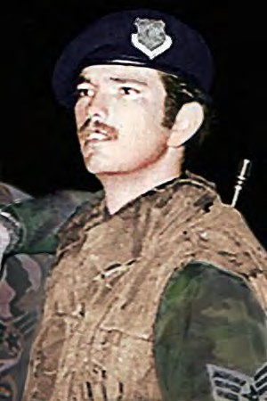
FRITZ, GERALD W.
SGT (E4) – Air Force Regular.
Age 21, Male
Born MAY 6, 1954, from JUNCTION, TX.
Tour of Duty was at,
NAKHON PHANOM RTAFB, ROYAL THAILAND,
56th SECURITY POLICE SQUADRON.
Casualty was on 13 MAY 1975.
NON-HOSTILE [LOD]: Helicopter Crash (Eighteen 56th SPS and 5 Aircrew were Killed enroute to the SS Mayaguez Incident and Operation Rescue, Thailand—the Last Battle of the Vietnam War.
Body was Recovered.
Panel 01W – Line 125
*

GLENN, JACKIE D.
TSGT (E6) – Air Force Regular.
Age 36, Male
Born 10 MAY 1939, from SEYMOUR, MO.
Tour of Duty began at,
NAKHON PHANOM RTAFB, ROYAL THAILAND,
56th SECURITY POLICE SQUADRON.
Casualty was on 13 MAY 1975.
NON-HOSTILE [LOD]: Helicopter Crash (Eighteen 56th SPS and 5 Aircrew were Killed enroute to the SS Mayaguez Incident and Operation Rescue, Thailand—the Last Battle of the Vietnam War.
Body was Recovered.
Panel 01W - Line 126
*

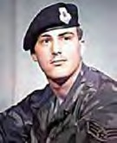
HAMLIN, DARRELL L.
SGT (E4) – Air Force Regular.
Age 19, Male
Born 20 OCT 1955, from IOWA CITY, IA.
Tour of Duty began at,
NAKHON PHANOM RTAFB, ROYAL THAILAND,
56th SECURITY POLICE SQUADRON.
Casualty was on 13 MAY 1975.
NON-HOSTILE [LOD]: Helicopter Crash (Eighteen 56th SPS and 5 Aircrew were Killed enroute to the SS Mayaguez Incident and Operation Rescue, Thailand—the Last Battle of the Vietnam War.
Body was Recovered.
Panel 01W – Line 126
*

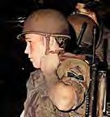
HANKAMER, GREGORY L.
SGT (E4) – Air Force Regular.
Age 21, Caucasian Male
Born 15 SEP 1953, from SAN PEDRO, CA
Tour of Duty began at,
NAKHON PHANOM RTAFB, ROYAL THAILAND,
56th SECURITY POLICE SQUADRON.
Casualty was on 13 MAY 1975.
NON-HOSTILE [LOD]: Helicopter Crash (Eighteen 56th SPS and 5 Aircrew were Killed enroute to the SS Mayaguez Incident and Operation Rescue, Thailand—the Last Battle of the Vietnam War.
Body was Recovered.
Panel 01W – Line 126
*

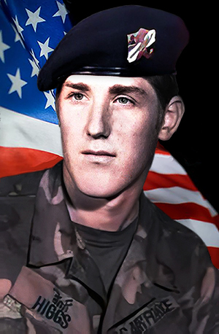
HIGGS, DAVID ALAN
SGT (E4) – Air Force Regular.
Age 20, Male
Born 05 MAY 1955, from SPOKANE, WA.
Tour of Duty began at,
NAKHON PHANOM RTAFB, ROYAL THAILAND,
56th SECURITY POLICE SQUADRON.
Casualty was on 13 MAY 1975.
NON-HOSTILE [LOD]: Thailand.
Helicopter Crash from NKP (Eighteen 56th SPS and 5 Aircrew were Killed enroute to the SS Mayaguez Incident and Operation Rescue, Thailand—the Last Battle of the Vietnam War.
Body was Recovered.
Panel 01W – Line 126

Description: ‘CH-53 KNIFE 13, Serial Number 68-10933, 21st SOS, with 4 Air Crew, a 56th Security Ops., and 18 56th SPS Airmen onboard, airlifted from NKP enroute to U-Tapao RTAFB. As one of three 3 CH-53s carrying 75 SPs, as requested by 7th Air Force, to join the assembling force for the SS Mayaguez Incident rescue operation.
At 2130 local, and about 37 miles west of NKP RTAFB, bound for U-Tapao, KNIFE 13 fell out of formation and crashed and exploded on impact. All 23 aboard were killed. Other CH-53s landed nearby, but exploding ammunition and burning fuel hindered all rescue attempts. The marines CH-53s continued on flight to Cambodia and on 15 May 1975, after an ongoing vicious battle, control of the SS Mayaguez returned to the United States.
*

ILAOA, FALEAGAFULA
SSGT (E5) – Air Force Regular.
Age 27, Male
Born 06 APR 1948, from SAN FRANCISCO, CA.
Tour of Duty began at,
NAKHON PHANOM RTAFB, ROYAL THAILAND,
56th SECURITY POLICE SQUADRON.
Casualty was on 13 MAY 1975.
NON-HOSTILE [LOD]: Helicopter Crash (Eighteen 56th SPS and 5 Aircrew were Killed enroute to the SS Mayaguez Incident and Operation Rescue, Thailand—the Last Battle of the Vietnam War.
Body was Recovered.
Panel 01W – Line 127

*

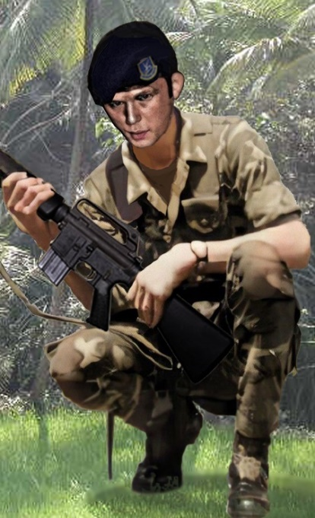
LANE, MICHAEL DAVID
SGT (E4) – Air Force Regular.
Age 25, Male Caucasian
Born 04 JAN 1950.
From JACKSONVILLE, FL.
Tour of Duty began at,
NAKHON PHANOM RTAFB, ROYAL THAILAND,
56th SECURITY POLICE SQUADRON.
Casualty was on 13 MAY 1975.
NON-HOSTILE [LOD]: Helicopter Crash (Eighteen 56th SPS and 5 Aircrew were Killed enroute to the SS Mayaguez Incident and Operation Rescue, Thailand—the Last Battle of the Vietnam War.
Body was Recovered.
Panel 01W – Lane 127
*

LONDON, DENNIS W.
SGT (E4) – Air Force Regular.
Age 25, Male, Caucasian
Born 21 AUG 1949, from SPARKS, NC
Tour of Duty began at,
NAKHON PHANOM RTAFB, ROYAL THAILAND,
56th SECURITY POLICE SQUADRON.
Casualty was on 13 MAY 1975.
NON-HOSTILE [LOD]: Helicopter Crash (Eighteen 56th SPS and 5 Aircrew were Killed enroute to the SS Mayaguez Incident and Operation Rescue, Thailand—the Last Battle of the Vietnam War.
Body was Recovered. Panel 01W – Line 127
*

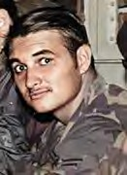
MATHIAS, ROBERT P.
SGT (E4) – Air Force Regular. Age 21, Male
Born 13 OCT 1953. from GRANADA HILLS, CA
Tour of Duty began at
NAKHON PHANOM RTAFB, ROYAL THAILAND,
56th SECURITY POLICE SQUADRON.
Casualty was on 13 MAY 1975.
NON-HOSTILE [LOD]: Helicopter Crash (Eighteen 56th SPS and 5 Aircrew were Killed enroute to the SS Mayaguez Incident and Operation Rescue, Thailand—the Last Battle of the Vietnam War.
Body was Recovered.
Panel 01W – Line 127
*

MC KELVEY, WILLIAM R.
SGT (E4) – Air Force Regular - Age 23, Male
Born 30 JAN 1952, from PHILADELPHIA, PA
Tour of Duty began, at
NAKHON PHANO RTAFB, ROYAL THAILAND,
56th SECURITY POLICE SQUADRON.
Casualty was on 13 MAY 1975.
Non-Hostile [LOD]: Helicopter Crash (Eighteen 56th SPS and 5 Aircrew were Killed enroute to the SS Mayaguez Incident and Operation Rescue, Cambodia—the last battle of the Vietnam War.
Body was Recovered.
Panel 01W – Line 128

Description: McKelvey was the last of the 630 servicemen from Philadelphia to die in the Vietnam Theater of Operations during the Vietnam Era, which the Department of Defense defines as the period from August 1964 through May 1975. The 23-year-old – Air Force Regular. sergeant was killed when the from CH-53 helicopter in which he was riding crashed 35 miles southwest of Nakhon Phanom, ROYAL THAILAND, on May 13, 1975. McKelvey had left Roxborough High School in 1969 at the age of 17 to enlist. He was assigned to the 56th Security Police Squadron in Vietnam. McKelvey had married a Thai woman and planned to adopt her daughter. In addition to his wife, he was survived by his parents and a sister. William lived on DuPont Street, in Roxborough, (PA. Source: Philadelphia Daily News 10/26/1987, Saturday, December 20, 2003). Don Graham.

*

MORAN, EDGAR CRAIG, II
AIRMAN (E2) – Air Force Regular.
Age 19, Male|
Born 16 FEB 1956, from PITTSBURG, PA
Tour of Duty began at
NAKHON PHANOM RTAFB, ROYAL THAILAND,
56th SECURITY POLICE SQUADRON.
Casualty was on 13 MAY 1975.
Non-Hostile [LOD]: Helicopter Crash (Eighteen 56th SPS and 5 Aircrew were Killed enroute to the SS Mayaguez Incident and Operation Rescue, Cambodia—the last battle of the Vietnam War.
Body was Recovered.
Panel 02W – Line 128
*

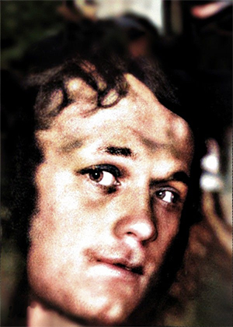
NEALIS, TOMMY R.
SGT (E4) – Air Force Regular.
Age 22, Male
Born 23 APR 1953, from MT STERLING, CT.
Tour of Duty began at,
NAKHON PHANOM RTAFB, ROYAL THAILAND,
56th SECURITY POLICE SQUADRON.
Casualty was on 13 MAY 1975.
NON-HOSTILE [LOD]: Helicopter Crash (Eighteen 56th SPS and 5 Aircrew were Killed enroute to the SS Mayaguez Incident and Operation Rescue, Thailand—the Last Battle of the Vietnam War.
Body was Recovered.
Panel 01W – Line 128
*

ROSS, ROBERT W.
SGT (E4) – Air Force Regular.
Age 19, Male
Born 09 JUL 1954, from CYPRESS, CA
Tour of Duty began at,
NAKHON PHANOM RTAFB, ROYAL THAILAND, 56th SECURITY POLICE SQUADRON.
Casualty was on 13 MAY 1975.
NON-HOSTILE [LOD]: Helicopter Crash (Eighteen 56th SPS and 5 Aircrew were Killed enroute to the SS Mayaguez Incident and Operation Rescue, Thailand—the Last Battle of the Vietnam War.
Body was Recovered.
Panel 01 – Line 129
*

MAYAGUEZ INCIDENT: Operation Rescue, Thailand—The Last Battle of the Vietnam War

15 |May 1975: Crew boarding SS Mayaguez off Cambodia.
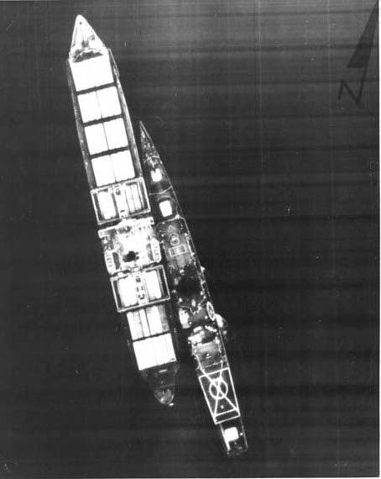
Photo: 15 May1975): U.S. freighter SS Mayaguez, boarded by U.S. crew from
the USS Harold E. Holt.

UNITED STATES MARINE CORPS

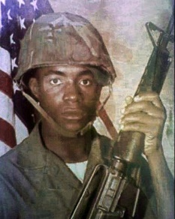
ASHTON, NATHANIEL LONEY
Marine Corps – LCPL – E3
Age 20, Male Negro, Single
Born 18 JUN 1954, from ALBANY, NY
Religion:
Tour of Duty began on 15 MAY 1975
Casualty was on 15 MAY 1975, in Cambodia.
HOSTILE, GROUND CASUALTY, MULTIPLE FRAGMENTATION WOUNDS.
Body was Not Recovered.
Panel 01W – Line 131
*

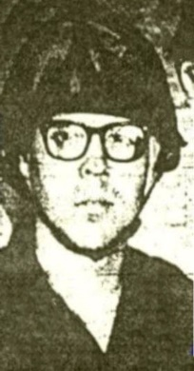

RIVENBURGH, RICHARD WILLIAM
Marine Corps – PFC – E2
Age 21, Male Caucasian, Single
Born 14 JUL 1953, from San Diego, CA
Tour of Duty began on 15 MAY 1975
Casualty was on 15 May 1975, in Cambodia.
HOSTILE, HELICOPTER – NONCREW, AIR LOSS, CRASH AT SEA
Religion:
Body was Not Recovered.
Panel 01W – Line 132

*

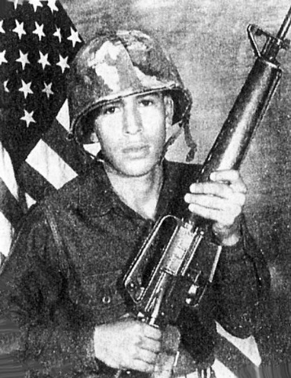

SANDOVALL, ANTONIO RAMOS
Marine Corps – PFC – E2
Age 19, Male, Caucasian, Single
Born 4 MAR 1956, from SAN ANTONI, TX
Tour of Duty began on 15 MAY 1975
Casualty was on 15 May 1975, in Cambodia.
HOSTILE, HELICOPTER – NONCREW
AIR LOSS, CRASH AT SEA
Body was Not Recovered.
Panel 01W – Line 129

*

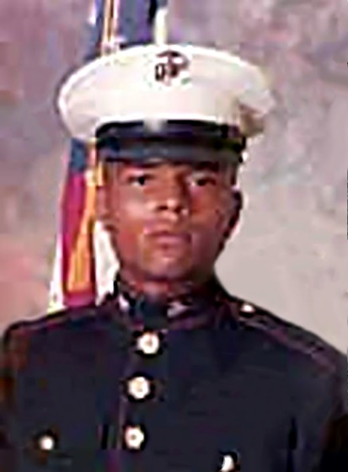
TURNER, KELTON RENA
Marine Corps – PFC – E2
Age 18, Male, Negro, Single
Born 15 JUL 1956, from Los Angeles, CA
Religion: PROTESTANT
Tour of Duty began on 15 MAY 1975
Casualty was on 15 May 1975, in Cambodia.
HOSTILE, HELICOPTER – NONCREW, AIR LOSS, CRASH AT SEA.
Body was Recovered.
Panel 01W – Line 130

*

UNITED STATES NAVY

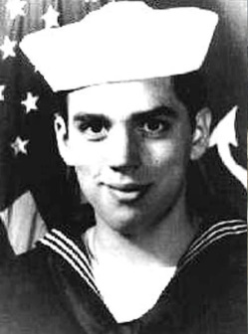
MANNING, RONALD JAMES
HN – E3 – Navy - Regular
Age 21, Male Caucasian, Single
Born 9 MAY 1954, from TORONTO, OH
Tour of Duty began on 15 MAY 1975
Casualty was on 15 May 1975, in Cambodia.
HOSTILE, HELICOPTER – NONCREW, AIR LOSS, CRASH AT SEA.
Religion: PROTESTANT
Body was Not Recovered.
Panel 01W – Line 131

