SS MAYAGUEZ INCIDENT
Rescue Operation
CASUALTIES NAMES AND PHOTOS

UNITED STATES AIR FORCE
“Aim High… Fly-Fight-Win”” — (“In Memory of”)

USAF 24 KILLED IN LINE OF DUTY (CH-53 KNIFE 13, CRASH)

18 – 56th SECURITY POLICE SQUADRON

04 – AF AIRCREW: 21ST SPECIAL OPS SQDN, 56TH SPECIAL OPS WING, 7TH AF (CH-53).
01 – AF AIRCREW: 20TH SPECIAL OPS SQDN, 56TH SPECIAL OPS WING, 7TH AF,
SECURITY SPECIALIST (CH-53)
01 – AF AIRCREW, TECH: 40TH AEROSPACE RESCUE AND RECOVERY SQUADRON (HH-53),
NAKHON PHANOM RTRAB

UNITED STATES MARINE CORPS
“Semper Fidelis” (“Always Faithful”)

USMC 14 KILLED IN ACTION
02 - 1ST PLT, G CO, 2ND BN, 9TH MARINES, 3RD MARDIV, III MAF
06 - G CO, 2ND BN, 9TH MARINES, 3RD MARDIV, III MAF
03 - E CO, 2ND BN, 9TH MARINES, 3RD MARDIV, III MAF
02 - H&S CO, 2ND BN, 9TH MARINES, 3RD MARDIV, III MAF
01 - WPNS PLT, G CO, 2ND BN, 9TH MARINES, 3RD MARDIV, III MAF

UNITED STATES NAVY

“Non Sibi Sed Patriae” (“Not Self but Country”)

USN 02 KILLED IN ACTION (NAVY HOSPITAL CORPSMEN)

02 - NAVY HOSPITAL CORPSMAN - H&S CO, 2ND BN, 9TH MARINES, 3RD MARDIV, III MAF
(USMC HH-53A)

THE SS MAYAGUEZ INCIDENT, RESCUE OPERATION

Thailand To Cambodia
Photo & Composite © 2020, Don Poss
Photo & Composite © 2020, Don Poss

A-Z, LOD (CH-53 Crash)

UNITED STATES AIR FORCE
“Aim High… Fly-Fight-Win (“In Memory of”)

56TH SEC POLICE SQDN, 56TH SPECIAL OPS WING, 7TH AF
18 KILLED IN THE SS MAYAGUEZ INCIDENT, RESCUE OPERATION, THAILAND,
CH-53 HELICOPTER CRASH, ENROUTE FROM NAKHON PHANOM RTAFB

TO U-TAPAO RTAFB, TO JOIN ASSAULT TO CABMODIA.
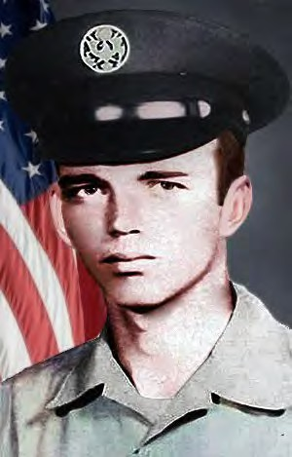
BLACK, JIMMY P.
SGT (E4) – Air Force Regular
56TH SEC POLICE SQDN, 56TH SPECIAL OPS WING, 7TH AF
Age 20, Male.
Born 24 AUG 1954, from DAPHNE, AL.
Tour of Duty began at,
NAKHON PHANOM RTAFB, ROYAL THAILAND,
Casualty was on 13 MAY 1975
NON-HOSTILE [LOD]: Thailand.
Helicopter Crash from NKP (Eighteen 56th SPS and 5 Aircrew were Killed enroute to the SS Mayaguez Incident and Operation Rescue, Thailand—the Last Battle of the Vietnam War.
Body was Recovered.
Panel 01W – Line 124 *

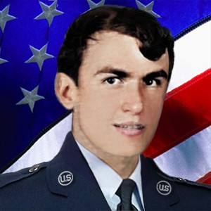
COLLUMS, BOBBY GLEN
SGT (E4) – Air Force Regular
56TH SEC POLICE SQDN, 56TH SPECIAL OPS WING, 7TH AF
Age 22, Male Caucasian.
Born 24 SEP 1952, from HELENA, AR.
Tour of Duty began at,
NAKHON PHANOM RTAFB, ROYAL THAILAND,
Casualty was on 13 MAY 1975
NON-HOSTILE [LOD]: Helicopter Crash (Eighteen 56th SPS and 5 Aircrew were Killed enroute to the SS Mayaguez Incident and Operation Rescue, Thailand—the Last Battle of the Vietnam War.
Body was Recovered.
Panel 01W – Line 125 *

COYLE, GERALD A.
SSGT (E5) – Air Force Regular
56TH SEC POLICE SQDN, 56TH SPECIAL OPS WING, 7TH AF
Age 31, Male
Born 14 MAY 1943, from BENTLEYVILLE, PA.
Tour of Duty began at,
NAKHON PHANOM RTAFB, ROYAL THAILAND,
Casualty was on 13 MAY 1975
NON-HOSTILE [LOD]: Helicopter Crash (Eighteen 56th SPS and 5 Aircrew were Killed enroute to the SS Mayaguez Incident and Operation Rescue, Thailand—the Last Battle of the Vietnam War.
Body was Recovered.
Panel 01W – Line 125
*

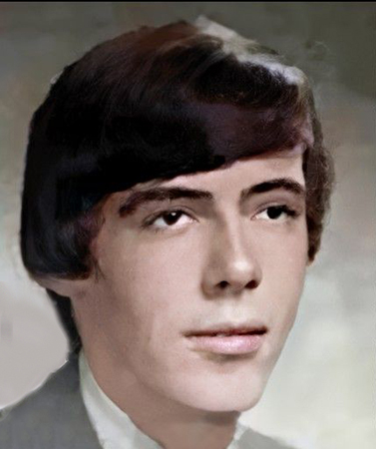
DWYER, THOMAS D.
SGT (E4) – Air Force Regular
56TH SEC POLICE SQDN, 56TH SPECIAL OPS WING, 7TH AF
Age 21, Male
Born JUN 17, 1953, from MIDDLEBURY, CT
Tour of Duty began at,
Casualty was on 13 MAY 1975
NON-HOSTILE [LOD]: Helicopter Crash (Eighteen 56th SPS and 5 Aircrew were Killed enroute to the SS Mayaguez Incident and Operation Rescue, Thailand—the Last Battle of the Vietnam War.
Body was Recovered. Panel 01W – Line 125
*

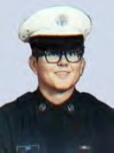
FORD, BOB WAYNE
SGT (E4) – Air Force Regular
56TH SEC POLICE SQDN, 56TH SPECIAL OPS WING, 7TH AF
Age 21, Male
Born 19 FEB 1954, from SEMINOLE, TX
Tour of Duty was at,
Casualty was on 13 MAY 1975
NON-HOSTILE [LOD]: Helicopter Crash (Eighteen 56th SPS and 5 Aircrew were Killed enroute to the SS Mayaguez Incident and Operation Rescue, Thailand—the Last Battle of the Vietnam War.
Body was Recovered. Panel 01W – Line 125
Steve Davidson - Comment: I have a better understanding of how things are now, but I don't agree with the "Washington D.C. bean counters" [not issuing Purple Hearts to Mayaguez SPs], but that's not unusual. Sgt Bob Wayne Ford was a good friend of mine. We were stationed together at Kingslely Field, OR, from 72-75. He left for Thailand in early 1975 and I was attending Camp Bullis en route to Korea when we first learned of his (and the others who were killed) death in the helicopter crash. You have a great web site and I'm glad to see that all Security Police who served in Vietnam are honored and remembered with integrity.
*

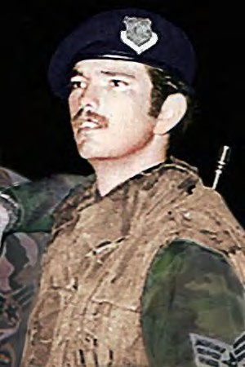
FRITZ, GERALD W.
SGT (E4) – Air Force Regular
56TH SEC POLICE SQDN, 56TH SPECIAL OPS WING, 7TH AF
Age 21, Male
Born MAY 6, 1954, from JUNCTION, TX
Tour of Duty was at,
NAKHON PHANOM RTAFB, ROYAL THAILAND,
Casualty was on 13 MAY 1975
NON-HOSTILE [LOD]: Helicopter Crash (Eighteen 56th SPS and 5 Aircrew were Killed enroute to the SS Mayaguez Incident and Operation Rescue, Thailand—the Last Battle of the Vietnam War.
Body was Recovered.
Panel 01W – Line 125

*

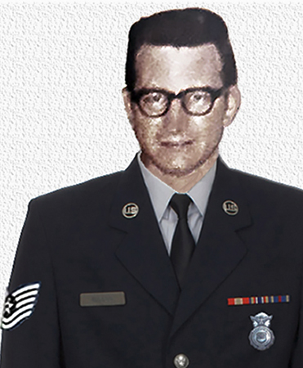
GLENN, JACKIE D.
TSGT (E6) – Air Force Regular
56TH SEC POLICE SQDN, 56TH SPECIAL OPS WING, 7TH AF
Age 36, Male
Born 10 MAY 1939, from SEYMOUR, MO
Tour of Duty began at,
NAKHON PHANOM RTAFB, ROYAL THAILAND,
Casualty was on 13 MAY 1975
NON-HOSTILE [LOD]: Helicopter Crash (Eighteen 56th SPS and 5 Aircrew were Killed enroute to the SS Mayaguez Incident and Operation Rescue, Thailand—the Last Battle of the Vietnam War.
Body was Recovered.
Panel 01W - Line 126

*

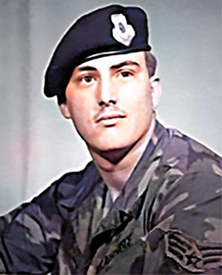
HAMLIN, DARRELL L.
SGT (E4) – Air Force Regular
56TH SEC POLICE SQDN, 56TH SPECIAL OPS WING, 7TH AF
Age 19, Male
Born 20 OCT 1955, from IOWA CITY, IA
Tour of Duty began at,
NAKHON PHANOM RTAFB, ROYAL THAILAND,
Casualty was on 13 MAY 1975
NON-HOSTILE [LOD]: Helicopter Crash (Eighteen 56th SPS and 5 Aircrew were Killed enroute to the SS Mayaguez Incident and Operation Rescue, Thailand—the Last Battle of the Vietnam War.
Body was Recovered.
Panel 01W – Line 126

*

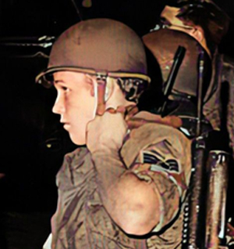
HANKAMER, GREGORY L.
SGT (E4) – Air Force Regular
56TH SEC POLICE SQDN, 56TH SPECIAL OPS WING, 7TH AF
Age 21, Caucasian Male
Born 15 SEP 1953, from SAN PEDRO, CA
Tour of Duty began at,
NAKHON PHANOM RTAFB, ROYAL THAILAND,
Casualty was on 13 MAY 1975
NON-HOSTILE [LOD]: Helicopter Crash (Eighteen 56th SPS and 5 Aircrew were Killed enroute to the SS Mayaguez Incident and Operation Rescue, Thailand—the Last Battle of the Vietnam War.
Body was Recovered.
Panel 01W – Line 126
*

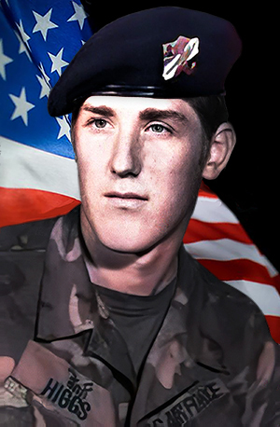
HIGGS, DAVID ALAN
SGT (E4) – Air Force Regular
56TH SEC POLICE SQDN, 56TH SPECIAL OPS WING, 7TH AF
Age 20, Male
Born 05 MAY 1955, from SPOKANE, WA
Tour of Duty began at,
NAKHON PHANOM RTAFB, ROYAL THAILAND,
Casualty was on 13 MAY 1975
NON-HOSTILE [LOD]: Thailand.
Helicopter Crash from NKP (Eighteen 56th SPS and 5 Aircrew were Killed enroute to the SS Mayaguez Incident and Operation Rescue, Thailand—the Last Battle of the Vietnam War.
Body was Recovered.
Panel 01W – Line 126

Description: ‘CH-53 KNIFE 13, Serial Number 68-10933, 21st SOS, with 4 Air Crew, a 56th Security Ops., and 18 56th SPS Airmen onboard, airlifted from NKP enroute to U-Tapao RTAFB. As one of three 3 CH-53s carrying 75 SPs, as requested by 7th Air Force, to join the assembling force for the SS Mayaguez Incident rescue operation.
At 2130 local, and about 37 miles west of NKP RTAFB, bound for U-Tapao, KNIFE 13 fell out of formation and crashed and exploded on impact. All 23 aboard were killed. Other CH-53s landed nearby, but exploding ammunition and burning fuel hindered all rescue attempts. The marines CH-53s continued on flight to Cambodia and on 15 May 1975, after an ongoing vicious battle, control of the SS Mayaguez returned to the United States.
*

ILAOA, FALEAGAFULA
SSGT (E5) – Air Force Regular
56TH SEC POLICE SQDN, 56TH SPECIAL OPS WING, 7TH AF
Age 27, Male
Born 06 APR 1948, from SAN FRANCISCO, CA
Tour of Duty began at,
NAKHON PHANOM RTAFB, ROYAL THAILAND,
Casualty was on 13 MAY 1975
NON-HOSTILE [LOD]: Helicopter Crash (Eighteen 56th SPS and 5 Aircrew were Killed enroute to the SS Mayaguez Incident and Operation Rescue, Thailand—the Last Battle of the Vietnam War.
Body was Recovered.
Panel 01W – Line 127

*

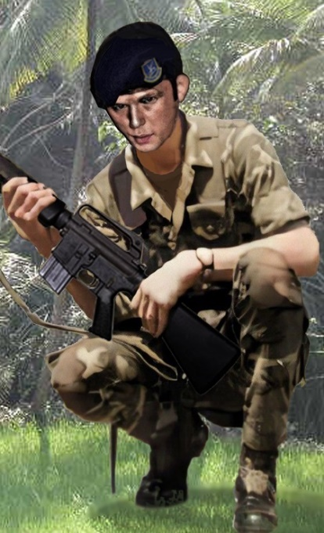
LANE, MICHAEL DAVID
SGT (E4) – Air Force Regular
56TH SEC POLICE SQDN, 56TH SPECIAL OPS WING, 7TH AF
Age 25, Male Caucasian
Born 04 JAN 1950.
From JACKSONVILLE, FL
Tour of Duty began at,
NAKHON PHANOM RTAFB, ROYAL THAILAND,
56TH SEC POLICE SQDN, 56TH SPECIAL OPS WING, 7TH AF
Casualty was on 13 MAY 1975
NON-HOSTILE [LOD]: Helicopter Crash (Eighteen 56th SPS and 5 Aircrew were Killed enroute to the SS Mayaguez Incident and Operation Rescue, Thailand—the Last Battle of the Vietnam War.
Body was Recovered.
Panel 01W – Lane 127
*

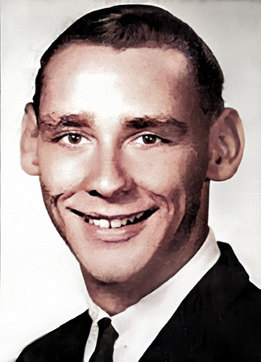
LONDON, DENNIS W.
SGT (E4) – Air Force Regular
56TH SEC POLICE SQDN, 56TH SPECIAL OPS WING, 7TH AF
Age 25, Male, Caucasian
Born 21 AUG 1949, from SPARKS, NC
Tour of Duty began at,
NAKHON PHANOM RTAFB, ROYAL THAILAND,
Casualty was on 13 MAY 1975
NON-HOSTILE [LOD]: Helicopter Crash (Eighteen 56th SPS and 5 Aircrew were Killed enroute to the SS Mayaguez Incident and Operation Rescue, Thailand—the Last Battle of the Vietnam War.
Body was Recovered.
Panel 01W – Line 127
*

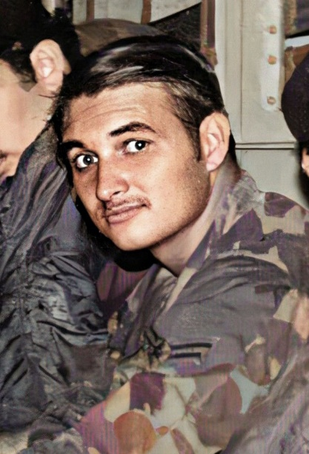
MATHIAS, ROBERT P.
SGT (E4) – Air Force Regular
56TH SEC POLICE SQDN, 56TH SPECIAL OPS WING, 7TH AF Regular. Age 21, Male
Born 13 OCT 1953. from GRANADA HILLS, CA
Tour of Duty began at
NAKHON PHANOM RTAFB, ROYAL THAILAND,
Casualty was on 13 MAY 1975
NON-HOSTILE [LOD]: Helicopter Crash (Eighteen 56th SPS and 5 Aircrew were Killed enroute to the SS Mayaguez Incident and Operation Rescue, Thailand—the Last Battle of the Vietnam War.
Body was Recovered.
Panel 01W – Line 127
*

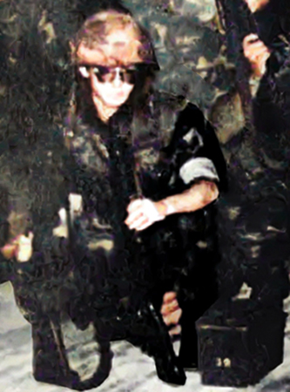
MC KELVEY, WILLIAM R.
SGT (E4) – Air Force Regular - Age 23, Male
56TH SEC POLICE SQDN, 56TH SPECIAL OPS WING, 7TH AF
Born 30 JAN 1952, from PHILADELPHIA, PA
Tour of Duty began, at
NAKHON PHANO RTAFB, ROYAL THAILAND,
Casualty was on 13 MAY 1975
Non-Hostile [LOD]: Helicopter Crash (Eighteen 56th SPS and 5 Aircrew were Killed enroute to the SS Mayaguez Incident and Operation Rescue, Cambodia—the last battle of the Vietnam War.
Body was Recovered.
Panel 01W – Line 128

Description: McKelvey was the last of the 630 servicemen from Philadelphia to die in the Vietnam Theater of Operations during the Vietnam Era, which the Department of Defense defines as the period from August 1964 through May 1975. The 23-year-old – Air Force Regular sergeant was killed when the from CH-53 helicopter in which he was riding crashed 35 miles southwest of Nakhon Phanom, ROYAL THAILAND, on May 13, 1975. McKelvey had left Roxborough High School in 1969 at the age of 17 to enlist. He was assigned to the 56TH SEC POLICE SQDN, 56TH SPECIAL OPS WING, 7TH AF in Vietnam. McKelvey had married a Thai woman and planned to adopt her daughter. In addition to his wife, he was survived by his parents and a sister. William lived on DuPont Street, in Roxborough, (PA. Source: Philadelphia Daily News 10/26/1987, Saturday, December 20, 2003). Don Graham.

*

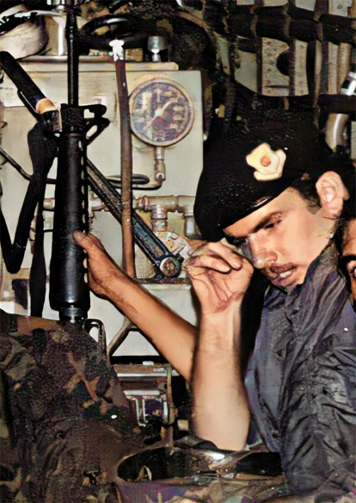
MORAN, EDGAR CRAIG, II
AIRMAN (E2) – Air Force Regular
56TH SEC POLICE SQDN, 56TH SPECIAL OPS WING, 7TH AF
Age 19, Male|
Born 16 FEB 1956, from PITTSBURG, PA
Tour of Duty began at
NAKHON PHANOM RTAFB, ROYAL THAILAND,
Casualty was on 13 MAY 1975
Non-Hostile [LOD]: Helicopter Crash (Eighteen 56th SPS and 5 Aircrew were Killed enroute to the SS Mayaguez Incident and Operation Rescue, Cambodia—the last battle of the Vietnam War.
Body was Recovered.
Panel 02W – Line 128
*

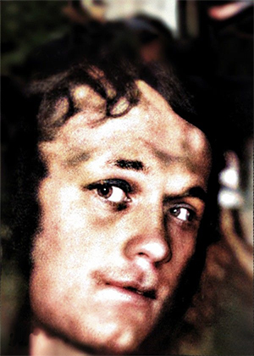
NEALIS, TOMMY R.
SGT (E4) – Air Force Regular
56TH SEC POLICE SQDN, 56TH SPECIAL OPS WING, 7TH AF
Age 22, Male
Born 23 APR 1953, from MT STERLING, CT
Tour of Duty began at,
NAKHON PHANOM RTAFB, ROYAL THAILAND,
Casualty was on 13 MAY 1975
NON-HOSTILE [LOD]: Helicopter Crash (Eighteen 56th SPS and 5 Aircrew were Killed enroute to the SS Mayaguez Incident and Operation Rescue, Thailand—the Last Battle of the Vietnam War.
Body was Recovered.
Panel 01W – Line 128
*

ROSS, ROBERT W.
SGT (E4) – Air Force Regular
56TH SEC POLICE SQDN, 56TH SPECIAL OPS WING, 7TH AF
Age 19, Male
Born 09 JUL 1954, from CYPRESS, CA
Tour of Duty began at,
NAKHON PHANOM RTAFB, ROYAL THAILAND,
Casualty was on 13 MAY 1975
NON-HOSTILE [LOD]: Helicopter Crash (Eighteen 56th SPS and 5 Aircrew were Killed enroute to the SS Mayaguez Incident and Operation Rescue, Thailand—the Last Battle of the Vietnam War.
Body was Recovered.
Panel 01W – Line 129
*

USAF CH-53 AIR CREW

06 USAF KILLED IN ACTION OR LINE OF DUTY, DURING THE SS MAYAGUEZ INCIDENT 1975
56TH SPECIAL OPS WING, 7TH AF, NKP RTAFB, THAILAND

CH-53 KNIFE 13, AIRLIFTED FROM NAKHON PHANOM RTAFB TO U-TAPAO RTAFB,
WITH 18 56TH SECURITY POLICE TO JOIN THE USMC ASSAULT AND SS MAYAGUEZ RESCUE

05 — LOD, AF AIRCREW, 21ST SPECIAL OPS SQDN. (USAF CH-53 KNIFE 13 CRASHED IN JUNGLE).

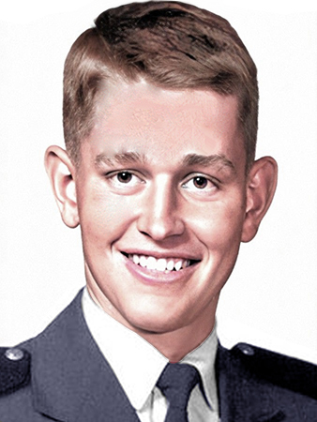
KAYS, JAMES G
Air Force – CAPT 03 – PILOT
21ST SPECIAL OPS SQDN, 56TH SPECIAL OPS WING, 7TH AF
Age 25, Male
Born 4 OCT 1949, from ATLANTA, GA
Tour of Duty began on 13 MAY 1975, in THAILAND,
Casualty was on 13 MAY 1975, in THAILAND
NON-HOSTILE [LOD]: Helicopter Crash (Eighteen 56th SPS and 5 Aircrew were Killed enroute to the SS Mayaguez Incident and Operation Rescue, Thailand—the Last Battle of the Vietnam War.
Body was Recovered.
Panel 01 – Line 127

*

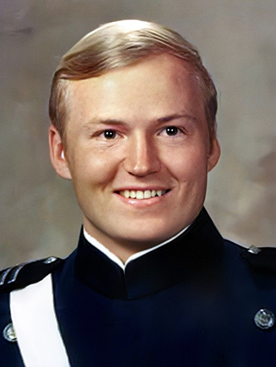
FROEHLICH, LAURENCE E.
Air Force — 1LT 02 – CO-PILOT
21ST SPECIAL OPS SQDN, 56TH SPECIAL OPS WING, 7TH AF
Age 25, Male Caucasian
Born 26 DEC 1949, from SODUS, MI
Tour of Duty began on 13 MAY 1975, in THAILAND,
Casualty was on 13 MAY 1975, in THAILAND
NON-HOSTILE [LOD]: Helicopter Crash (Eighteen 56th SPS and 5 Aircrew were Killed enroute to the SS Mayaguez Incident and Operation Rescue, Thailand—the Last Battle of the Vietnam War.
Body was Recovered.
Panel 01 – Line 126

*

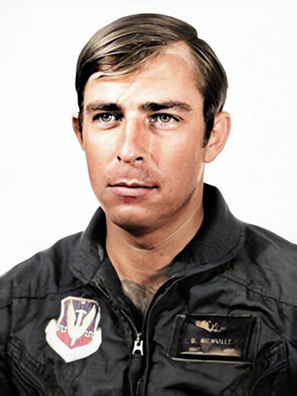
MC MULLEN, GEORGE E. III
Air Force Regular. TSGT – E6 . (FLIGHT MECHANIC)
21ST SPECIAL OPS SQDN, 56TH SPECIAL OPS WING, 7TH AF
Age 31, Male
Born 7 SEP 1943, from OXFORD, CA
Tour of Duty began on 13 MAY 1975, in THAILAND,
Casualty was on 13 MAY 1975, in THAILAND
NON-HOSTILE [LOD]: Helicopter Crash (Eighteen 56th SPS and 5 Aircrew were Killed enroute to the SS Mayaguez Incident and Operation Rescue, Thailand—the Last Battle of the Vietnam War.
Body was Recovered.
Panel 01 – Line 128

*

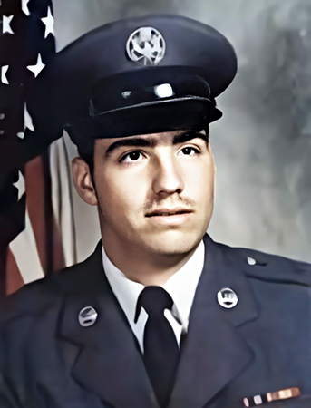
RABER, PAUL J.
Air Force Regular – SGT - SECURITY SPECIALIST,
56TH SEC POLICE SQDN, 56TH SPECIAL OPS WING, 7TH AF
Age 21, Male Caucasian
Born 21 APR 1954, from PORT ANGELES, WA
Tour of Duty began on 13 MAY 1975, in THAILAND,
21ST SPECIAL OPS SQDN, 56TH SPECIAL OPS WING, 7TH AF
Casualty was on 13 MAY 1975, in THAILAND
NON-HOSTILE [LOD]: Helicopter Crash (Eighteen 56th SPS and 5 Aircrew were Killed enroute to the SS Mayaguez Incident and Operation Rescue, Thailand—the Last Battle of the Vietnam War.
Body was Recovered.
Panel 01 – Line 128
*

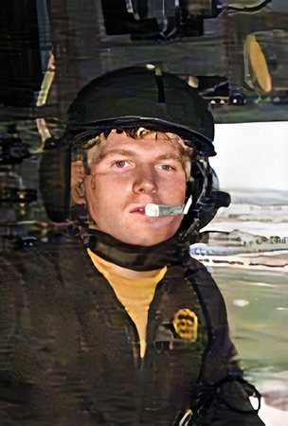
WELDON, ROBERT PAUL
Air Force Regular - SGT - E4 – AIRCREW
21ST SPECIAL OPS SQDN, 56TH SPECIAL OPS WING, 7TH AF
Age 19, Male.
Born 10 OCT 1955, from KANSAS CITY, KS
Tour of Duty began on 13 MAY 1975, in THAILAND,
Casualty was on 13 MAY 1975, in THAILAND
NON-HOSTILE [LOD]: Helicopter Crash (Eighteen 56th SPS and 5 Aircrew were Killed enroute to the SS Mayaguez Incident and Operation Rescue, Thailand—the Last Battle of the Vietnam War.
Body was Recovered.
Panel 01 – Line 129
*

01 — KIA, AF AIRCREW, 20TH SPECIAL OPS SQDN (USMC HH53 KNIFE ??, SHOT DOWN WHILE INSERTING MARINES IN TO HOT LZ, WEST BEACH, KOH TANG ISLAND, CAMBODIA, AND CRASHED AT SEA. MIA, BNR.):

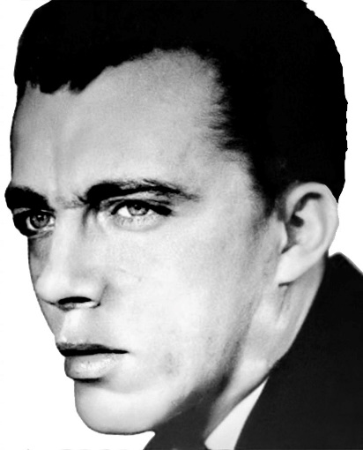
RUMBAUGH, ELWOOD EUGENE
SSGT (E5) – Air Force Regular
Age 31, Male Married
Born 10 SEP 1943, from SPANGLER, PA
Tour of Duty began on 15 MAY 1975, in CAMBODIA
20th SPECIAL OPS SQDN (SOS), 56TH SPECIAL OPS WING, 7TH AF [Helicopter Technician)
CASUALTY WAS ON 17 MAY 1975
HOSTILE [KIA], Died While Missing, HELICOPTER – CREW AIR LOSS, CRASH AT SEA [Mayaguez Incident]
Religion: Nazarene
Body was Not Recovered.
Panel 01W – Line 125

A Note from The Virtual Wall (16 APR 2002) - From a fellow Green Hornet, Robert Hall:
While off-loading Marines on the West Beach (Hostile LZ) of Koh Tang Island, Cambodia, in support of the Mayaguez Incident. His CH-53 [carrying marines in to a hostile LZ] was hit by ground fire. The pilot managed a single engine takeoff and headed out to sea, skipping along the water, taking on water each time hit surface. The helicopter made it nearly a mile off shore when it crashed… rolled on its left side and all the crew managed to exit … [however] SSgt Rumbaugh disappeared a short time later and is presumed drowned. SSgt Rumbaugh was serving with the 20th SOS in 1970-1971.

His remains have not been recovered.

*

UNITED STATES MARINE CORPS
“Semper Fidelis” (“Always Faithful”) — In Memory of
FOURTEEN KILLED IN ACTION

IN THE SS MAYAGUEZ INCIDENT, RESCUE OPERATION

Thailand To Cambodia

USMC 14 KILLED IN ACTION
02 - 1ST PLT, G CO, 2ND BN, 9TH MARINES, 3RD MARDIV, III MAF
06 - G CO, 2ND BN, 9TH MARINES, 3RD MARDIV, III MAF
03 - E CO, 2ND BN, 9TH MARINES, 3RD MARDIV, III MAF
02 - H&S CO, 2ND BN, 9TH MARINES, 3RD MARDIV, III MAF
01 - WPNS PLT, G CO, 2ND BN, 9TH MARINES, 3RD MARDIV, III MAF

UNITED STATES MARINE CORPS

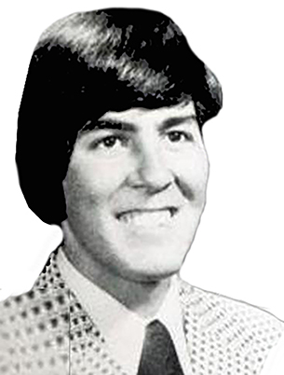
BENEDETT, DANIEL ANDREW
Marine Corps – PFC – E2 – Regular
G CO, 2ND BN, 9TH MARINES, 3RD MARDIV, III MAF (Rifleman)
Age 19, Male Caucasian, Single
Born 30 OCT 1955, from AUBURN, WA
Tour of Duty began on 15 May 1975
Casualty was on 15 MAY 1975, in Cambodia.
HOSTILE, HELICOPTER – NONCREW, AIR LOSS, CRASH AT SEA
Religion: ROMAN CATHOLIC
Body was Not Recovered.
Panel 01W – Line 129

*

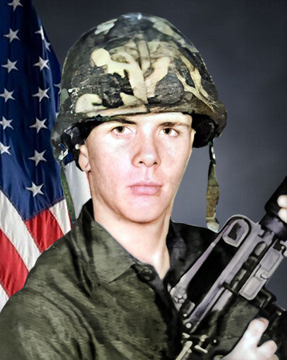
BLESSING, LYNN
Marine Corps – PFC – E2 – Regular
G CO, 2ND BN, 9TH MARINES, 3RD MARDIV, III MAF (Rifleman)
Age 18, Male Caucasian, Married
Born 16 JAN 1957, from LANCASTER, PA
Tour of Duty began on 15 MAY 1975,
Casualty was on 15 MAY 1975, in Cambodia.
HOSTILE, HELICOPTER – NONCREW, AIR LOSS, CRASH AT SEA
Religion:
Body was Recovered.
Panel 01W – Line 129

*

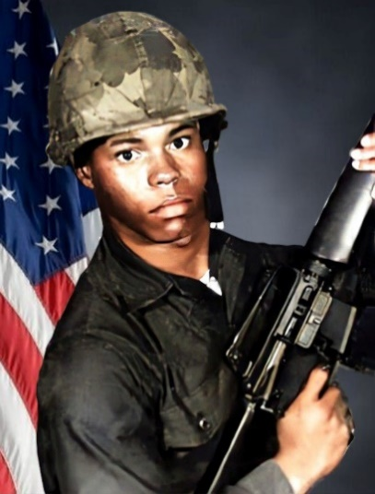
BOYD, WALTER
Marine Corps – PFC – E2 – Regular
G CO, 2ND BN, 9TH MARINES, 3RD MARDIV, III MAF (Rifleman)
Age 18, Male Negro, Single
Born 17 APR 1956, from NORFOLK, VA
Tour of Duty began on 15 MAY 1975,
Casualty was on 15 MAY 1975, in Cambodia.
HOSTILE, HELICOPTER – NONCREW, AIR LOSS, CRASH AT SEA
Religion: PROTESTANT
Body was Recovered.
Panel 01W – Line 132

*

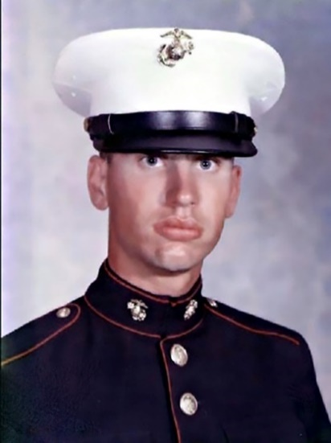
COPENHAVER, GREGORY SCOTT (Rifleman)
Marine Corps – LCPL – E3 – Regular
G CO, 2ND BN, 9TH MARINES, 3RD MARDIV, III MAF
Age 19, Male Caucasian, Single
Born 21 JUL 1955 from PORT DEPOSIT, MD
Tour of Duty began on 15 MAY 1975,
Casualty was on 15 MAY 1975, in Cambodia.
HOSTILE, HELICOPTER – NONCREW, AIR LOSS, CRASH AT SEA
Religion: PROTESTANT
Body was Recovered.
Panel 01W – Line 132

*

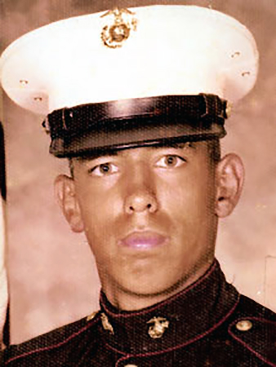
GARCIA, ANDRES
Marine Corps – LCPL – E3 – Regular
H&S CO, 2ND BN, 9TH MARINES, 3RD MARDIV, III MAF (Rifleman)
Age 20, Male Caucasian
Born 27 OCT 1954, from CARLSBAD, NM
Tour of Duty began on 15 MAY 1975,
Casualty was on 15 MAY 1975, in Cambodia.
HOSTILE, HELICOPTER – NONCREW, AIR LOSS, CRASH AT SEA
Religion: ROMAN CATHOLIC
Body was Recovered.
Panel 01W – Line 132

*

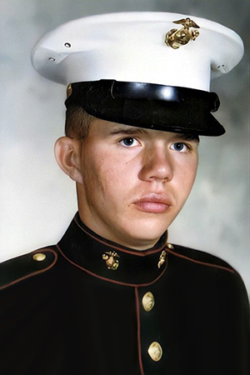
HALL, GARY LEE
Marine Corps – PFC – E3 – Regular
E CO, 2ND BN, 9TH MARINES, 3RD MARDIV, III MAF (Engineer Equipment)
Age 19, Male Caucasian, Single
Born 26 JUL 1956, from COVINGTON, KY
Tour of Duty began on 15 MAY 1975
Casualty was on 21 JUL 1976, in Cambodia (MIA: Captured, Torched, Executed)
HOSTILE, died while missing, GROUND CASUALTY AIR LOSS, CRASH ON LAND
Religion: SOUTHERN BAPTIST CONVENTION
Body Not Recovered.
Panel 01W – Line 130
*

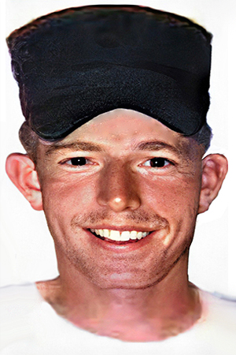
HARGROVE, JOSEPH NELSON (Engineer Equipment)
Marine Corps – LCPL – E3 – Regular
E CO, 2ND BN, 9TH MARINES, 3RD MARDIV, III MAF (Engineer Equipment)
Age 25, Male Caucasian, Married
Born 15 May 1951, MT OLIVE, NC
Tour of Duty began on 15 MAY 1975
Casualty was on 21 JUL 1976, in Cambodia (MIA: Captured, Torched, Executed)
HOSTILE, died while missing, GROUND CASUALTY AIR LOSS, CRASH ON LAND
Religion: PRESBYTERIAN
Body Not Recovered.
Panel 01W – Line 130

*

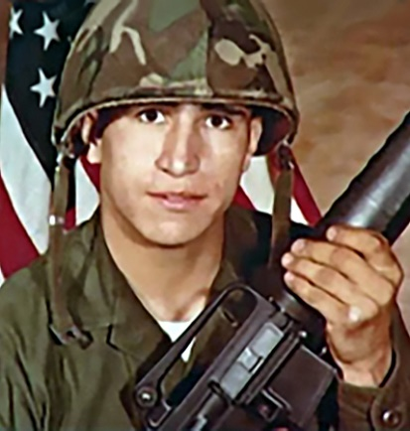
JACQUES, JAMES JOSEPH
Marine Corps – PFC – E2 – Regular
G CO, 2ND BN, 9TH MARINES, 3RD MARDIV, III MAF (Rifleman)
Age 18, Male Caucasian, Single
Born 18 JUN 1954, from ALBANY, NY
Tour of Duty began on 15 MAY 1975
Casualty was on 15 MAY 1975, in Cambodia.
HOSTILE, GROUND CASUALTY, MULTIPLE FRAGMENTATION WOUNDS
Religion: ROMAN CATHOLIC
Body was Not Recovered.
Panel 01W – Line 131

*

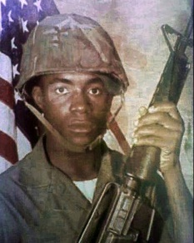
LONEY, NATHANIEL ASHTON
Marine Corps – LCPL – E3
1ST PLT, G CO, 2ND BN, 9TH MARINES,
3RD MARDIV, III MAF (Rifleman)
Age 20, Male Negro, Single
Born 18 JUN 1954, from ALBANY, NY
Tour of Duty began on 15 MAY 1975
Casualty was on 15 MAY 1975, in Cambodia.
HOSTILE, GROUND CASUALTY, MULTIPLE FRAGMENTATION WOUNDS
Religion:
Body was Not Recovered.
Panel 01W – Line 131
*

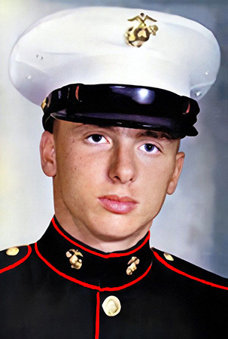
MARSHALL, DANNY GLEN
Marine Corps – PVT – E1 – Regular
E CO, 2ND BN, 9TH MARINES, 3RD MARDIV, III MAF (Equipment Engineer)
Age 19, Male Caucasian, Single
Born 9 MAR 1957, from WAVERLY, WV
Tour of Duty began on 15 MAY 1975
Casualty was on 21 JUL 1976, in Cambodia (MIA: Captured, Torched, Executed)
HOSTILE, died while missing, GROUND CASUALTY AIR LOSS, CRASH ON LAND
Religion:
Body Not Recovered.
Panel 01W – Line 131

*

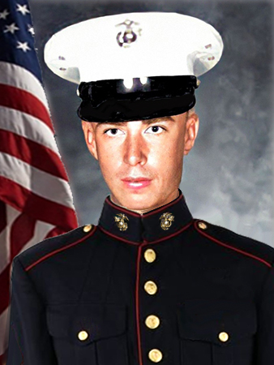
MAXWELL, JAMES RICKEY
Marine Corps – PFC – E2
2ND PLT, G CO, 2ND BN, 9TH MARINES,
3RD MARDIV, III MAF (Hospitalman)
Age 18, Male Caucasian, Single
Born 20 FEB 1957, from CENTER RIDGE, AR
Tour of Duty began on 15 MAY 1975,
Casualty was on 15 MAY 1975, in Cambodia.
HOSTILE, HELICOPTER – NONCREW, AIR LOSS, CRASH AT SEA
Religion: PROTESTANT
Body was Not Recovered.
Panel 01W – Line 131

*

RIVENBURGH, RICHARD WILLIAM
Marine Corps – PFC – E2
WPNS PLT, G CO, 2ND BN, 9TH MARINES,
3RD MARDIV, III MAF (Assaultman)
Age 21, Male Caucasian, Single
Born 14 JUL 1953, from San Diego, CA
Tour of Duty began on 15 MAY 1975
Casualty was on 15 May 1975, in Cambodia.
HOSTILE, HELICOPTER – NONCREW, AIR LOSS, CRASH AT SEA
Religion:
Body was Not Recovered.
Panel 01W – Line 132

*

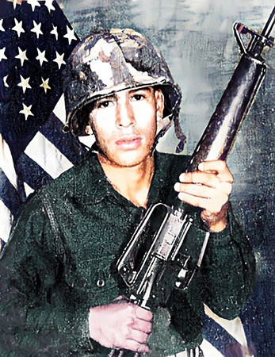
SANDOVAL, ANTONIO RAMOS
Marine Corps – PFC – E2
H&S CO, 2ND BN, 9TH MARINES, 3RD MARDIV, III MAF (Rifleman)
Age 19, Male, Caucasian, Single
Born 4 MAR 1956, from SAN ANTONI, TX
Tour of Duty began on 15 MAY 1975
Casualty was on 15 May 1975, in Cambodia.
HOSTILE, HELICOPTER – NONCREW, AIR LOSS, CRASH AT SEA
Religion:
Body was Not Recovered.
Panel 01W – Line 129

*

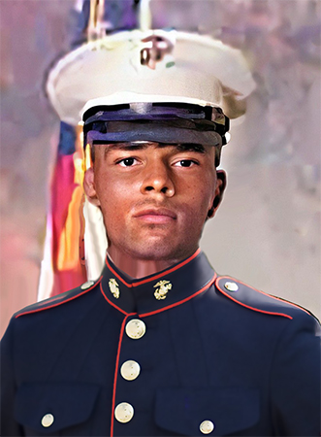
TURNER, KELTON RENA
Marine Corps – PFC – E2 – Regular
G CO, 2ND BN, 9TH MARINES, 3RD MARDIV, III MAF
Age 18, Male, Negro, Single
Born 15 JUL 1956, from Los Angeles, CA
Religion: PROTESTANT
Tour of Duty began on 15 MAY 1975
Casualty was on 15 May 1975, in Cambodia.
HOSTILE, HELICOPTER – NONCREW, AIR LOSS, CRASH AT SEA.
Religion: PROTESTANT
Body was Recovered.
Panel 01W – Line 130

*

UNITED STATES NAVY
“Semper Fortis,” “ Ever Strong” —

In Memory of
TWO NAVY CORPSMAN KILLED IN ACTION

IN THE SS MAYAGUEZ INCIDENT, RESCUE OPERATION, CAMBODIA

USN 02 KILLED IN ACTION
02 - NAVY CORPSMAN - H&S CO, 2ND BN, 9TH MARINES, 3RD MARDIV, III MAF

UNITED STATES NAVY

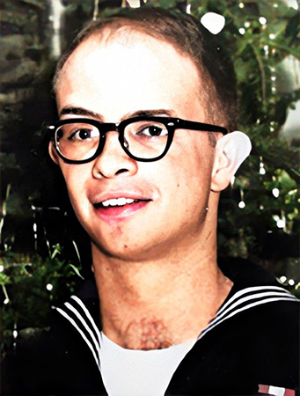
GAUSE, BERNARD JR.
Navy – HM1 – E6
NAVY HOSPITAL CORPSMAN - H&S CO, 2ND BN, 9TH MARINES, 3RD MARDIV, III MAF
Age 34, Male, Caucasian, Married
Born 11 NOV 1940, from BIRMINGHAM, AL
Religion: PROTESTANT
Tour of Duty began on 15 MAY 1975
Casualty was on 15 May 1975, in Cambodia.
HOSTILE, HELICOPTER – NONCREW, AIR LOSS, CRASH AT SEA.
Religion: PROTESTANT
Body was Recovered.
Panel 01W – Line 130

*

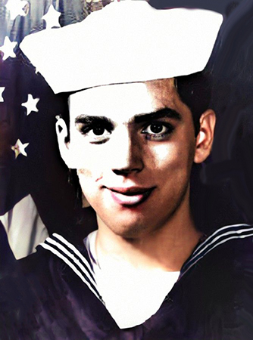
MANNING, RONALD JAMES
Navy — HN – E3 – Navy - Regular
NAVY HOSPITAL CORPSMAN - H&S CO, 2ND BN, 9TH MARINES, 3RD MARDIV, III MAF
Age 21, Male Caucasian, Single
Born 9 MAY 1954, from TORONTO, OH
Tour of Duty began on 15 MAY 1975
Casualty was on 15 May 1975, in Cambodia.
HOSTILE, HELICOPTER – NONCREW, AIR LOSS, CRASH AT SEA.
Religion: PROTESTANT
Body was Not Recovered.
Panel 01W – Line 131

*

MAYAGUEZ INCIDENT – 03 US MARINES, MIA, CAPTURED, TORCHERED, AND EXECUTED
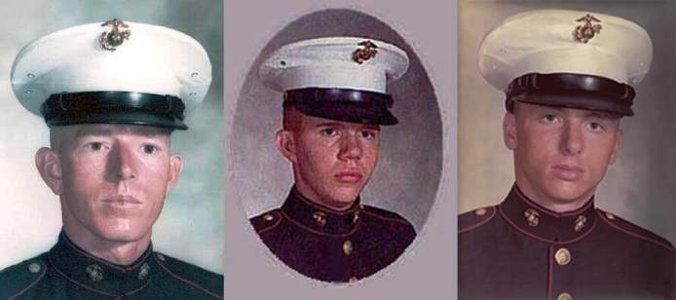
BY KHMER ROUGE, CAMBODIA. DIED WHILE MISSING. BNR.

Lance Cpl. Joseph Hargrove Pfc. Gary Hall Pvt. Danny Marshall
H/T Stars and Stripes, for this image

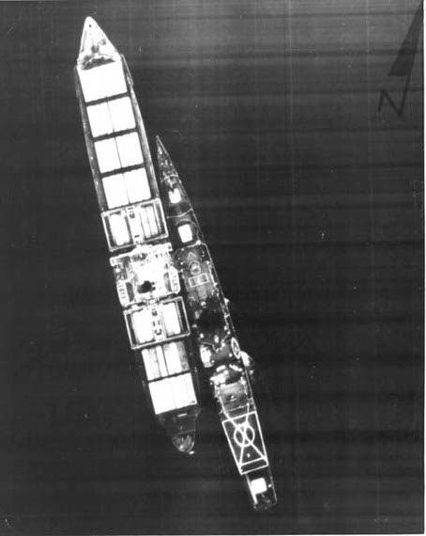

MAYAGUEZ INCIDENT:
Operation Rescue, Thailand—
The Last Battle of the Vietnam War.

Photo: 15 May1975):
U.S. freighter, SS Mayaguez,
boarded by U.S. crew from the SS Harold E. Holt. The first ship-to-ship boarding since the Civil War.

INCIDENT
We identified 17 casualties in our archive that might be related to the #750515-MAYAGUEZ incident on May 15, 1975.
◼Daniel A Benedett :: Rifleman
◼Lynn Blessing :: Rifleman
◼Walter Boyd Jr :: Rifleman
◼Gregory S Copenhaver :: Rifleman
◼Andres Garcia :: Rifleman
◼Bernard Gause Jr :: Hospital Corpsman
◼Gary L Hall :: Engineer Equipment
◼Joseph N Hargrove :: Engineer Equipment
◼James J Jacques :: Rifleman
◼Ashton N Loney :: Rifleman
◼Ronald J Manning :: Hospitalman
◼Danny G Marshall :: Engineer Equipment
◼James R Maxwell :: Rifleman
◼Richard W Rivenburgh :: Assaultman
◼Elwood E Rumbaugh :: Helicopter Technician
◼Antonio R Sandoval :: Rifleman
◼Kelton R Turner :: Rifleman
REMEMBERED
Elwood Eugene Rumbaugh is buried or memorialized at Courts of the Missing at the Honolulu Memorial. This is an American Battle Monuments Commission location.
Elwood is honored on the Vietnam Veteran's Memorial in Washington DC. Name inscribed at VVM Wall, Panel 01w, Line 132.

