KNIFE-13 MEMORIAL
(Center title between the two logos for the 56th SPS and 56th SFS. Delete all Bronze Star information below the title and above the photos per BG Coleman)
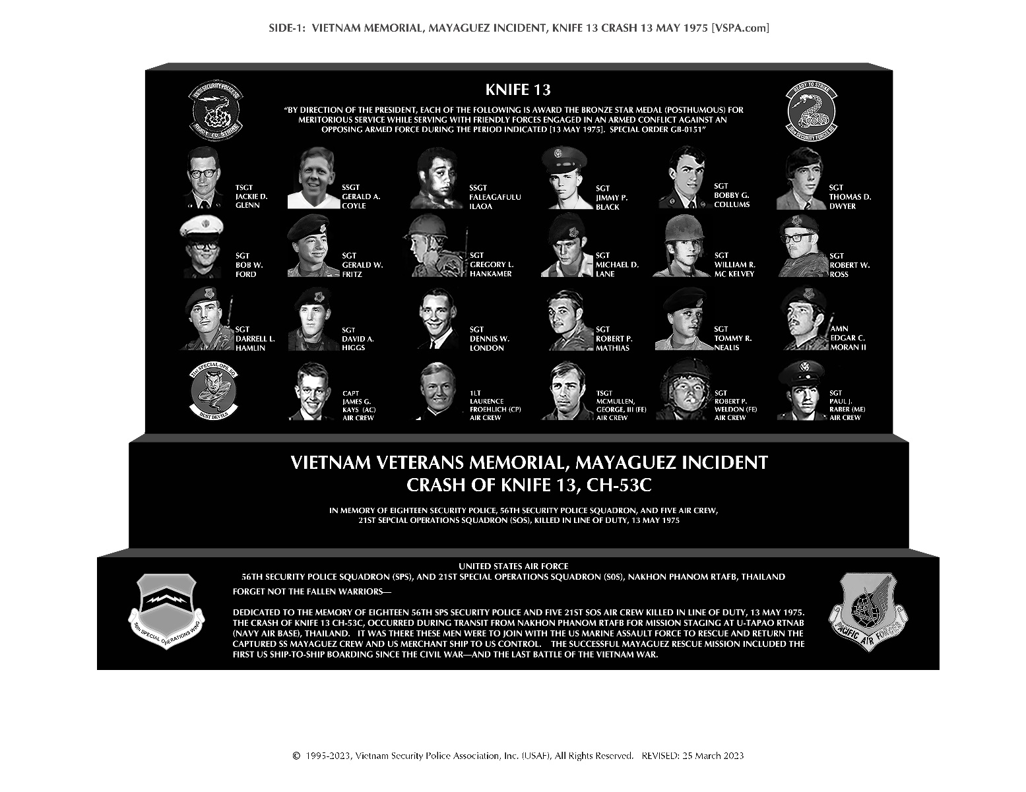
(CENTER BASE TEXT)
DEDICATED TO THE MEMORY OF OUR BROTHERS
18 SECURITY POLICEMEN FROM THE 56TH SECURITY POLICE SQUADRON AND FIVE AIRCREW MEMBERS FROM THE 21ST SPECIAL OPERATIONS SQUADRON, WHO WERE ALL ASSIGNED TO THE 56TH SPECIAL OPERATIONS WING AT NAKHON PHANOM ROYAL THAI AIR FORCE BASE, THAILAND. OUR BROTHERS WERE VOLUNTEERS WHO GAVE THEIR LIVES ON MAY 13, 1975 IN THE VALIANT HOPE OF SAVING THE LIVES OF THE CAPTURED CREW OF THE SS MAYAGUEZ.

(Delete all text below and substitute above text)
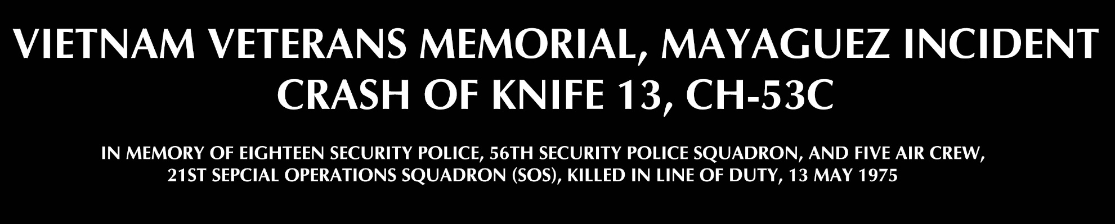

(BOTTOM BASE TEXT)
OUR BROTHERS PERISHED IN THE CRASH OF KNIFE-13, A CH-53C HELICOPTER #68-10933, WHILE ENROUTE FROM NAKHON PHANOM RTAFB TO THE STAGING AREA FOR THE MAYAGUEZ RESCUE OPERATION AT U-TAPAO ROYAL THAI NAVY BASE. WE SHALL ALWAYS REMEMBER!
UNITED STATES AIR FORCE

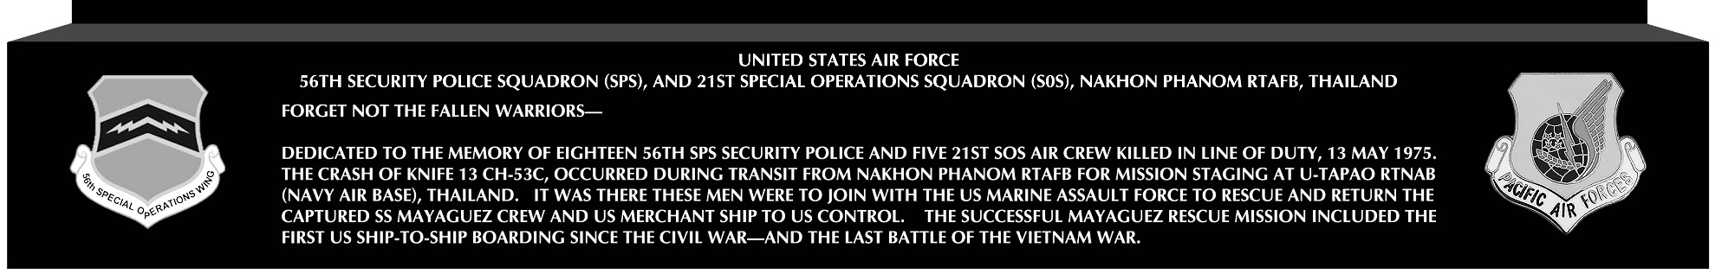
(DELETE ALL TEXT ON THE BOTTOM BASE AND CENTER THE ABOVE TEXT BETWEEN THE 56TH SOW LOGO AND THE PACAF LOGO)

