KNIFE-13 MEMORIAL
© 2023, Vietnam Security Police Association, Inc. (USAF)

EIGHTEEN UNITED STATES AIR FORCE SECURITY POLICEMEN FROM THE 56TH SECURITY POLICE SQUADRON AND FIVE AIRCREW MEMBERS FROM THE 21ST SPECIAL OPERATIONS SQUADRON, THEY WERE ASSIGNED TO THE 56TH SPECIAL OPERATIONS WING AT NAKHON PHANOM ROYAL THAI AIR FORCE BASE, THAILAND. OUR BROTHERS WERE VOLUNTEERS WHO GAVE THEIR LIVES ON MAY 13, 1975, IN THE VALIANT HOPE OF SAVING THE LIVES OF THE CAPTURED CREW OF THE SS MAYAGUEZ. ALL PERISHED IN THE CRASH OF KNIFE-13, A CH-53C HELICOPTER #68-10933, WHILE EN ROUTE FROM NAKHON PHANOM RTAFB TO THE STAGING AREA FOR THE MAYAGUEZ RESCUE OPERATION AT U-TAPAO ROYAL THAI NAVY BASE.
WE SHALL ALWAYS REMEMBER!
WE SHALL BUILD THE KNIFE-13 MEMORIAL!
WILL YOU HELP US REMEMBER?
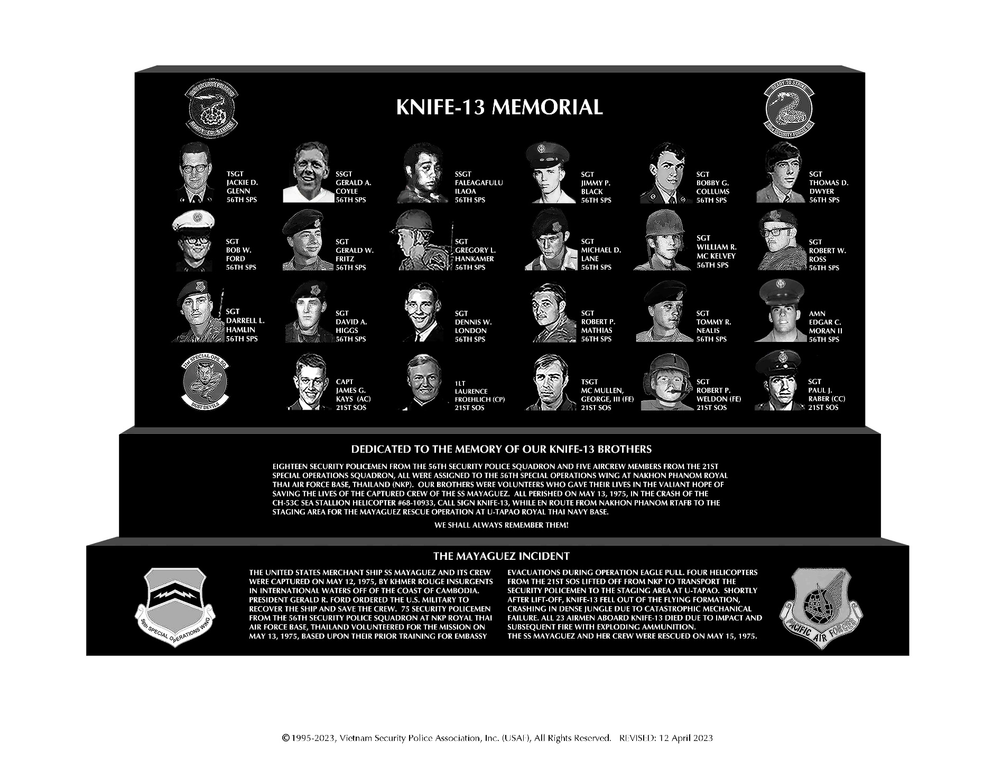
DONATE HERE AND HELP BUILD THE KNIFE-
