From: twebb16@woh.rr.com
To: k9nightfighter@msn.com
CC: jerold.haupt@luke.af.mil
Subject: Re: great photos!
Date: Sun, 9 May 2010 14:25:29 -0400
Phil

Captions added...not to detailed...tough assignment. It's been a long time, therefore unable to recall most names. All photo were taken the night of deployment on the NKP flight line with the exception of File Photos TWebb 7, 8 and 9.

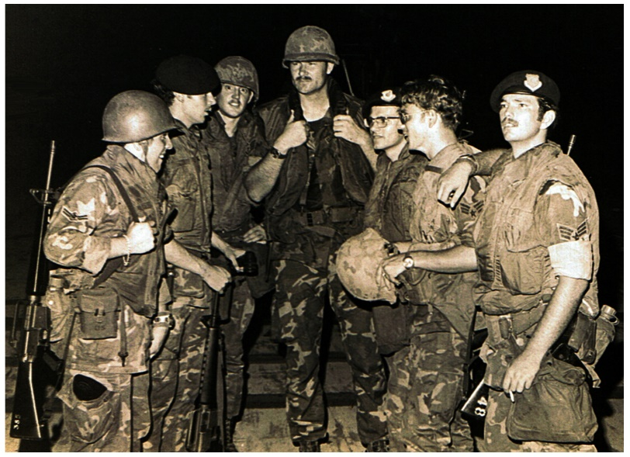
a. File Photo TWebb1. Some of the 56th SPS members who were mobilized to deploy to Utapao RTAFB for staging in preparation for the attack. Equipment issue and deployment orientation complete...these troops were "shooting the bull" and "killing time" awaiting helicopter assignment and departure from Nakhon Phanom (NKP) RTARB.

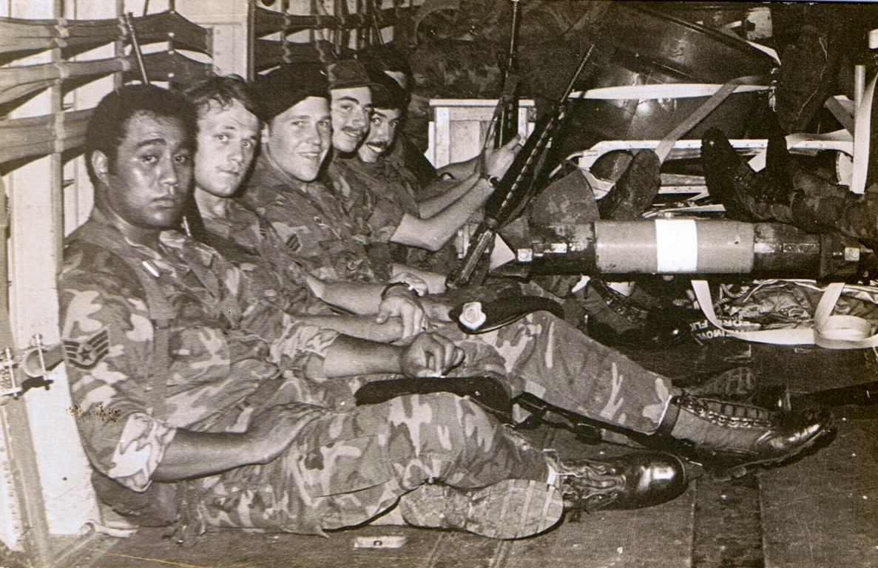
b. File Photo TWebb2. Security Police personnel that gave their lives during the Mayaguez rescue operation. (Don Poss and Larry have the names of these personnel)

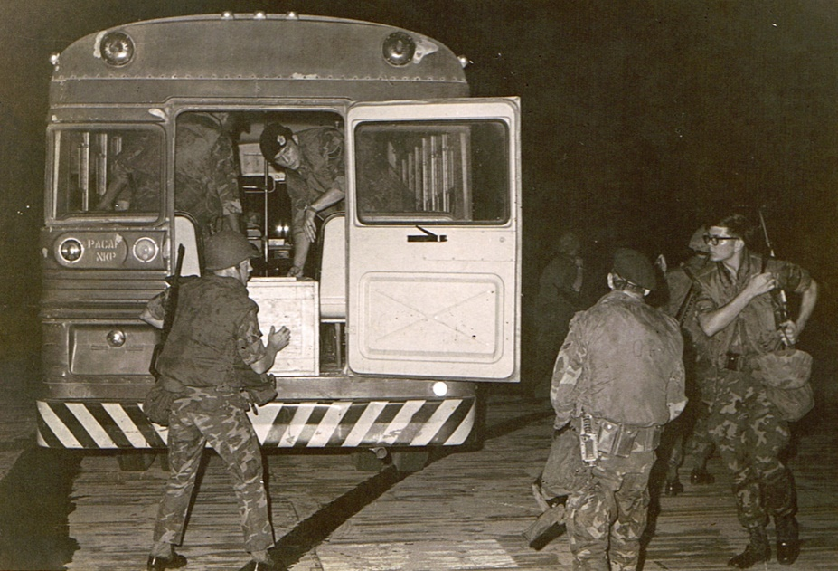
c. File Photo TWebb3. Unloading equipment and placing it aboard the helicopters. Sgt Bob W. Ford is located far right without hat.

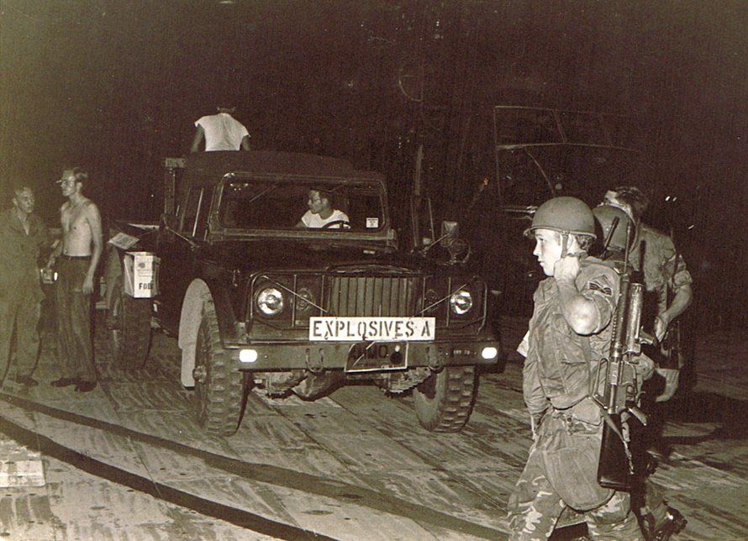
d. File Photo TWebb4. 56th MMS personnel unloading ammo and other explosives for placement on the choppers. Three SPS members in front of the vehicle...Sgt Ford far right without hat.

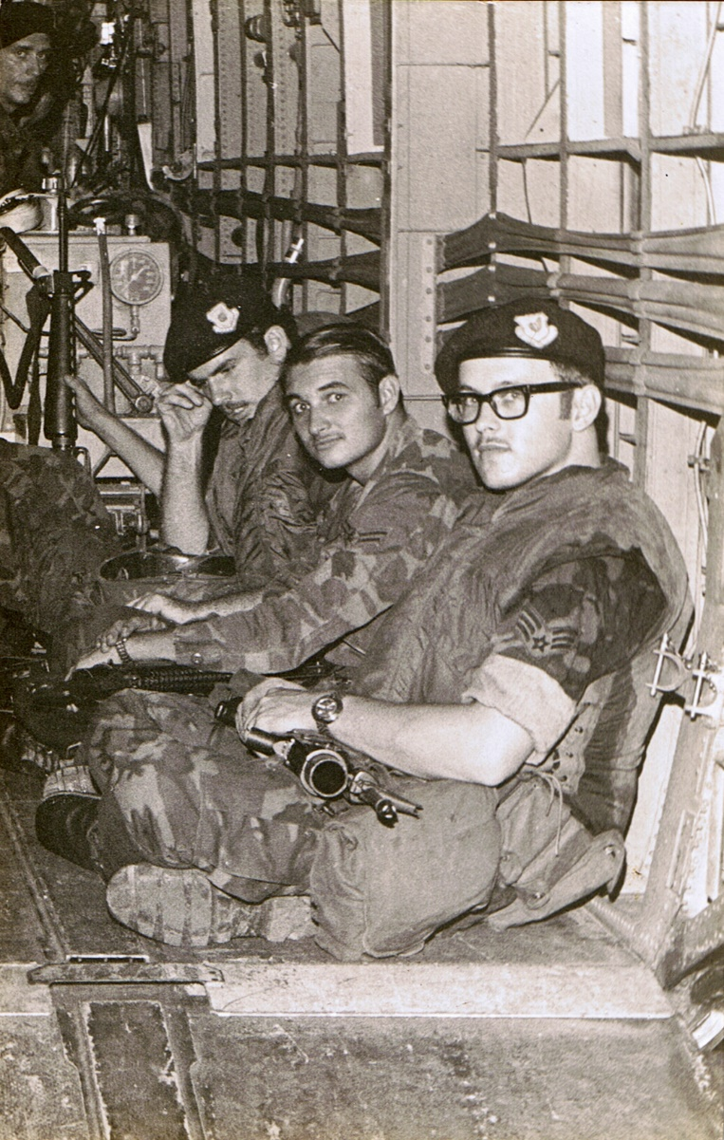
e. File Photo TWebb5. Security Police personnel that gave their lives during the Mayaguez rescue operation. (Again, Don and Larry have names)

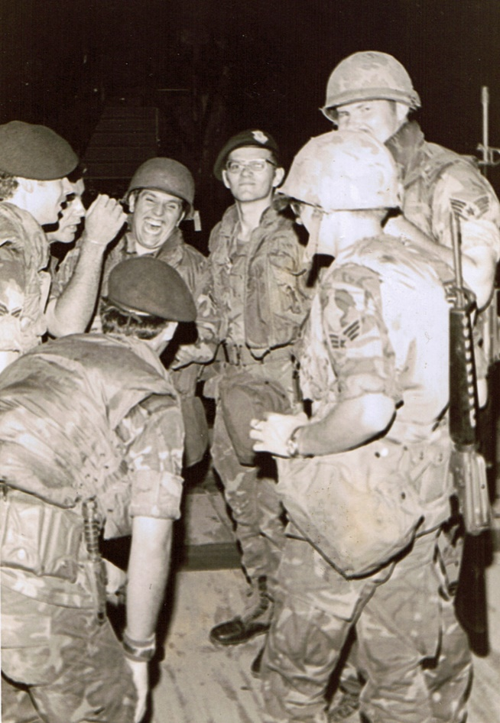
f. File Photo TWebb6. Same troops in Photo 1 awaiting helicopter assignment and departure.

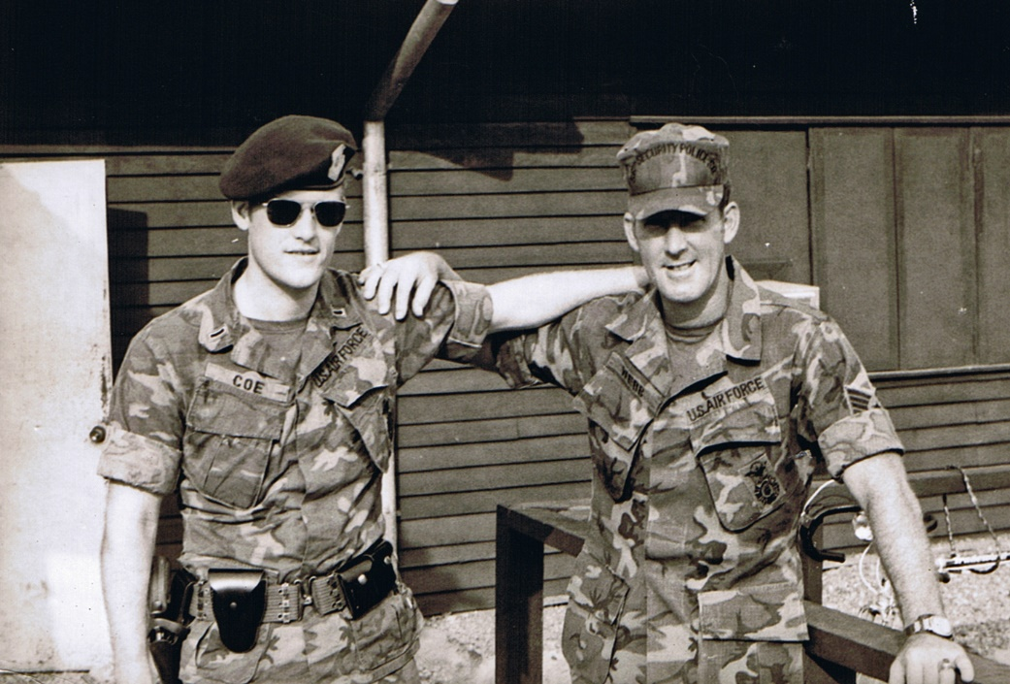
g. File Photo TWebb7. 56th SPS members 1Lt Robert L. Coe and MSgt Tommy L. Webb in front of the 56SPS Operations Building. Both Coe and Webb were part of the security police contingent that deployed to Utapao in support of the Mayaguez rescure operation.

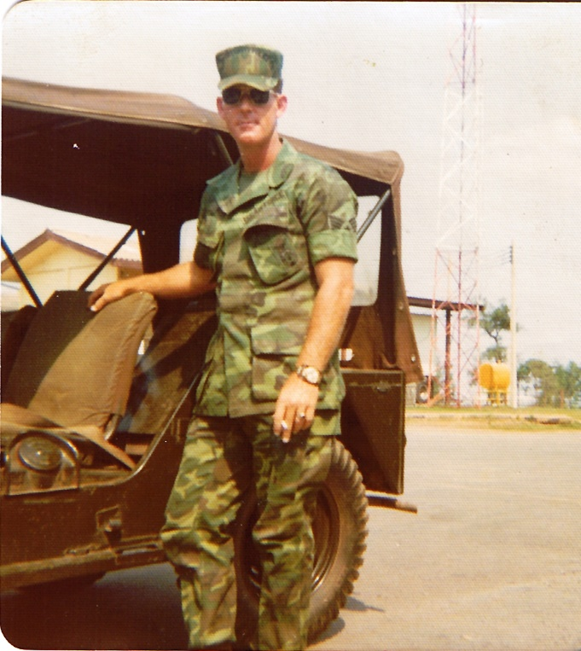
h. File Photo TWebb8. MSgt Tommy, 56 SPS, NKP RTAFB, 1975.

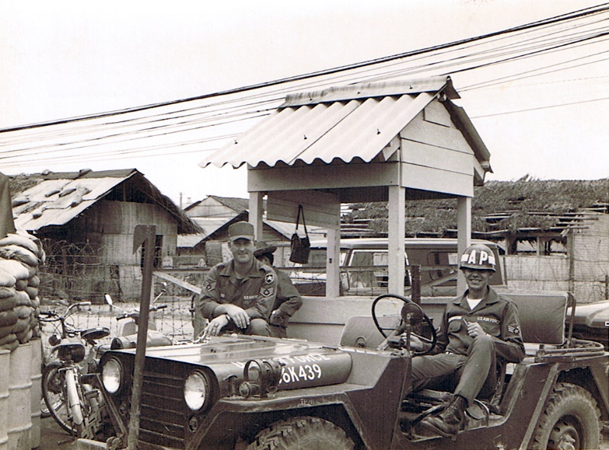
i. File Photo TWebb9. BS session. SSgt Tommy Webb, unidentified LE troop and Vietnamese entry controller (EC) at CSC (located left of jeep with barrels and sandbags) entry control point, Nha Trang RVN, 1966.

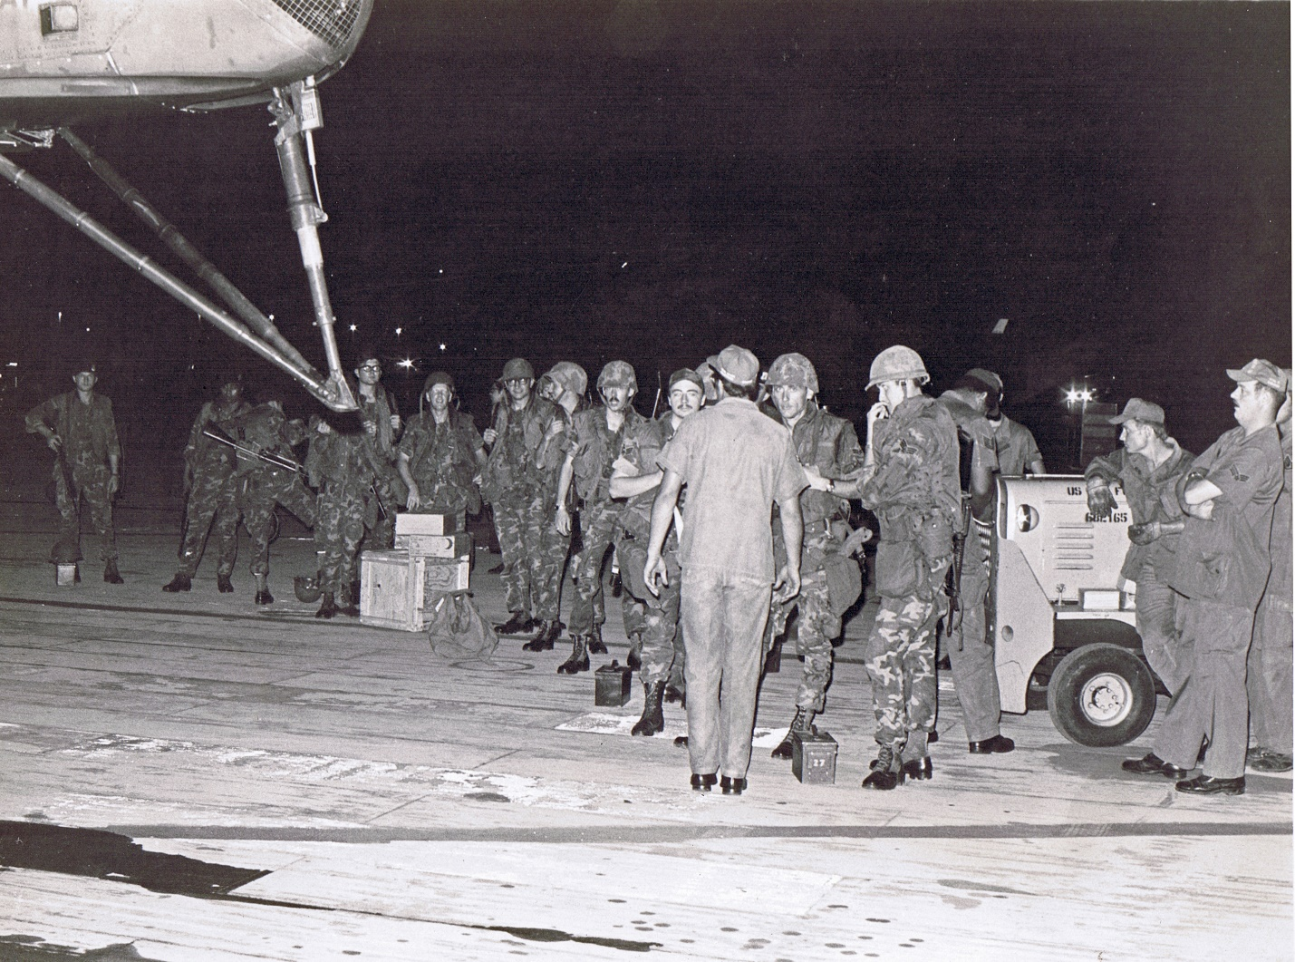
j. File Photo TWebb10. Security Police and Maintenance personnel standing by at the rear of the destined fatal helicopter. SSgt Gerald Coyle located center behind equipment/C-rat boxes. To Coyle"s right, wearing glasses and no hat is Sgt Bob Ford. To Coyle's left, wearing glasses and helmet, facing camera is TSgt Jackie Glenn. Surrounding Glenn, Coyle and Ford are the other Security Police personnel who gave their lives.

It should be noted that TSgt Glenn, SSgt Coyle and Sgt Ford worked for me in the 56 SPS Reports and Analysis Section.

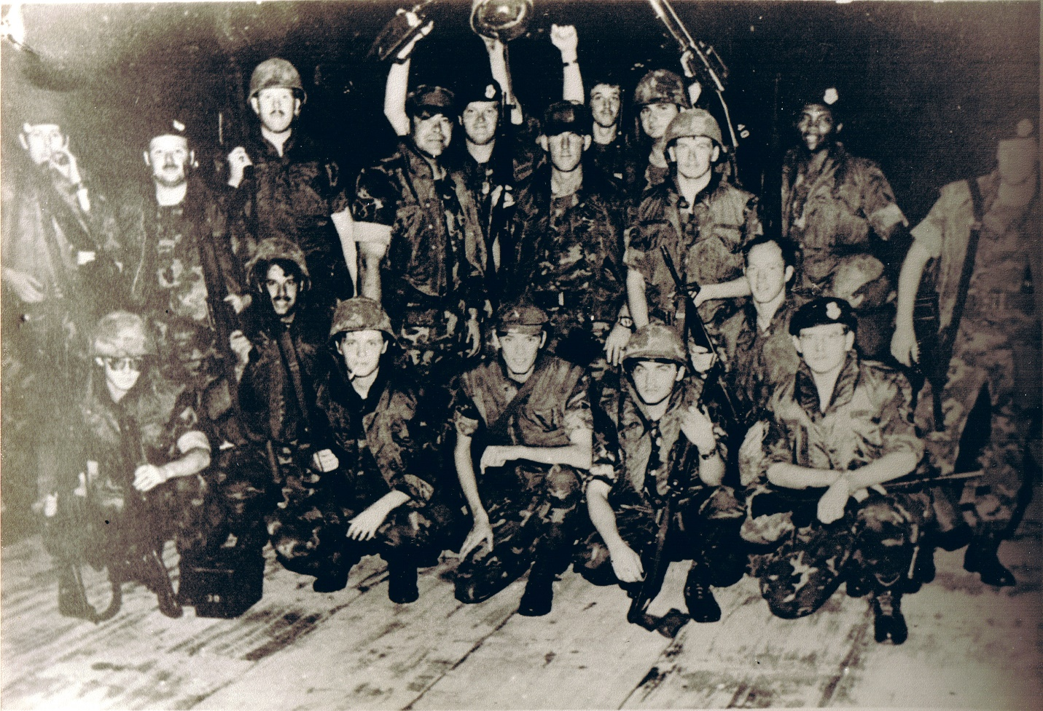
k. File Photo TWebb11. Group photo of some the 56th SPS contingency members that deployed to Utapao in support of the Mayaguez rescue operation. MSgt Tommy Webb located center wearing base ball type cammo hat. To Webb's right, wearing baseball type cammo hat is MSgt Francis P. Walls. To Webb's far left, standing with weapon slung over right shoulder, wearing a beret is 1Lt Robert Coe.

Take Care!

Tommy

Here is a photo with known names for the 56th SPs”

